 | Dukes County Emergency Management Agency  9 Airport Road, Edgartown, Ma.  RR1 Box 860  Vineyard Haven, MA 02539  Phone: 508-696-3811 Fax: 508-696-3841  email: emergencymanagement@dukescounty.org | 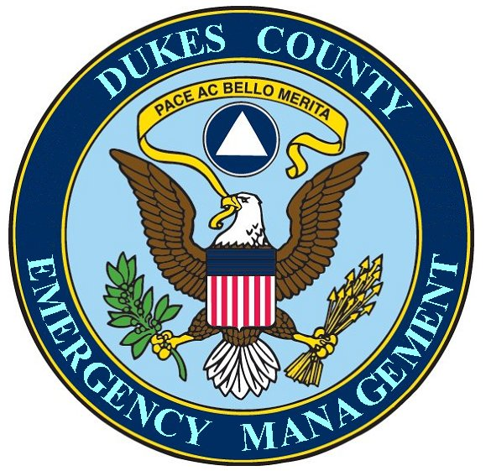
Chuck Cotnoir, Director |  | Dukes County  Emergency Management Team  www.  dukescounty.org/emteam

Mar. 26, 2006

Mr. Sean Flynn, Airport Manager
Dukes County
Edgartown, Ma. 02539

Dear Sean,
Here are the suggestions that you asked for. I am happy to be of service and do not hesitate to call on me again.

Suggestions
1) Concurrent with the initial Fire Suppression activities at the scene, the following actions are suggested to be implemented at the Incident Command Post:

a) The leading decision makers from Fire, Police, EMS, Emergency Management, etc. should check in at the Incident Command Post for a briefing of the incident
b) a portable ICS organizational chart should be filled out with the names of these decision makers
c) A review of Communications Procedures should be accomplished by all of the above
d) A review of the disposition of assets should be accomplished by all of the above
e) A review of a plan for Area Containment, Site Security, Patient Extraction, and the handling of Human Remains should be accomplished

2) The position of Coordinator, with laptop, which would be attached to the Incident Commander, could be added to the Incident Command Staff. The duties of the Coordinator would be as follows:

a) Plot a listing and the position of assets available for the Incident Commander
b) Plot a list of assets as they are deployed and removed to and from the scene, which would be updated upon movement of the assets
c) Keep a current record of the number of injured by priority
d) Keep a current record of the number of injured removed from the scene
e) Keep a record of the number of Human Remains and their location
f) Keep a record of the Human Remains removed from the site and their current location
g) Keep a record of the disposition of human assets injured
h) Gather information for the Incident Commander from Fire Ops, EMS Ops, and Law Enforcement Ops, and the Hospital
i) Act as messenger to these groups for the Incident Commander, when the IC is occupied
j) Map the disposition of assets at the scene on Pictometry
j) Map the containment area and the aircraft debris field on Pictometry
3) The need for extra EMT’s and 1st Responders should be assessed shortly after the time that the aircraft crashes, based on the number of Souls on Board and the initial assessment of the On-scene Commander. The alerting of these extra personnel should be made immediately upon the receipt of the On-scene Commander’s assessment, when necessary
4) A Liaison to Families, along with support from Family Services and Chaplains should be arranged for
5) A Recovery Phase EOC should be designated and staffed for large-scale incidents
6) An MOU or other agreement between the Airport Manager and the County Manager could be initiated to designate the County Building as a Media Center for the use of the Public Information Officer and the Media
7) An MOU between the Martha’s Vineyard Airport and a Human Remains storage facility could be initiated
8) The Airport could partner with the Dukes County Emergency Management Agency for the procurement and storage of body bags
9) Efforts could be made to procure and train personnel to remove and transport Human Remains

10) The Airport Manager, Fire Chiefs, Police Chiefs, and Emergency Managers should reach out, as a group, to the Hospital CEO to strongly encourage the Hospital to participate in Airport Incident Planning

11) Establish a Airport Incident Planning Committee of Fire Chiefs, West Tisbury Emergency Manager, MV Hospital, Mass State Police and local Police Chiefs, EMS, District Attorney, Medical Examiner, the relevant Airport agencies (Tower, etc.), Morgue and Funereal services, and the Dukes County Emergency Manager to establish a regional plan for dealing with both the Response Phase and the Recovery Phase of large scale Aircraft Incidents

Thank You,

Chuck Cotnoir, Director
Dukes County Emergency Management

