` | Dukes County Emergency Management Agency  9 Airport Road, Edgartown, Ma.  RR1 Box 860  Vineyard Haven, MA 02568  Phone: 508-696-3811 Fax: 508-696-3841  email: emergencymanagement@dukescounty.org | 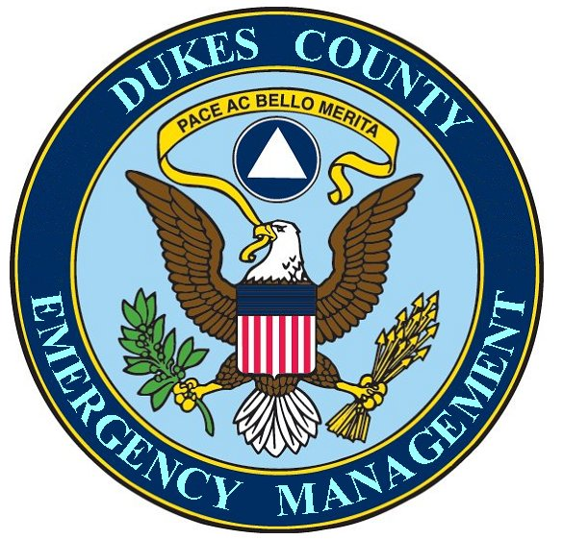
Chuck Cotnoir, Director |  | Dukes County  Emergency Management

March 14, 2008

Courtney Connor, MEMA Intern

SURVEY QUESTIONS:
1. Age: 65
2. Gender: Male
3. Education leve: Some college
4. Military service, if yes branch and position:
USAF 30 years; Grade - Senior Master Sergeant, E8; Duties - Air Traffic Controller, Aircraft Combat Loadmaster,
Westover AFB military liaison to FEMA Regional Director for Air Ops (duty station – FEMA Regional Office, Boston, Ma) and subsequently liaison to MEMA HQ. Framingham.
5. Full-time, part-time, collateral duty:
Volunteer EM Director, Chairman – Martha’s Vineyard Emergency Managers Directors Association; Treasurer – Martha’s Vineyard Medical Reserve Corps; Martha’s Vineyard Emergency Dispensing Site - Logistics Section Chief;
also … Distributed pre-staged hurricane supplies of 38 pallets of MRE’s and two trailers of water to 7 towns of Dukes County and the Wampanoag Tribe on instructions from FEMA/MEMA
6. How long have you held this position: 3 years
7. Are you a member of any professional emergency management organizations/associations: International Association of Emergency Managers
8. What is the operating budget of the emergency management department: $9,000 – $12,000
9. What is the source of the budget: County funds
10. Is the emergency manager's job description in written form: yes
11. Do you have a functional EOC: no
12. Is your MEMA radio operational: As a County, I was not authorized to receive a radio
13. Do you use WebEOC: yes
14. Do you participate in courses offered by MEMA/FEMA: yes
15. What is the highest level of ICS you have completed: 200 and plan to take 300 and 400
16. What is your responsibility in a major disaster: information coordination and dissemination
17. Have you conducted a recent hazard or vulnerability analysis for your community: yes
18. Are there regular meetings with other agencies or businesses in your community for the purpose of sharing emergency management information: yes
19. What serious hazards, both natural and technological, has your community faced since January 2000:
winter storms, blizzards, northeasterers, flooding, hurricanes, power and communication outages

Thank You,

Chuck Cotnoir, Director,
Dukes County Emergency Management Agency

