` | Dukes County Emergency Management Agency  9 Airport Road, Edgartown, Ma.  RR1 Box 860  Vineyard Haven, MA 02568  Phone: 508-696-3811 Fax: 508-696-3841  email: emergencymanagement@dukescounty.org | 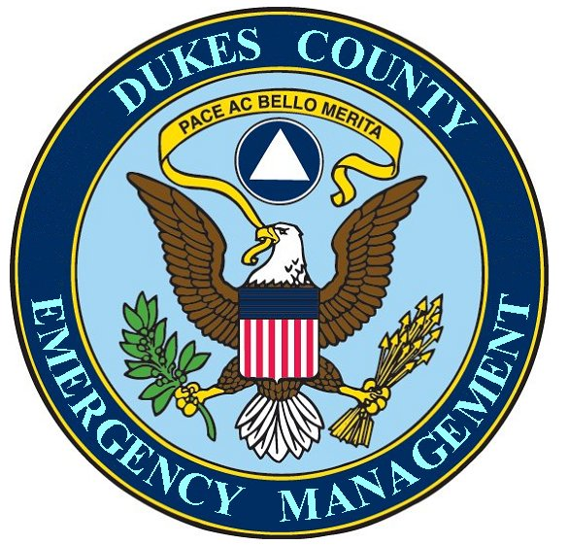
Russell Smith  Dukes County  Manager |  | Chuck Cotnoir  Dukes County  Emergency Management
Mr. Don Boyce, Director April 29, 2008
Massachusetts Emergency Management Agency
Framingham, Massachusetts

Dear Mr. Boyce,
This letter is an offer to open a dialogue between the County of Dukes and its Emergency Management department and your office that may amplify your efforts to regionalize the dissemination of emergency information and disaster resources during and after disasters.

Our Emergency Management department, in the past, was asked by MEMA and FEMA to devise and implement a plan to distribute 38 pallets of pre-positioned MREs and 76 pallets of bottled water among the 7 towns of the County, the Federally recognized Wampanoag tribe, and the County. This entire effort was devised and implemented by the County, successfully, within three weeks.

In 2007, the County Emergency Manager initiated an effort to form a chapter of the Medical Reserve Corps. On Martha’s Vineyard, this is a partnership of the 6 Island town Boards of Health, the Martha’s Vineyard Hospital, The Wampanoag Tribal Health office, the County Emergency Management department and the Cape & Islands Health Coalition. The County also hosts the Martha’s Vineyard Medical Reserve Corps.

The County EM acts as the Logistics Section Chief and Transportation Officer for the activation of the Island Emergency Dispensing Site. This also is an example of our spirit of partnership, as this appointment was made by the health agents of the 6 towns of Martha’s Vineyard.

Notwithstanding the legislative imperatives put forward in MGL c 34A Sec. 16 (B), which limits the actions that can be taken by county government and, conversely, the assistance that you can legally call upon from us during times of disaster; we believe, however, that there are ways that our county government can legally be a valuable asset which would help you to implement the necessary regionalization of the dissemination of emergency information and disaster resources in these times of ever decreasing funding and manpower downsizing.

These Island partnerships that we have formed fall within the purview of MGL c34 A Sec. 16 (C),[“Based on the need to develop effective services to meet problems which cross city or town boundaries and which cannot be met effectively on an individual basis by the cities and towns, or the state, this chapter shall be construed as intending to give the county power to establish innovative programs and to perform such regional services as the Constitution of the Commonwealth of Massachusetts and the General Laws permit and to establish such other programs and services as may from time to time be permitted.”] and we believe that our partnerships will be beneficial during times of disasters. We also believe that Section 16 (C) could be used to amplify your regionalization efforts. We would like to talk with you to see if there are ways that we can make your job easier.

Thank You,
__________________________ _______________________
Chuck Cotnoir Russell Smith
Dukes County Emergency Management Dukes County Manager

