 | Dukes County Emergency Management Agency  9 Airport Road, Edgartown, Ma.  RR1 Box 860  Vineyard Haven, MA 02539  Phone: 508-696-3811 Fax: 508-696-3841  email: emergencymanagement@dukescounty.org | 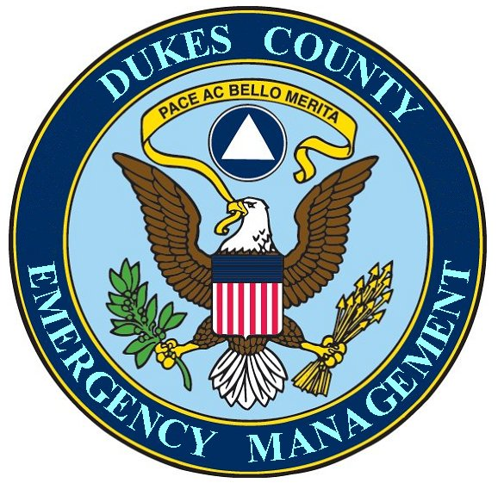
Chuck Cotnoir, Director |  | Dukes County  Emergency Management Team  www.  dukescounty.org/emteam

May 18, 2006

Mr. Wayne Lamson
Woods Hole, Martha’s Vineyard, and Nantucket Steamship Authority
1 Railroad Av.
Woods Hole, Ma.

Dear Wayne,

Thank you for your support of our getting together to open the lines of communication during times of emergency.

The County Manager thought that it would be a good idea to have me explain where the County Emergency Management position is, as it relates to the overall picture. He reminded me that I once told him that on an organizational chart that there are lines and boxes and that I had told him that the Emergency Management position is really the lines, not the box. My position is really the communications link between the boxes

That really is how I see my relationship with the Steamship Management. My position is really only a conduit of emergency information and does not imply any actual authority over anyone.

This emergency information conduit runs both ways. In one direction, it relays emergency information regarding the Steamship Authority operations from you, through me, to the appropriate Island entities. In the other direction, it relays Island emergency information regarding emergency needs that involve the Steamship Authority, gathered from various sources by me, back to you.

I have next Tuesday and Wednesday off and could meet with you and whomever you feel could contribute ideas to this endeavor.

Thank You,

Chuck Cotnoir, Director
Dukes County Emergency Management

Cc: Mr. Marc Hanover

