 | Dukes County Emergency Management Agency  9 Airport Road, Edgartown, Ma.  RR1 Box 860  Vineyard Haven, MA 02539  Phone: 508-696-3811 Fax: 508-696-3841  email: emergencymanagement@dukescounty.org | 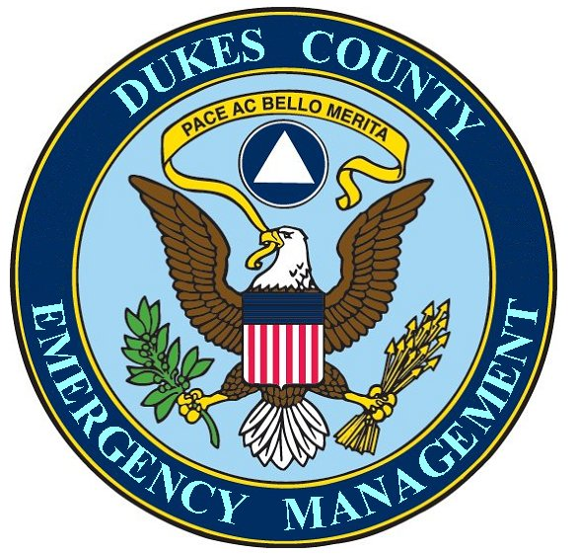
Chuck Cotnoir, Director |  | Dukes County  Emergency Management Team  www.  dukescounty.org/emteam

May 2, 2006

Mr. Michael McCormack
Dukes County Sheriff
Edgartown, Ma. 02539

Dear Sheriff McCormack,
The Island Boards of Health and the Island Emergency Managers are hosting a Pandemic Flu Planning meeting on May 17th at 7 pm at the High School Cafeteria. Each Health Agent and Emergency Manager from each of the towns will invite his Selectmen, Executive Secretary, Police Chief, and Fire Chief to this round-table discussion. The discussion will focus on an island-wide response to the consequences of a Flu Pandemic.

Other invitees are from the Hospital, State Police, and Environmental Police.

Hopefully, we’ll be able to discuss the concept of an Island-wide Planning Committee that encompasses all of the disciplines from all of the towns, County, and the State Officers stationed here.

The Boards of Health are inviting a Mass Department of Public Health official to tell us what consequences to expect here on the Island from a Flu Pandemic.
.
I would like to invite you, as the County’s Public Safety Officer and through you, Susan Schofield from the Comm. Center. I am also inviting Winn, Kendra Read, and the Assistant Commissioner for Health, Dr. Ilene Klein.

I realize that this meeting is short notice and also falls on the same night as the County Commissioners Annual Meeting, but hopefully that meeting’s duration will allow you sufficient time to be able to make it to this meeting.

I believe that this planning effort is a worthwhile endeavor and you should know that, although I did not initiate this process, I believe that many County Departments could be substantially affected by the consequences of a Flu Pandemic. I believe that certain departments will be called upon to respond in a way, which could stretch their capabilities and resources to the utmost. If you have any questions, please don’t hesitate to call me.

Thank You,

Chuck Cotnoir, Director
Dukes County Emergency Management Agency

