` | Dukes County Emergency Management Agency  9 Airport Road, Edgartown, Ma.  RR1 Box 860  Vineyard Haven, MA 02568  Phone: 508-696-3811 Fax: 508-696-3841  email: emergencymanagement@dukescounty.org | 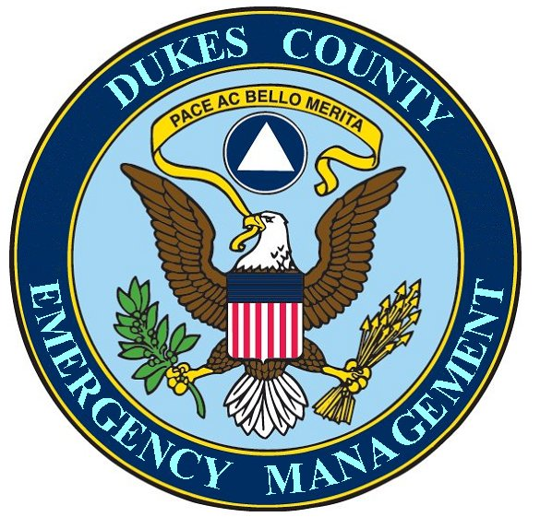
Chuck Cotnoir, Director |  | Dukes County  Emergency Management

June 9, 2009

To: All Dukes County Employees

From: Russell H. Smith, County Manager
Chuck Cotnoir, County Emergency Manager

As you have seen from Tuesday’s Gazette, Swine Flu has come to Dukes County. There is no need to be alarmed, as this version of the flu is very mild; milder even than our regular winter flu. However, normal precautions should be taken to protect yourself from infection and normal precautions should be taken to prevent the spread of this flu among your co-workers.

We have assembled a number of informational brochures in a packet to help you to protect yourself, your family and your co-workers and have distributed them to each County employee.

Although this time around, swine flu is a very mild form, Federal disease specialists are directing their efforts toward continuous monitoring of this flu, checking to see if it mutates into something more serious when it returns in the autumn. It is for this reason that we are making sure that you have some instructional materials now to get used to making good health protection habits. It is our hope that you will be able to gradually begin to use these habits now in the event that the next phase should suddenly turn more deadly.

We will be sending you more information, as we get closer to the fall of the year.

We will be monitoring the flu situation to be able to give adequate warning to all County employees. However, bear in mind that it only took 3 weeks for swine flu to show up in all 52 states and only a month to spread around the world.

Thank You,

Russell H. Smith, County Manager
Chuck Cotnoir, Director, County Emergency Management Agency

P.S. Some of our employees are on the Dukes County Emergency Management Employee Bulletin List and have received weather and other disaster information. We will be expanding this service into a County Employee Early Warning System. If you are not already receiving these bulletins and would like to do so, please send an email request to emergencymanagement@dukescounty.org

