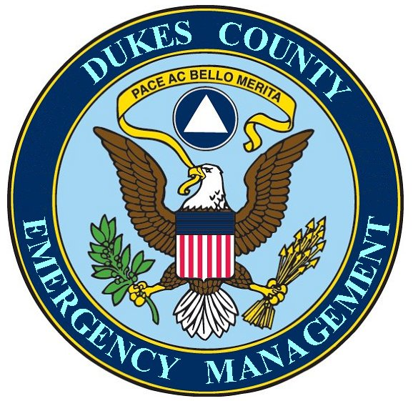

MISSION STATEMENT

Dukes County Emergency Management Agency

INTERNAL | EXTERNAL
To contribute to the continuity of County government, before, during, and after an emergency or disaster. | To collect disaster related information and disseminate the information to interested governmental and non-governmental bodies.
To contribute to the ability of County employees to be better able to prepare themselves and their families for emergencies and disasters. | To facilitate multi-departmental and multi-jurisdictional cooperation between Island governmental bodies and between Island governmental bodies and non-governmental bodies.
 | To contribute to the ability of Island residents to be better able to prepare themselves and their families for emergencies and disasters.
 | To perform Search and Rescue operations through the Dukes County Search and Rescue department.

