` | Dukes County Emergency Management Agency  9 Airport Road, Edgartown, Ma.  RR1 Box 860  Vineyard Haven, MA 02539  Phone: 508-696-3811 Fax: 508-696-3841  email: emergencymanagement@dukescounty.org | 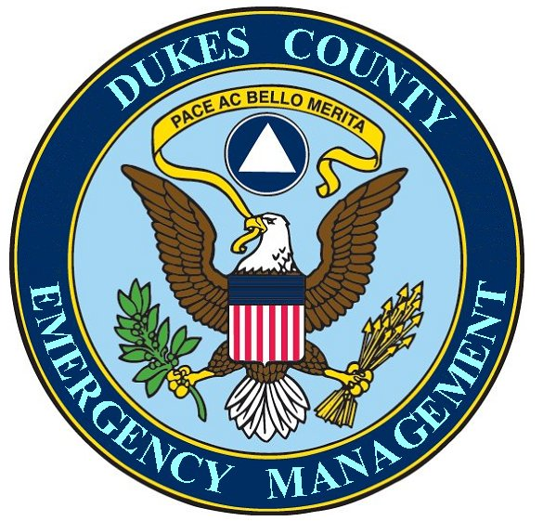
Chuck Cotnoir, Director |  | Dukes County  Emergency Management Team  www.  dukescounty.org/emteam

20 February 2007

Mr. Robert Nadeau
Regional Manager
Region II,
Bridgewater, MA.

Dear Mr. Nadeau,

The Executive Director of the Cape Cod and Islands Chapter of the American Red Cross, Mr. Glenn Beasley, has requested my assistance to facilitate a meeting with a representative of MEMA, along with representatives of the Federal Emergency Management Agency, the Steamship Authority, the Martha’s Vineyard Airport, and the Packer Barging Company.

The purpose of this meeting would be to establish a Red Cross Disaster Response Preparedness Plan on Martha’s Vineyard.

The goal of this initial meeting is to begin a process for the development of a plan for the pre-positioning of disaster supplies, along with specific plans for defined distribution channels, both from the mainland and on Martha’s Vineyard. Additionally, the plan would include a section on centralized secure storage. The final part of the goal of this meeting would be to discuss the establishment of memorandums of agreement between the parties for the implementation of the plan.

On the part of Dukes County, I am hoping that this meeting will also be of use to your mission, in that, all parties could also create a similar plan for the transportation, positioning and distribution of emergency supplies by your office.

I am sending this letter to you in the hopes that we can continue the work that we had recently done together regarding the distribution of emergency supplies here on the Vineyard and to continue the conversations that we had about creating an emergency distribution plan for emergency supplies by MEMA to the Island during disasters. I have also invited Mr. Scott Erickson from FEMA.

This letter is an invitation to this meeting and if you and your office are amenable to this invitation, we can work out a meeting date that would be convenient for you.

Chuck Cotnoir, Director
Dukes County Emergency Management Agency

