` | Dukes County Emergency Management Agency  9 Airport Road, Edgartown, Ma.  RR1 Box 860  Vineyard Haven, MA 02539  Phone: 508-696-3811 Fax: 508-696-3841  email: emergencymanagement@dukescounty.org | 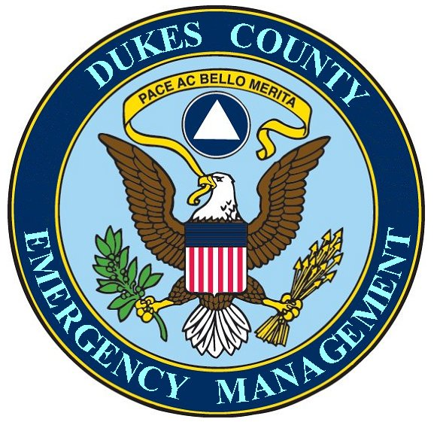
Chuck Cotnoir, Director |  | Dukes County  Emergency Management Team  www.  dukescounty.org/emteam

20 February 2007

Mr. Marc Hanover
Woods Hole, Martha’s Vineyard & Nantucket Steamship Authority Member – Dukes County

Dear Mr. Hanover,

The Executive Director of the Cape Cod and Islands Chapter of the American Red Cross, Mr. Glenn Beasley, has requested my assistance to facilitate a meeting with representatives of the Steamship Authority, the Martha’s Vineyard Airport, and the Packer Barging Company, along with representatives of the Federal Emergency Management Agency, and the Massachusetts Emergency Management Agency.

The purpose of this meeting would be to establish a Red Cross Disaster Response Preparedness Plan on Martha’s Vineyard.

The goal of this initial meeting is to begin a process for the development of a plan for the pre-positioning of disaster supplies, along with specific plans for defined distribution channels, both from the mainland and on Martha’s Vineyard. Additionally, the plan would include a section on centralized secure storage. The final part of the goal of this meeting would be to discuss the establishment of memorandums of agreement between the parties for the implementation of the plan.

I am sending this letter to you in the hopes that we can continue the conversations that we had recently regarding the transportation of emergency supplies, vehicles, and personnel to the Vineyard. I have also invited Mr. Scott Erickson from FEMA and Mr. Robert Nadeau, MEMA Region II Manager. I am awaiting their written responses, although both have expressed verbal interest in this meeting.

This letter is an invitation to this meeting and if you and your office are amenable to this invitation, we can work out a meeting date that would be convenient for you.

Chuck Cotnoir, Director
Dukes County Emergency Management Agency

cc: Mr. Wayne Lamson, CEO, Woods Hole, Martha’s Vineyard, and Nantucket Steamship Authority

