 | Dukes County Emergency Management Agency  9 Airport Road, Edgartown, Ma.  RR1 Box 860  Vineyard Haven, MA 02539  Phone: 508-696-3811 Fax: 508-696-3841  email: emergencymanagement@dukescounty.org | 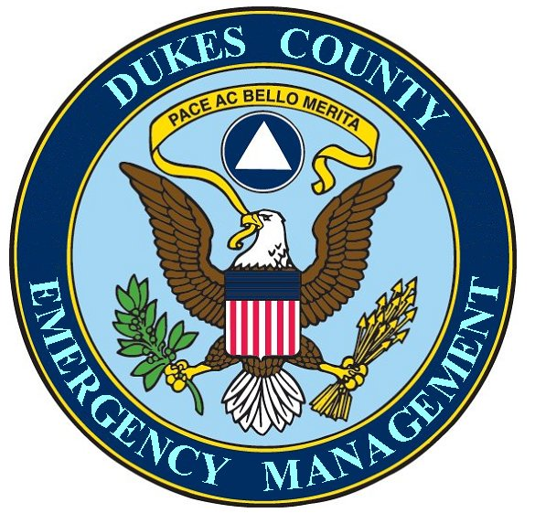
Chuck Cotnoir, Director |  | Dukes County  Emergency Management Team  www.  dukescounty.org/emteam

Dec 22, 2005

Dr. Timothy W. Tsai
Martha’s Vineyard Hospital
Oak Bluffs, Ma.

Hi Tim,
Thank you for your attention yesterday at the Disaster Committee meeting.
I am enclosing the text of my written remarks as I promised you.
Thank you also for allowing me to offer the services of the County Emergency Management office in the realm of Information Gathering and Information dissemination, along with the use of the County Emergency Management library for your Flu Pandemic planning. I hope you found the proffered manuals and documents of use for information or planning tools. Please keep them for as long as they are useful to you.
One of your members suggested that it would be useful to look at a hospital Flu Pandemic Response plan. As part of the community service that the County Emergency Management office does, my staff or I would be happy to search for such a plan through the Emergency Management and Homeland Security channels or through my other sources. Please let me know if this would be helpful to you and I'll assign it as a task to one of my staff.

Also, Happy Holidays from myself and the rest of the staff at Dukes County Emergency Management.

Chuck Cotnoir, Director
Dukes County Emergency Management

