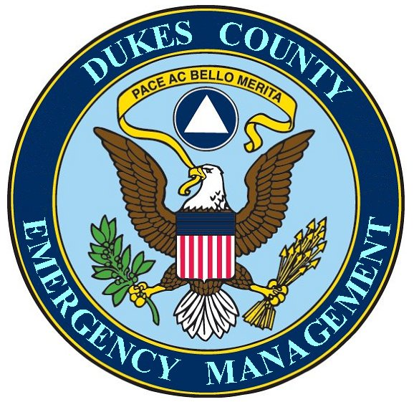

Memo
Date: 23 January 2005

To: Winn Davis, County Manager
From: Chuck Cotnoir, Director, DCEMA

Dear Winn,

Last year, you assigned me a project for building a plan for Disaster Recovery Procedures for the County regarding the recommendations as noted in the Powers and Sullivan Management Letter of June 30, 2005. A Disaster Recovery program (DRP) refers to recovery of IT systems, as noted in recommendations 1, 2, 3. However, recommendations 4 and 5 deal more with Continuity of Operations procedures.

As you know, my preliminary assessment of the county’s readiness in this area revealed that there are unwritten procedures that various departments believe that they will implement, on the spot, during and after an event that interrupts the normal flow of County business. It has become clear to me that it will take much more than the simple approach of correcting and implementing the few recommendations noted by Powers and Sullivan, to insure that the County can operate during and after a large scale disaster.

This issue is really a need for a comprehensive, written, all County departments, Continuity of Government plan (GOG) and a Continuity of Operations Plan (COOP).

I would suggest the following approach and it is an approach that is only an interim method of coping with the need for a COG plan and a COOP. The County may decide to hire a professional planner to write a more comprehensive plan, at a later date.

I have downloaded the following reference materials:

- An Operations Plan template from the State of Washington
- A FEMA/DHS document entitled “Interim Guidance on the Continuity of Operations Planning for State and Local Government
- A NGA center for Best Practices, Homeland Security and Technology Division, on Planning for Government Continuity
- A Continuity Central website article entitled Continuity of Operations Planning: Survival for Government
- The County of Los Angeles manual for their Business Continuity program
- The New Zealand Business Continuity Planning Guide for Influenza pandemic Planning
- The Regional Influenza Pandemic Response Plan form Vancouver Canada

In order for the County’s plan to actually work during a disaster, these references all stress the need for the active involvement of all department heads in the planning process and the commitment of the chief executive to require that involvement.

I suggest that you and I start the initial planning effort by setting aside some time each week to review the above reference materials for relevance to Dukes County and then to plan the involvement of the different department heads. From my research to date, I am finding that the effort to build a complete COG and COOP may take many months and that once built, it will require consistent practice to make sure that the County can operate according to the plans.

Chuck Cotnoir, Dirctor, DCEMA

