



The BioTerrorism Readiness Suite (BTRS)
Portal & Alerting System
User Manual with BTRS Admin Reference
Version 2.2, Upgrade



About Virtual Alert BTRS v2.2

BTRS Users
First Log In Profile Set Up
The v2.2 release of the Virtual Alert BTRS product provides a more intuitive user profile set-up the first time new users log onto the system. With step-by-step guidance, a user will have all required information entered within a short time after their initial log in.

BTRS Admin
Docs Awaiting Approval Log
Now Admins will be able to generate a Documents Awaiting Approval Log to determine the number of outstanding approvals that are awaiting action in the system.

Documents Checked Out Log
The default action of clicking on the title of a document is no longer used to download the document nor open the document in a new window. Instead, the title is now a link to Document Inspection Page so that the document properties can be examined.

Basic User Report
It is now simple to generate a report of one or several pieces of profile info for users. The report uses a screen with checkboxes for selecting the desired information.

Manage Subscriptions
It is now possible to assign subscriptions to PHRoles that you manage. Also, a new resizable User/OU tree allows for easier navigation and the ability to view long OU and user names without having to scroll the frame.

Manage Users
It is now much easier to manage users with the new admin tools. Improved functions for moving users and renaming/modifying OUs have reduced the support efforts for the BTRS Admins. Some features include:
- Move a single user to another OU
- Rename an OU
- Move an OU and all of its contents
- Tabbed appearance for user search

Manage PHRoles
The ease of use that has been added to the user directory and OUs is also a part of the new management structure of the Public Health Directory and the associated PHRoles. The new features for managing PHRoles include:
- Move a single PHRole to another OU
- Move a batch of PHRoles to another OU
- Rename an OU
- Rename a PHRole
- Move an OU and all of its contents
- Tabbed appearance for PHRole search
BTRS Portal User Guide

Index
About Virtual Alert BTRS v2.2 2
Index 3
System Requirements 7
Logging onto the BTRS Portal 7
Portal Permissions 8
Permission-based Security 8
Readers 8
Authors 8
Approvers 8
BTRS Admin 8
Using the BTRS Portal 9
The Home Page 9
News and Announcements 10
To Open News and Announcement Items 10
Quick Links 10
To Open a Quick Link 10
Categories 10
To Open a Category 10
Subscription Summary 10
To Open a Subscription Notification 11
Active Public Health Alerts 11
To Open an Active Public Health Alert 11
Document Status 11
To View Documents Checked Out to You 11
To View Documents Awaiting Your Approval 11
To View Your Documents Pending Approval 11
Accessing Additional Dashboards from the Home Dashboard 12
About Search 12
Searching Folders 13
To Search Folders 14
Understanding Search Results 14
Sorting Search Results 15
Advanced Searching 15
To Conduct an Advanced Search 15
About Categories 16
About the Document Library 16
About Subscriptions 17
To Subscribe to a Folder or Document 18
About Alerts 18
About Public Health Directory 19
About My Profile 19
About BTRS Admin 19
About Logoff 20
How to Logoff 20
Document Management and Publishing 21
Document Profiles 21
Document Publishing 21
Discussions 21
Version History 22
Managing Folders and Documents 22
About Folders 22
Creating Folders 22
To Create a New Folder 22
Adding a Document to a Folder 23
To Add a Document 24
Discussing Documents 24
To Discuss a Document 25
Show Actions 25
Checking In Documents 26
To Check-in a Document 27
Checking Out Documents 28
To Check-out a Document 28
Publishing Documents 29
To Publish a Document 30
Editing Document Profiles 30
To Edit a Document Profile in an Enhanced Folder 30
To Edit a Document Profile in a Standard Folder 30
Viewing a Document’s Version History 30
To View a Version History 30
Editing Documents in Standard Folders 31
Renaming Documents 31
To Rename a Document 32
Deleting Documents 32
To Delete a Document 32
Distributing Documents Via Fax 32
To Distribute a Document Via Fax 32
Viewing Your Sent Faxes 34
To View My Sent Faxes 34
Alerting 37
About the Alerting System 37
Sending Alerts 37
To Send an Alert 37
Viewing Alerts 40
Using Active Public Health Alerts 40
To View an Alert From the Home or Alerts dashboards 40
How to use View My Sent Alerts 41
To View Your Sent Alerts 41
Confirming Receipt of Alerts 44
To Confirm Receipt of an Alert via E-mail 44
To Confirm Receipt of an Alert via Telephone 45
To Confirm Receipt of an Alert via the Portal 45
Public Health Directory 46
About the Public Health Directory 46
Using My Public Health Directory 46
My Profile 48
About My Profile 48
To Change Your Profile Information 48
How to Change My Password 50
To Change Your User Password 50
How to Set/Change My Alerting Security Code 51
To Change My Alerting Security Code 52
How to Change My Alerting Profiles 52
To Create an Alerting Profile 52
To Activate an Alerting Profile 54
To Edit an Alerting Profile 55
To Delete an Alerting Profile 55
BTRS Admin 55
About BTRS Admin 55
Using Manage Discussions 56
Using Manage Categories 57
Using Manage Subscriptions 59
To Manage Another User's Subscriptions 60
To Assign Subscriptions to PHRoles 61
Using Manage Folders 63
Set Folder Profiles 64
Set Folder Permissions 66
Set Folder Approval Routing 67
Using Manage Users (Public Health Users Directory) 69
Create a New User 69
Create a New Organizational Unit (OU) 70
Rename an OU 71
Move an OU (and all of its contents) 72
Move Several Users to a Different OU 73
Assign Manager(s) to an OU 74
Edit User Properties 75
Edit User Alerting Profiles 77
Move a Single User to a Different OU 79
Deactivate a User 81
Reset a User Password 82
Reset a User's Alerting Security Code 83
Assign a User To PHRole(s) 83
Assign a User Portal Permissions 84
View User Properties 86
Use the Search Tab to Locate an Individual User 86
Using Manage PHRoles (Public Health Directory) 87
Create a New PHRole 87
Create a New Organizational Unit (OU) 88
Rename an OU 89
Move an OU (and all of its contents) 90
Move Several PHRoles to a Different OU 91
Assign Manager(s) to an OU 92
Assign Alertable PHRoles 93
Assign Users to PHRoles 94
Rename a PHRole 95
Move a Single PHRole to a Different OU 96
View PHRole Members and Corresponding Alertable PHRoles 97
Use the Search Tab to Locate an Individual PHRole 98
Using Manage Portal Permission Groups 99
Create a New Portal Permission Group 99
Assign Users to a Portal Permission Group 101
Delete a Portal Permission Group 102
View the Members of a Portal Permission Group 103
Using Basic User Report 103
Generate a Basic User Report 103
Using Alert History Log 105
Generate an Alert History Log 105
Using Fax History Log 106
Generate a Fax History Log 106
Using Alert Confirmation Reports 107
Generate an Alert Confirmation Report 108
Sample of Alert Confirmation Report Sorted by User 109
Using Folder Permission Reports 110
Generate a Folder Permission Report 110
Using Documents Checked Out Log 111
Generate a Documents Checked Out Log 111
Using Document Documents Awaiting Approval Log 112
Generate a Documents Awaiting Approval Log 112
Using Document History Report 113
Generate a Document History Report 113
Using Document Totals Log 114
Generate a Document Totals Log 114
Using Modified Content Report 117
Generate a Modified Content Report 117
Managing Home Page Content 119
Adding News or Announcements 119
Adding Quick Links 121
Help 123
About Help 123
Glossary 124
Supplementary Information 130
Part 1 - Levels of Licensing for BTRS 130
Part 2 - Office XP and Discussions 131
Part 3 - Alternate System and Browser Compatibility 132
Part 4 – View Refreshment Needs 133

System Requirements
The BTRS System requires the following:

- Microsoft Windows 98 or higher
- Microsoft Internet Explorer 5.5 or higher

Note: If you have Microsoft Office XP, please see “Office XP and Discussions” in the Supplementary Information section.

Logging onto the BTRS Portal

When you go to the URL of your BTRS portal, you will always get a login prompt box. When you get the prompt box, you will need to enter your user name and your password into the corresponding fields in order to gain access to the portal.

Note: User names and passwords ARE CASE SENSITIVE! Please use care when entering this information to access the portal.

Example:

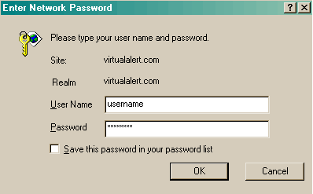

Caution: If you are presented with a 3-line login prompt, please contact your BTRS System Administrator.

Note: Users with limited and full access user licenses will be assigned a user name and password for their initial access to the portal. At their first login, they will immediately be sent to the My Profile page where they will be prompted (screen-by-screen) to confirm their profile information, set their Alerting Security Code, and create an Alerting Profile. It is also highly recommended that users change their password to whatever they prefer upon their first login. If a user forgets their password, the BTRS Admin must arrange to reset it so that they may login again and customize it. Passwords are not available to be “looked up”.

Portal Permissions

Permission-based Security

The BTRS system uses permissions to control access to content and functions. The permissions of BTRS Admin, Author, Reader and Approver are assigned to users based on the tasks they perform. BTRS Admins handle management tasks and publish Portal Content to the Home page. Authors add and update files. Readers have read-only access to published documents. Approvers approve or reject documents submitted for publishing.

Readers

A Reader can search for and read published documents but cannot add them to the site. Subscription and discussion functions are available to Readers as well. A Reader cannot check-out, edit, or delete documents and cannot view draft (checked-in) versions of documents.

Authors

From the portal, a user with Author permissions can add new documents to a folder, edit all documents in the folder, delete any document from the folder, and read all documents, drafts or published, in the folder.

An Author can also create, rename, and delete folders. However, an Author cannot change the user permissions on folders that they create. That must be done by a BTRS Admin.

Approvers

An Approver on a folder has the ability to approve or reject a document that has been submitted for publishing to that folder. Approval routing on a folder is set up by a BTRS Admin.

BTRS Admin

BTRS Admins have full Author privileges, but can also perform a set of administrative tasks that pertain to the entire portal.
For users with the proper permissions, a BTRS Admin page is available. This page will allow the user to perform administrative functions for BTRS, such as managing portal content, settings, groups and users, as well as generating reports and logs.

Using the BTRS Portal

The BTRS portal is composed of multiple pages, also called dashboards, each of which provides users with access to content and functions. The primary dashboard is Home, where all users will usually enter the site upon successful login.

Note: Users will enter the site on the My Profile dashboard in two instances: 1) The very first time they login to the site, and 2) If they have not changed their profile information in at least 30 days. This is to ensure users keep their profile information accurate and up-to-date, and change passwords if required. For more information, see About My Profile.

The Home Page

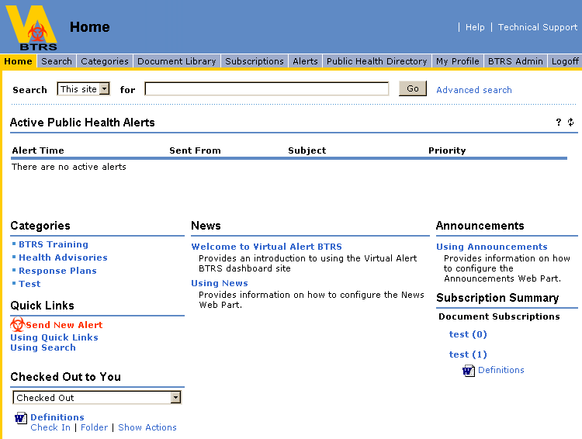

Figure 1: View of BTRS Portal Home

From the Home dashboard users can access all of the other pages on the site, content contained within the site, and view important information posted there.

Home contains the following items:

- A set of site navigation buttons that link to other dashboards: Home, Search, Categories, Document Library, Subscriptions, Alerts, Public Health Directory, My Profile, BTRS Admin and Logoff.
- A Search area containing a search bar with a drop-down menu from which users can select search scopes and a text box in which users can type search terms.

Home also contains additional areas for information and data to be posted and linked for users to review, and tools to assist in browsing the content of the site:

News and Announcements
Displays general items of interest for all users to access.

To Open News and Announcement Items

1. Click the title of the item that you want to read. The page or item associated with the link opens.
2. To return to Home click the Back button of your browser.

Quick Links
Displays links to other information, resources, and Web sites that may be of interest to all users.

To Open a Quick Link

1. Click the link title. The page or item associated with the link opens.
2. To return to Home click the Back button of your browser.

Categories
Displays topical groupings of information and content within the site. You can view categories by using the Categories section on the Home dashboard, or by clicking the link to the Categories dashboard on the main menu of the site.

To Open a Category

1. Click a Category name. That category opens to reveal all subcategories and/or documents assigned to that category and available to the user.
2. To return to Home, click Home or Back on your Browser toolbar.

Note: On the Home dashboard, the Category section only shows the top-level categories. Each of the categories listed may contain multiple subcategories nested within. For a complete listing of ALL categories and subcategories available, refer to the Categories dashboard. For further detailed information, see About Categories.

Subscription Summary
Provides a summary of the current user’s subscription notifications. If you find a document, folder, category, or a set of search results useful, you can subscribe to that content and the portal notifies you if changes occur. In this area, you will see the title of the item to which you subscribed. When an active notification exists, a number will appear next to the item title.

To Open a Subscription Notification

1. Click the link for the item that you want to view. This will take you directly to the item to which you subscribed.
2. To view additional listings, click the Subscriptions link on the navigation bar to go to the Subscriptions dashboard listing your current subscriptions.

Note: The Subscriptions Summary displays only the two most recent notifications for each of the items to which you have subscribed. For further detailed information, see About Subscriptions.

Active Public Health Alerts

Recipients of alerts can receive e-mails, phone calls, faxes, and text messages on their pagers, which include the alert subject and message. They may also view the alert through the portal in the Active Public Health Alerts section on the Home page, or in the Active Public Health Alerts section of the Alerts page.

To Open an Active Public Health Alert

1. Click on the Alert Time of an individual alert to view all details of that particular alert.
2. When you are finished, click Back to Previous View.

Document Status
Shows which documents each user has checked out, which documents await the user's approval, and the user's documents that are pending approval by others.

To View Documents Checked Out to You

1. From within the Document Status web part, select Checked Out from the drop-down menu.
2. If you have any documents checked out from the portal, they will appear below the drop-down menu with the options to either check the document in, or view the Show Actions page.

To View Documents Awaiting Your Approval
1. From within the Document Status web part, select Awaiting Your Approval from the drop-down menu.
2. If you have any documents awaiting your approval, they will appear below the drop-down menu with the options to approve or reject.
3. If you wish to approve or reject the document, click the Approve/Reject link. You will be taken to the Show Actions page for the document.
4. Verify that the correct document is selected, and then click Approve or Reject.
5. The BTRS System confirms that you wish to approve this document.
6. Review the title of the document under approval, and then click OK.

Note: If a document is rejected by an approver, it is returned to a checked-in state

To View Your Documents Pending Approval

1. From within the Document Status web part, select Pending Approval from the drop-down menu.
2. If you have any documents pending approval, they will appear below the drop-down menu with the option to view the Show Actions page.

Accessing Additional Dashboards from the Home Dashboard

Navigation links appear at the top of most dashboards. All users can access the following dashboards of the portal site:

Search - Conduct simple and advanced search queries.

Categories - View a list of all categories, subcategories and the content assigned to each.

Document Library - View the folders and subfolders containing the content of the portal site. Users with the proper permissions can view and manage their documents and folders from the Document Library.

Subscriptions - View all of your current subscriptions in detail, and access and manage your notifications.

Alerts – View current Active Public Health Alerts, alerts you’ve sent, and send new alerts to your Alertable PHRoles.

Public Health Directory – View your Alertable PHRoles and the profile information associated with the individuals in those PHRoles.

My Profile – View and edit your profile information for the Public Health Directory, set or change your personal Alerting Security Code, change your Alerting Profiles and reset your password via the user interface.

Logoff – Guidance on how to completely logoff of the BTRS System.

Note: Only users with BTRS Admin privileges can access the following dashboard of the portal site:

BTRS Admin – Manage portal content, settings, groups and users, as well as generate and view reports and logs.

About Search

Use the Search feature on the portal to search for documents, content and information located in folders or categories. You can easily define the range and depth of searches. With a search scope, you can narrow or expand the range of documents that the portal examines when looking for your search criteria.

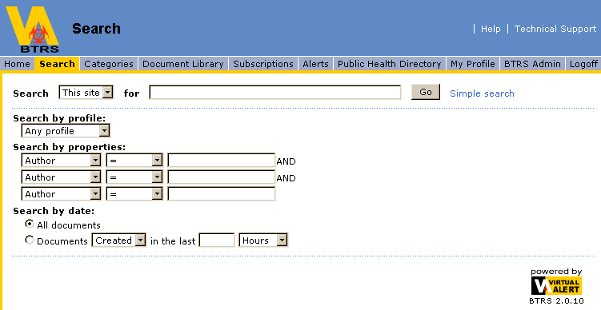

For example, if you type the search term “medical reports”, you can narrow the scope of your search to a particular area that you expect to contain pertinent information, such as focusing on a specific folder or category. This reduces the number of documents that the portal examines and returns in a more specific list of search results.

In the Search drop-down list, the following scopes can help narrow your search:

This site (always default) Searches all public documents on the portal.
This category Searches the current category and any associated subcategories.
This folder Searches the current folder and any associated subfolders.
These results Searches in a set of search results.

Searching Folders

Searching for documents by using words or phrases can be a simple and powerful search method. The portal conducts a full-text search of all the content in your chosen folder by using your search terms to identify documents that match your search criteria. Search also identifies documents by using additional descriptive information, called metadata, included with document profiles. The portal then sorts the results and returns a list of matching documents arranged in order of relevance, organized in a list. You can sort and browse through them by using the navigation arrows in the bar at the bottom of the search results page.

At the top of the search results page, the portal displays a search results summary, outlining the nature of your search. For example, if you typed in the search term “medical reports” and focused the scope of your search to a folder called Epidemiology, your search summary would say, Searched: Epidemiology folder for: medical reports.

When performing a search, remember that detailed search terms often return the best results. In general, the more words that you use as search terms, the more accurate your search results.

To Search Folders

- On the navigation bar of the dashboard site, click Document Library. This displays all the folders for which you are associated with an appropriate permission. Select the scope of your search by deciding whether you want to search all folders or only a specific folder.
- If you want to search a single folder, click that folder, and then in the Search drop-down list, select This folder. If you do not select a search scope, all available folders are included in the search.
- In the Search field, type a word or phrase to direct your search, then click Go.

Your search results may appear on more than one page. If this is the case, you can use the Next and Previous links to browse through your results.

Understanding Search Results

Based on the search criteria that you enter, a full-text search of all documents available is conducted, including associated metadata, and all documents that match the criteria are reviewed.

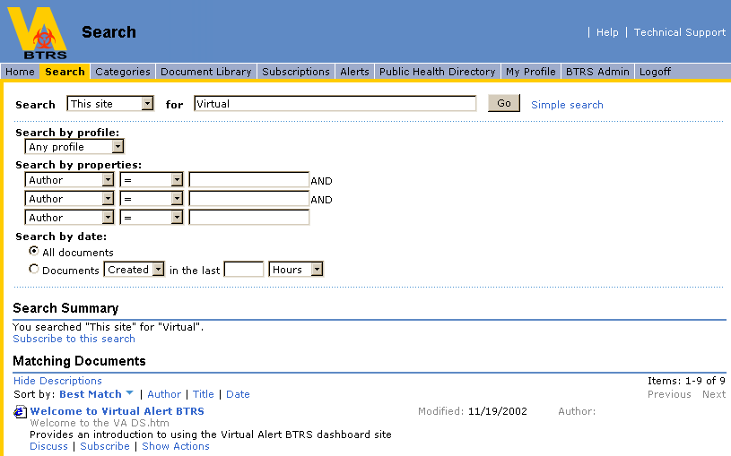

The portal organizes search results into Matching Documents, documents that match your search criteria. Search results appear in a list that you can sort by Author, Title, Date, or Best Match. To view additional results, click the Next or Previous links at the bottom of the page to browse through your results.

Tip: If the search results are too broad and you want to make them more specific, you can conduct another search in the current results. In the Search drop-down list, select These Results, type a keyword, click Go.

Sorting Search Results

The portal enables you to sort your search results in a number of different ways. Sorting is useful if you are looking for a certain document for which you have limited information. For example, if you know the Author or title of the document, you can sort a list of search results by either of those attributes:

Best Match - Sorts documents by how well each document matches your search criteria.

Author - Sorts documents alphabetically by Author name.

Title - Sorts documents alphabetically by document name.

Date - Sorts documents by the date they were last modified.

Advanced Searching

Advanced Search features allow you to specify additional properties to include in a search, in addition to the standard full-text search. A standard search simply searches for all documents that match any of the words that you type in the Search field.

An advanced search enables you to specify property matches in your search. By using the Advanced Search options, you can choose to include some or all of the following properties on a search, in addition to the full-text query that you can enter in the Search box:

Document Profile - Retrieve all documents classified by using a specific document profile.

Document Properties - Retrieve all documents classified by using specific document properties such as Author, subject, file size, etc.

Note: If you use Advanced Search to look for documents by file size, you must enter the number for the file size in terms of bytes, rather than kilobytes (KB). One kilobyte equals 1,000 bytes. For example, if the list of documents in a folder includes file size in terms of KB, and you want to search for all documents larger than 10 KB, make sure to enter 10,000, rather than 10, in the advanced search field.

Date - Retrieve all documents that match your search criteria and sort them by date. You can also retrieve all documents last added or modified in a certain period of time.

Note: You can search for dates in only the Gregorian calendar, formatted mm/dd/yyyy or mm-dd-yyyy, on the site. You cannot search for non-Gregorian calendar dates.

For example, you type “medical reports” in the Search field, and, in the Additional Options section of the Search function, you specify a particular document profile to include in the search. The search results include any documents that contain the word medical or the word report and that are classified by using the document profile that you specified.

To Conduct an Advanced Search

- In the Search field, type a word or phrase to direct your search.
- To the right of the Search field, click Advanced Search.
- Under Search by, select a profile, properties, or date criteria for the search, then click Go.

About Categories

All BTRS portal content should be assigned to categories according to topic. This allows users to browse for documents on the site without being familiar with the structure of the folder directory where the documents reside (see About the Document Library).

All categories and subcategories are arranged according to structure, and clicking on a category title on the Categories dashboard will reveal its description and the list of documents assigned to it. Clicking on their titles easily opens the documents. Users navigate back through the categories by using the Up One Category link.

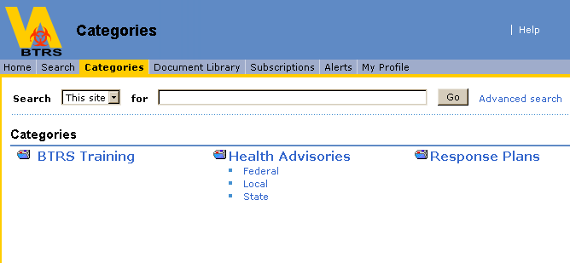

If you subscribe to a category, you can specify that you want to be notified when a document is assigned to that category. Use the Subscribe to this Category link to submit a subscription.

About the Document Library

The Document Library is a dashboard that links to the folder directory used to store documents. The structure of this directory will relate to the organization of the documents and content, as well as the security permissions of the users. You can use the Document Library to manage documents and folders on the site. You can also search and browse through the document folders stored in the portal.

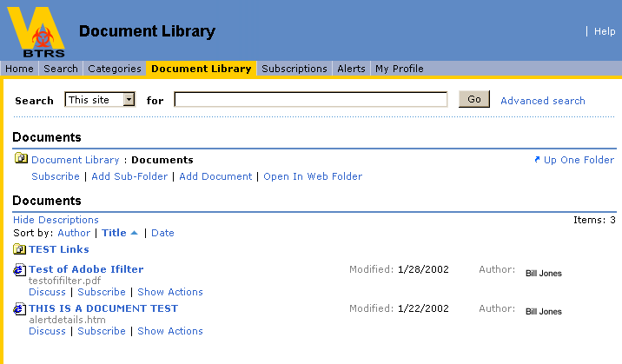

The folders and documents you will see in the Document Library depend upon your permissions. If you are a:

Reader in a folder: You only see published documents.

Author in a folder: You see all documents, published and checked in, and you can add new documents to the folder, create or delete your own folders, edit any documents, delete any documents, and publish any documents in your folder(s).

Approver on a folder: You have the ability to approve or reject a document that has been submitted for publishing to that folder.

BTRS Admin: You see all folders and documents. You can also add documents to the folder, delete any documents, create or delete folders, and manage documents.

To view the list of documents stored in a particular folder, click the folder name. To view a document, click the name link for the document to open in read-only mode.

Note: For each folder you view, your permissions on that folder will appear at the top of the page.

About Subscriptions

Using the Subscriptions dashboard, users can review their subscription information in detail and manage their subscriptions and notifications.

You can subscribe to documents, folders, search results, and categories. When you subscribe to something, you specify that you want to be notified of specific changes to that item. For example, if you subscribe to a document, you specify that you want to be notified when the document is modified or deleted. If you subscribe to a category or folder, you specify that you want to be notified when a document is added.

The Subscription Summary on the Home dashboard provides a summary of your most recent subscription notifications. You can see the current subscription notifications along with links to the documents, folders or categories. If you want to delete a notification, you must go to the Subscriptions dashboard of the portal.

To Subscribe to a Folder or Document

- On the navigation bar of the site, click Document Library.
- In the Document Library, locate the folder or document to which you want to subscribe. Under the title of the folder or document, click the Subscribe link that appears below the description for the folder or document.
- If you want notifications sent to you via e-mail, in E-mail Notification enter your full e-mail address (for example, someone@virtualalert.com).
- To specify a notification frequency, select an option from the How Often menu.
- Click OK.

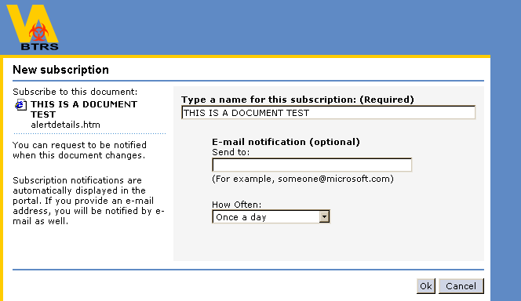

The portal notifies you whenever the content changes according to the frequency you select. You can view your subscription notifications under Subscriptions Summary on the Home dashboard or the Subscriptions dashboard on the portal.
The Subscriptions dashboard displays all your subscriptions and all the notifications for each subscription. It is here that subscriptions are managed, cleared or deleted as necessary by the user. After you have created a subscription, you cannot edit it. You must delete and re-create a subscription to change it (e.g. e-mail address, frequency).

About Alerts
This dashboard gives users the ability to send new alerts, view their sent alerts, and view their Active Public Health Alerts.
Send New Alert - Provides a comprehensive system for sending alerts to recipients via the portal, e-mail, pager, phone (via text-to-speech conversion) and fax. The role-based Public Health Directory is designed to show only those Public Health Roles (PHRoles) to which the user has the ability to send alerts (also referred to as their Alertable PHRoles), controlling the flow of critical information through the proper channels. For alerting, users simply choose PHRoles from the directory tree.

View My Sent Alerts - Users can easily view the alerts they have initiated to other PHRoles (including who has confirmed receipt of the alert) and BTRS Admins can view the details of all alerts sent to all PHRoles.
Active Public Health Alerts - Recipients can view their active alerts via the portal, including all alert details such as priority, sender, subject and message.

About Public Health Directory

The Public Health Directory is the core of the BTRS system, and users can use the Public Health Directory to view the members and contact information of the PHRoles that they have permissions to send alerts to.

About My Profile

The My Profile dashboard is where users are able to self-maintain all of their pertinent profile information.

Change My Profile – where users keep all of their contact information current.

Change My Alerting Profiles – where users create, edit, activate or delete alerting profiles based on their location & alerting preferences.

Change My Password – where users are able to change their personal passwords for access to the portal. This is very important in a secure portal environment.

Change My Alerting Security Code – users who receive alerts via telephone must have an Alerting Security Code that has to be keyed into the phone in order for the alert to be read. Users can set and change their own Alerting Security Code on the My Profile dashboard.
Note: Alerting Security Codes must be exactly 4 numeric characters

About BTRS Admin

The BTRS Admin dashboard is where users with the proper permissions are able to manage several aspects of the system, including portal content, settings, groups and users. Additionally, BTRS Admins are able to generate and view reports and logs. BTRS Admins have the ability to do the following tasks:

- Manage Discussions, including the ability to delete discussions.
- Manage Categories, including creating, deleting and editing categories and subcategories.
- Manage Subscriptions, including the ability to delete subscriptions or assign subscriptions to specified PHRoles.
- Manage BTRS Folders, in which the user can assign and remove folder permissions, document profiles and approval routing to each folder within the Document Library.
- Manage Users, which is the ability to create new users, create new Organizational Units (OU), rename OUs, move OUs, move users to different OUs, assign OU managers, edit user properties, edit user alert profiles, deactivate users, reset user passwords, reset user Alerting Security Codes, assign users to PHRole(s) and assign users portal permissions.
- Manage PHRoles, which is the ability create new PHRoles, create new Organizational Units (OU), rename OUs, Move OUs, move several PHRoles to different OUs, assign OU Managers, assign Alertable PHRoles, assign users to PHRoles, rename PHRoles, move individual PHRoles to different OUs view members of PHRoles and view corresponding Alertable PHRoles.
- Manage Portal Permission Groups, which is the ability to create custom Portal Permission Groups, delete Portal Permission Groups, add members to Portal Permission Groups, as well as view the members of any Portal Permission Group.
- Generate a report of profile information for all of the users that the BTRS Admin manages.
- Generate Alert History Logs using a search criteria.
- Generate Alert Fax Logs using a search criteria.
- Generate Alert Confirmation Reports, showing which users have confirmed alerts and which users have not confirmed alerts.
- Generate Folder Permission Reports, showing which users, PHRoles or Portal Permission Groups are assigned to any specified folder as a Reader, Author, Admin or Approver.
- Generate a report of all documents that are checked out on the portal, including the document title, the folder where it resides, who checked out the document and the date it was checked out.
- Generate a Documents Awaiting Approval Log, showing all documents that are awaiting approval, the folder the document resides and who needs to approve the document in order for it to publish (i.e. if any approvers have already approved the document, the list will only consist of who is left). The Admin has the option to override the approval process, or cancel the publishing.
- Generate a Document History Report, showing the version history of documents within a selected folder in the Document Library, and its subfolders.
- Generate a Document Totals Log, giving document counts within the portal that can be sorted according to: folder, category, or the user who last modified a document.
- Generate a Modified Content Report, showing which documents in a selected folder have been modified, according to a specified search criteria.

About Logoff

How to Logoff

1. Click the Logoff button on the navigation bar.
2. The logoff dashboard will instruct you to close all open browser windows.

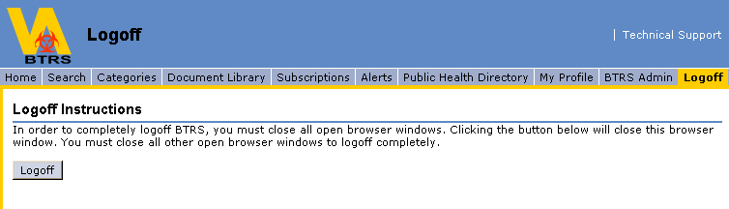

3. Clicking the Logoff button again on the Logoff dashboard will pull up a confirmation box asking if you are sure you want close your current browser window. Click Yes.

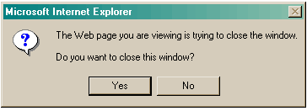

4. Be sure you have closed all other browser windows to be completely logged out of the BTRS system.

Document Management and Publishing

Users may find large and complex information sources, such as multiple file shares, difficult to organize and use because there is little or no organizational framework in place. The difficulty increases with the addition of information sources such as Web sites, e-mail servers, and databases. Users might also have difficulty collaborating with others on documents, controlling access to those documents, and publishing documents. Important information may also be lost, overwritten, or hard to find.

The BTRS System offers a number of features to help streamline your document development and avoid these common problems.

To help you manage documents, the site offers:

- Control of document access based on user permissions
- Application of descriptive, searchable information to identify a document
- Document publishing control
- Web discussions for online comments by multiple document reviewers
- Version tracking to record the history of documents

The portal helps you collaborate with others, receive feedback from reviewers, identify the document with descriptive information such as keywords, and publish for narrow or wide-range access.

Document Profiles

Document profiles offer a way to add searchable information pertaining to a document. This information can help describe or identify the document more clearly. A profile includes basic properties such as Author, Title, Categories, Description and Keywords to capture additional information that makes it easier to organize and find documents.

Document Publishing

Published documents are available for users to search or view on the site. The Document Library supports private and public versions of a document. You can publish a document automatically each time you save it or you can choose to maintain private document drafts and publish the document when it is finalized. You can generate as many drafts as you want before publishing a version of a document.

Discussions

Using Web discussions, you can post online comments about a document without modifying it. Instead of using e-mail to discuss a document or try to capture feedback about a document, Authors and reviewers can now communicate with each other through Web discussions on the portal. Simultaneous discussions about a document can occur even if one person has the document checked out. Comments are stored as threaded conversations, grouping comments and replies together for easy review.

Version History

The portal records a document’s history to help you track changes and eliminate the possibility of people overwriting another user’s modifications. To edit a document, you must check it out first. This prevents others from changing it until you check it in. Every time you check-in a document, a new version number is assigned to the document and the previous version is archived. When you check-out a document, you retrieve the most recent version unless you select an earlier version.

Managing Folders and Documents

About Folders

The portal supports two types of folders for storing documents: enhanced folders and standard folders.

Enhanced folders support document management features such as document profiles, check-in, check-out, publishing, and document version history.

Standard folders support document profiles, but do not support check-in, check-out, publishing, or document version history.

You can browse and search in both types of folders. However, users must at least have Reader access on a folder to view that folder and its documents. Depending on permissions, users see different folders in the Document Library.

If you create a subfolder, that folder automatically inherits the properties of the parent folder. Therefore, if you create a subfolder under an enhanced folder, the new folder is also an enhanced folder.

Important: When you create a subfolder, it inherits the permission settings from its parent folder by default. Only a BTRS Admin can change the permission settings on a folder.

Creating Folders

You can only create a new folder as a subfolder within the Documents folder or the Portal Content folder. The new folder inherits the properties, settings, and security information from its parent folder.

You can only change the properties of the new folder if you are a BTRS Admin. If you are an Author, you can create and delete folders, but you cannot modify the properties, settings, or user permissions.

To Create a New Folder

- On the navigation bar for the dashboard site, click Document Library.
- Under the Document Library heading, view the folders and documents available from this site.
- The folders and documents that appear depend on your permissions. You see only the folders and documents to which you are assigned an appropriate permission.
- Click the folder under which you want to add a new subfolder.
- Click Add Subfolder.
- Type a unique name for the folder, and click Create.

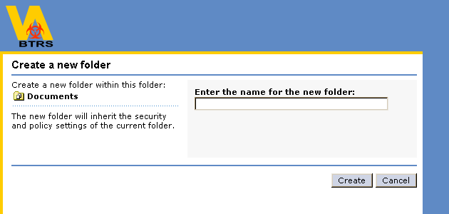

Adding a Document to a Folder

If you are an Author in a folder, you can add a document to that folder while you are in the site. To do this, use the Add Document command for the folder to which you want to add a document. If you are adding a document to an enhanced folder, you must check the document in or publish it after adding to the folder.

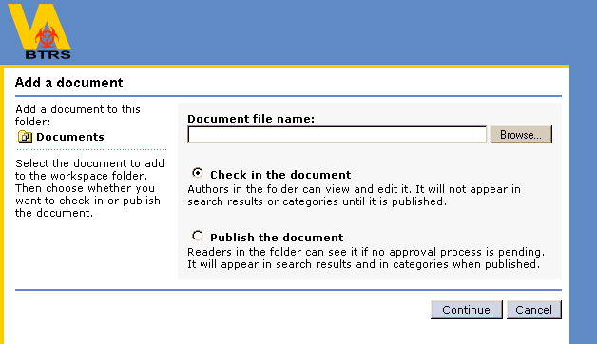

Tip: If you want to allow Readers to search for and view the document, you must publish the document.

If you are adding a document to a standard folder, you do not need to check-in or publish the document. The portal automatically publishes documents in a standard folder to the site when you add them to the folder. This means that after you add documents to a standard folder, they are immediately available for searching and viewing on the site.

To Add a Document

- On the navigation bar of the dashboard site, click Document Library.
- Under the Document Library heading, view the folders and documents available from this site. The folders and documents that appear depend on your permissions.
- Click the folder or subfolder to which you want to add a document.
- Click Add Document.
- Under the Document File Name heading, click Browse to locate the document on your computer. Once you select the document, choose Open. If you are adding the document to an enhanced folder, you have the following two options:
1. If you want to add the document to the folder but do not want to publish it, select Check-in the document. If you check-in the document, Authors in the folder can view and edit it. The document will not appear in search results or categories until it is published.
2. If you want to publish the document after adding it, select Publish the document. If you publish the document, Readers can see it immediately.
- Click Continue. The profile form appears. Enter the required information on the document profile and fill in the version comments if applicable.
- Click Save.

To close the Document Inspection dashboard, click Return to previous view.

The portal adds the new document to the folder you have selected. If the target folder is a standard folder, the document is available immediately for users to search for and view on the site.

Discussing Documents

Use Web discussions to collaborate on a document with other users on the portal. Web discussions are stored separately from the document to which they refer. The portal maintains only one set of discussions for each document. For documents stored in enhanced folders, only one set of discussions exists, even though there may be several versions of that document.

Note: When you open a discussion thread, the document and discussion box will open together in a new window. However, only the first uploaded version (draft or published) of the document will open with the discussion. From then on, only published versions will open with the discussion box.

Checked in (or draft) versions after the first checked in version (X.x, where X = a published version # other than the number 0; and x = a draft version # other than the number 0) of a document will not open with the discussion box.

If the document will be checked in and out several times, creating several versions for feedback/revision purposes, it is recommended that authors open and review the latest version of the document (by clicking on the document title link) and then open the discussion thread to make comments, as only the first version will open with the discussion box until the document has been published.

If you do not want revision feedback by authors to be available to the general reader public, be sure to request that the discussion thread be deleted by a BTRS Admin before the document is published.

To Discuss a Document

- On the site, locate the document you want to discuss.
- Click the Discuss link under the title of the document.
- The document you select opens in a new browser window with a discussion box for your comments. You can type your contribution to the discussion and post it for others to review.
- To delete or edit your discussion, use the Delete or Edit icons located next to your comment.
- To reply to another user’s specific comment, click on the Reply icon located next to their discussion. This will post your comment in a discussion thread as a response to theirs.
- To exit discussions, close the browser window.

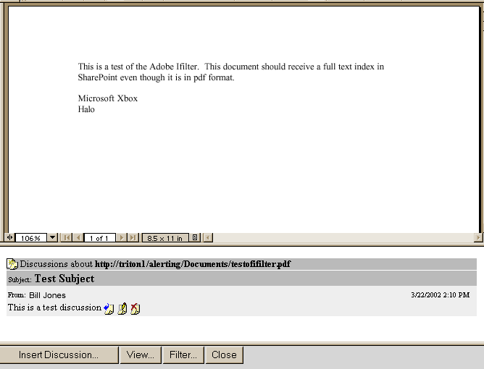

Show Actions

Clicking on the link entitled, Show Actions, located underneath any document title, accesses the Document Inspection dashboard. On the left side of the Document Inspection dashboard, all the actions available for the document are displayed as links. To perform an action, click the appropriate link.

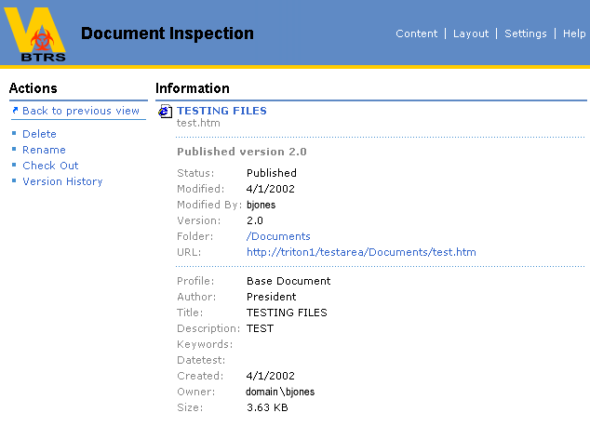

Also displayed on the Document Inspection dashboard are the document properties. These can include:

Document title - Clicking on either of these links opens the document in read-only form.
Status - Indicates whether the document is checked in, checked out, or published.
Modified - Indicates the date the document was last modified.
Version - Indicates the version number.
Folder - Provides a link to the folder in which the document resides.
Profile - Indicates the name of the profile applied to the document. Below this heading, there may be other headings indicating specifics taken from the document profile.

There are also two additional properties available for viewing on the Document Inspection dashboard. They are the Modified By property and the Owner property. The ability to view these properties will be based on the user’s permissions on the portal. All users will be able to see the Owner property. The Owner is the person who initially adds a document to the portal. The Modified By property will only be viewable to Authors and BTRS Admins if they have access to that particular document. The Modified By property will display the user name of the person who last modified the document. However if there is no version history, which is the case until the document has been checked out and checked back in at least once, the Modified By property will remain blank until such action takes place.

Checking In Documents

To let users view the changes that you have made to a document, you must check-in the document. Consider the following points when checking in a document:

- When you add a document to an enhanced folder, you must check-in the document. Until you check-in a document, users cannot check-out the document and/or edit it. For more information about checking out a document, see Checking Out Documents.
- You can only check-in a document that is new or that you have checked out. You cannot check-in a document that another user has checked out.
- No one can view the changes that you make to a document until you check-in the new draft of the document. Even after you have checked in the document, Readers cannot see your changes until you publish the latest version of the document.

To Check-in a Document

- On the Document Inspection dashboard, verify the correct document is selected and click Check-in.
- Specify how to locate the document: If you did not save a working copy of the document to your computer, uncheck the Copy the document from my computer to the workspace check box. If you saved a working copy of the document to your computer, make sure that the Copy the document from my computer to the workspace check box is selected. Under the Document File Name heading, click Browse to locate the document on your computer, and then click Open.
- Click Continue.
- Make any necessary changes to the document profile and fill in version comments, being sure to explain how you changed the document while you had it checked out in the Version Comments box.
- Click Save.

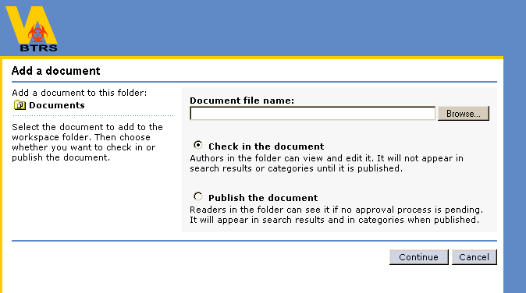

You have now checked the document in to the portal. Authors in the folder can see and edit the document. The changes to the document are not visible to users who search for the document on the site until you choose to publish the newest version of the document.

Checking Out Documents

To edit a document, you must first check-out that document. While you have a document checked out, the previous version remains visible, but cannot be checked out or edited by other users. A working copy is created for you and allows you to download it to your computer.

Consider the following points when checking out a document:

- You must have appropriate folder permissions to check-out and edit a document.
- No one can view your changes until you check-in the new draft of the document. Even after you have checked in the document, users with Reader only permissions cannot see your changes on the site until you publish the latest version of the document.

To Check-out a Document

- On the Document Inspection dashboard, verify that the correct document is selected, and then click Check-out. The Check-out Wizard opens. The document is now checked out in your name. To work with the document, you must download a working copy to your computer.
- Right-click the document link, and then select the command that allows you to save the document to your computer.

Note: The wording of the Save command may vary depending on your browser. Save, Save As, and Save Target As are common variations.

- In the Save dialog box, complete the necessary actions to download the document to your computer.
- After the document has been downloaded, click OK at the bottom of the Check-out Wizard.

Note: If you are a BTRS Admin, you have the ability to Undo the Checkout of any documents on the portal from the Show Actions page of that document.

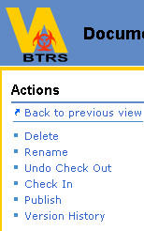
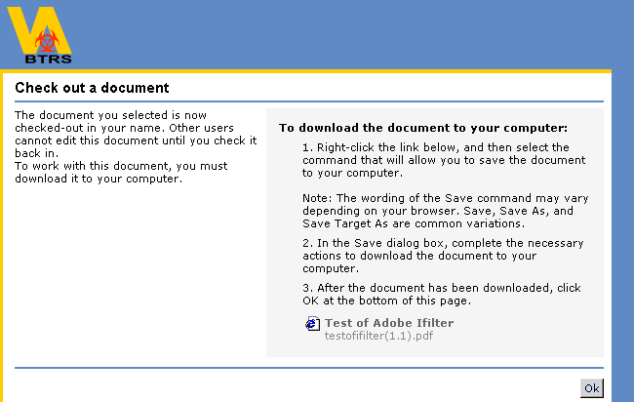

Tip: If you later decide to check-in the document without saving your changes, you can use the Undo Check-Out command on the Document Inspection dashboard. You lose any changes made while you checked out the document. The document reverts to the last checked in version, and no version history is kept for the unsaved changes.

Publishing Documents

You can publish documents stored in enhanced folders by using the Publish command on the Document Inspection dashboard. When you publish a document, you make the current version of that document visible to users associated with the Reader permissions in the folder where the document resides.

Documents stored in standard folders do not use the Publish command, because they are automatically available for public view when they are added to the folder. In a standard folder, all the changes to a document are automatically visible to Readers when you save the modified document to the site. Consider the following points when publishing a document:

- You must have appropriate folder permissions to publish a document.
- If a document is not published, the current version does not appear in search results or in categories.

You can manage unpublished documents on the site through the Document Library, but unpublished documents are only visible to users who have appropriate permissions, such as Authors.

The portal publishes the document immediately when you use the Publish command, and makes the document available to Readers on the site.

To Publish a Document

- On the Document Inspection dashboard, verify that the correct document is selected and checked in, and then click Publish.
- Click OK.

Once published, the document is now available for search and viewing on the site.

Editing Document Profiles

Sometimes the only revisions needed are to the profile information (metadata) of the document.

To Edit a Document Profile in an Enhanced Folder

- On the Document Inspection dashboard, verify that the correct document is selected and checked out, and then click Check-in.
- If you did not save a working copy of the document to your computer, go to the next step in this procedure.
If you saved a working copy of the document to your computer: Select the Copy the document from my computer to the workspace check box.
- Under the Document File Name heading, enter the location of the document you want to check-in. Click Browse to locate the document. When you have located the document, click Open.
- Click Continue.
- Make any necessary changes to the document profile and then click Save.

To Edit a Document Profile in a Standard Folder

- On the Document Inspection dashboard, verify that the correct document is selected, and then click Edit Profile.
- Make any necessary changes to the document profile, and click Save.

Viewing a Document’s Version History

The portal keeps a version history for each document in an enhanced folder as Authors check the document in and out, and publish it. At any point, users with Author or admin permissions can inspect a previous version of a document by using the Version History feature on the site. Viewing the version history for a document is useful for tracking changes or viewing the progress of a project. Although users that only have BTRS Reader permissions can see the Version History link for a document, they are unable to actually view anything but the most recent, published version of any given document.

To View a Version History

- On the Document Inspection dashboard, verify that the correct document is selected, and then click Version History.
- From the version history list, click the appropriate link to view a document version.
- The document version that you select opens in read-only mode. You cannot edit it.
- To exit the version history dashboard, click OK.

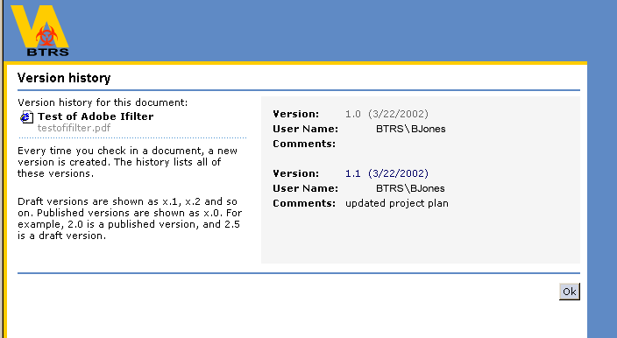

Editing Documents in Standard Folders

If you are working with a document from a standard folder, you cannot check-out the document to edit it, but you can download a copy of it to your computer to edit it there. When you are finished with the document, you must upload it from your computer to the site, overwriting the existing copy.

If the document has multiple Authors, consider transferring it to an enhanced folder so that you can use the check-in and check-out functions to control the editing process. Using check-in and check-out is also useful if you want to make edits to a document without the revised document becoming immediately available to all Readers on the site.

Renaming Documents

If you want to change the name of a document, you can use the Rename command.

Note: If you rename a document, users with subscriptions for the old document name no longer receive notifications regarding that document, nor receive a notification regarding the name change. Users who subscribe to the document under its new name receive subscriptions normally.

Consider the following points when renaming documents:

- If the document is in an enhanced folder, you must check-in the document before it can be renamed.
- If a renamed document remains in the same enhanced folder and you do not move it to a different folder, it retains its version history. If you move the document to another folder and then rename it, it loses the version history. The portal considers the renamed document to be a new document.

To Rename a Document

- On the Document Inspection dashboard, verify that the correct document is selected, and then click Rename.
- Type a new name for the document, and then click Save.

Deleting Documents
If you no longer want the portal to display a document or folder, you can remove it by using the Delete command. Deleting a document from a folder permanently removes it. Only Authors in a folder or BTRS Admins can delete a document.

To Delete a Document

- On the Document Inspection dashboard, verify that the document information is correct, and then click Delete.
- Click OK.

Distributing Documents Via Fax
Specific document types can be distributed directly from the portal to PHRoles that a user has the permissions to notify. The document types that can be distributed are:

- Microsoft Word (DOC)
- Microsoft PowerPoint (PPT)
- Text files (TXT)
- Files in Rich Text Format (RTF)
- Portable Document Format (PDF)

To Distribute a Document Via Fax

Note: Only systems with a telephone server can distribute documents via fax.

1. On the dashboard site, locate the document you want to distribute.
2. Click the Fax link under the title of the document.
Note: If the document cannot be distributed via fax, the Fax link will not appear below the title of the document.
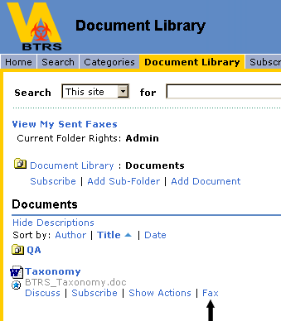
3. On the Fax Documents dashboard, select the PHRoles you would like to fax the document to within the Public Health Directory. Click on the PHRole name to add them to the Distribution Recipients box.

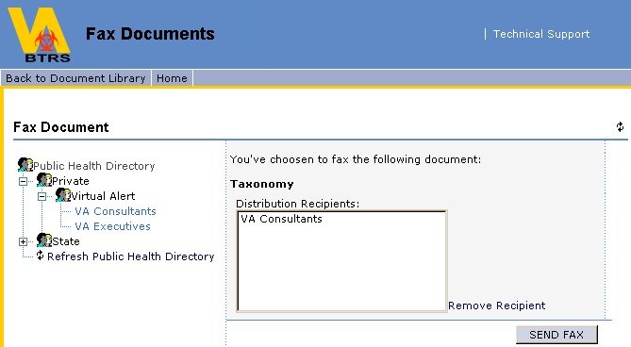
4. Once all PHRoles have been selected to receive the fax, click the Send Fax button. You will be asked to confirm your choice to send the fax. Click OK.
5. You will receive a confirmation that the fax has been sent. Click OK.
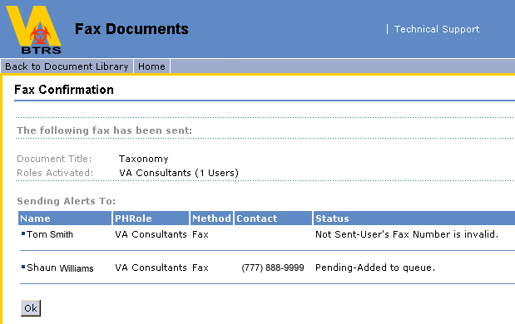

Viewing Your Sent Faxes

Users are able to locate and view the faxes they have sent based on a given search criteria.

To View My Sent Faxes

1. On the navigation bar of the dashboard site, click Document Library.
2. On the Document Library dashboard click View My Sent Faxes.
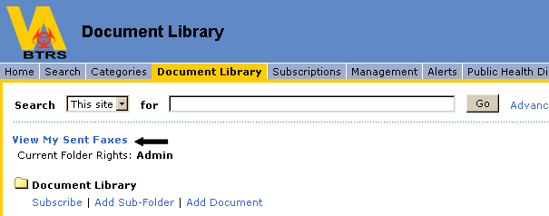
3. Within the My Sent Faxes web part, enter your search criteria.
- PHRole Sent To (You can enter a specific PHRole, or leave the field blank to include all PHRoles in the PHD).
- Sent On or After Date (You can use the automatic date selector, or put the date in manually in the mm/dd/yyyy format).
- Sent Before Date (You can use the automatic date selector, or put the date in manually in the mm/dd/yyyy format).
- Sort by (You can sort results by Date or Subject)
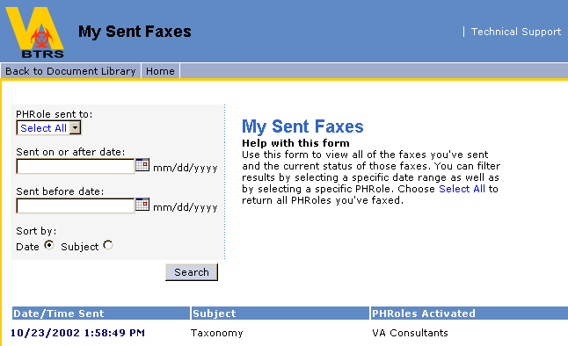

4. Click Search. Results will appear below the Search button.

The log provided will include:

- Date/Time fax was sent
- Subject
- PHRoles Notified

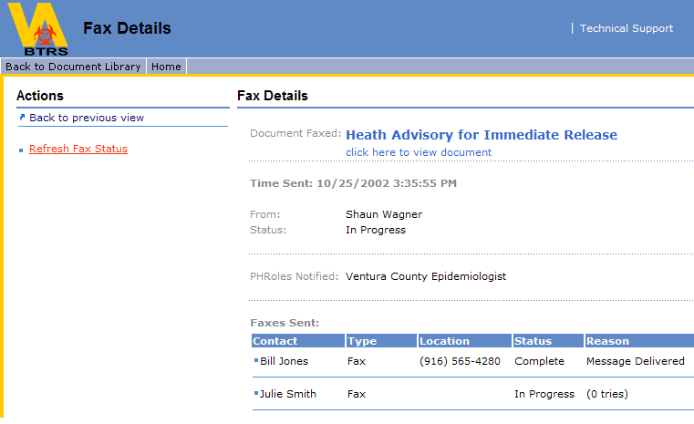

Alerting

About the Alerting System

If you need to send notifications to public health professionals about important occurrences and required activity, BTRS provides alerting functions directly from the portal. This gives users the ability to send alerts to officials via a role-based Public Health Directory. These roles are referred to as PHRoles (Public Health Roles).

The Public Health Directory used for sending alerts is a multi-level hierarchy of health and public safety related PHRoles associated with your BTRS. The PHRoles to which a user can send an alert are restricted by the user's permissions.

When you send an alert, a message is generated and can be sent to the selected recipients’ e-mail address, text pager, telephone, or fax. The recipient is also notified of the alert through the portal and can view the alert from the Home or the Alerts dashboards via the Active Public Health Alerts web part.

Note: Only systems with a telephone server can send alerts via telephone & fax.

Sending Alerts

A user may send alerts only if they have the proper permissions to do so and only to PHRoles for which they have alerting access. The user will see a directory tree composed of only those PHRoles for which they have permissions to alert (referred to as their Alertable PHRoles). All sent alerts appear on the recipient's portal for a designated time indicated by the alert sender, after which the alert will expire and be stored offline in a database.

To Send an Alert

1. On the navigation bar of the dashboard site, click Alerts.
2. In the Alerts Menu section, click Send New Alert.

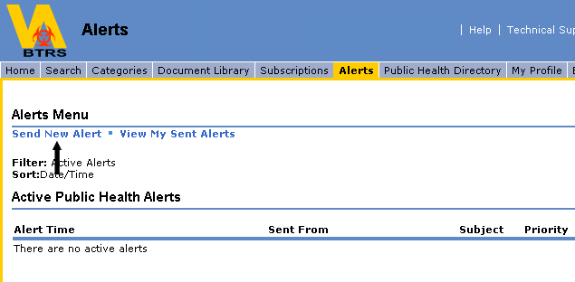

3. In the Alert Notification section, click the plus sign next to the desired organization to view the PHRoles available for alerting, according to your permissions.
4. Click on a PHRole title to select and add that PHRole to the Alert Recipient list.
5. Select a priority level from the Priority drop-down menu. The priority level will be based on the level of urgency of the alert being sent.
6. Select an alert type for the alert you are sending from the Alert Type drop-down menu. The alert type options are Use Alert Profiles, which will alert everyone in your alert recipient list by way of the alerting profiles that they have each set up, or Fax Only Alert, which will send the alert via fax only to everyone in your alert recipient list.
7. Select a duration from the Duration drop-down menu. The duration will be based on how long the alert being sent will need to remain active. The duration will also be how long the alert will be viewable on the portal within the Active Public Health Alerts section. There are three default durations to choose from: 1 hour, 1 day or 1 week. There is also an option to select a custom duration. To do so, click on custom and select the number of days and hours from the drop-down menus.
8. In the Subject field, enter the subject of the alert. This will appear as the subject of each e-mail message and as the title of the alert displayed on the portal.
9. In the Message field, enter a message for the alert. This will appear as the body text of the e-mail message and as the detail of the alert displayed on the portal.
Note: The message of the alert has a 2000 character maximum limit
10. Click SEND ALERT.
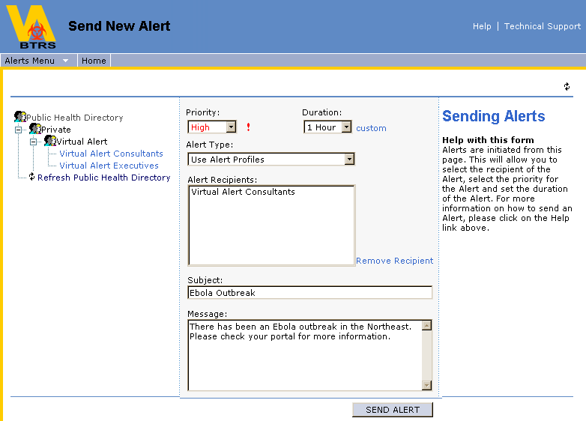

11. A screen appears to confirm the sending of the alert notification. Click OK to send, or Cancel to cancel the alert.

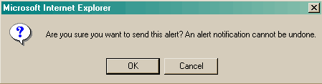

The user will be shown an Alert Confirmation screen containing detailed information about the alert just sent, including subject, message, priority, duration, PHRoles activated and the user the alert was sent to with their methods of contact. Clicking OK will return the user to the Send New Alert Directory page. If no further alerts need to be sent, click Home.

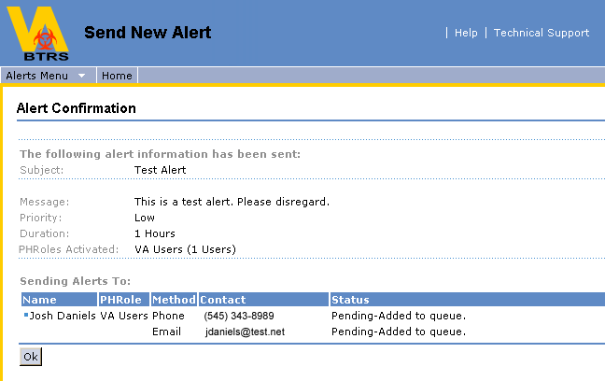

Viewing Alerts

Recipients of alerts can receive phone calls, faxes, e-mails and text messages on their pagers, which include the alert subject and message. They may also view the alert through the portal in the Active Public Health Alerts section on the Home dashboard, or in the Active Public Health Alerts section of the Alerts dashboard.

Using Active Public Health Alerts

Clicking on the Alert Time of an individual alert will take you to the Alert Details dashboard and give you all details of that particular alert.
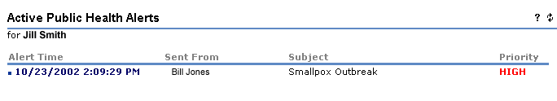

To View an Alert From the Home or Alerts dashboards

1. On the Home dashboard and on the Alerts dashboard, in the Active Public Health Alerts section, you will be able to see a listing of all of your active alerts. Each alert line will contain the date the alert was sent, the time the alert was sent, the person who sent the alert, the subject of the alert and the priority of the alert.
2. To view the details of a specific alert click on the Alert Time of that particular alert.
3. You will be taken to a new screen with the details of the alert you selected. The details of the alert will include:

- The subject of the alert
- The priority of the alert
- The time the alert was sent
- Who the alert is from
- The message of the alert
- When the alert expires
- The PHRoles notified by the alert
- The alerts sent
  - Contact Name
  - Contact Type
  - Location
  - Status
  - Reason for status

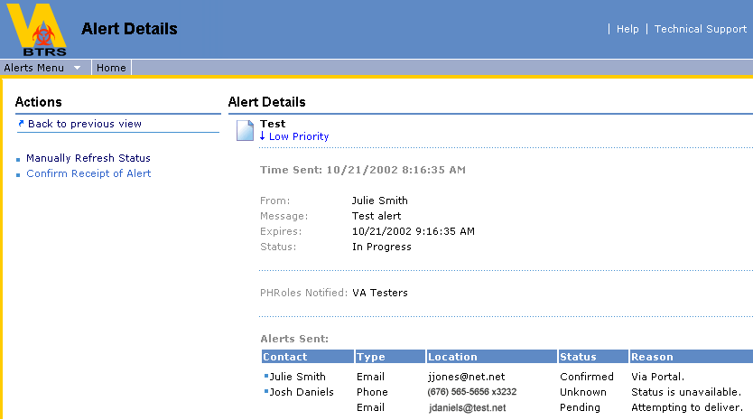

How to use View My Sent Alerts

A user has the ability to view all of the alerts they have initiated during a particular time period, including all the details of those alerts.

To View Your Sent Alerts

1. From the portal home dashboard, click on Alerts to go to the Alerts dashboard.
2. From the Alerts dashboard, click on View My Sent Alerts.

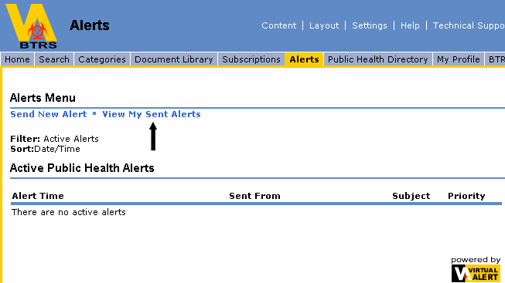

3. You will be taken to the My Sent Alerts dashboard, where you will select search criteria. Help is provided to the right of the Search Criteria.

a) PHRole Sent To (A drop-down menu to select a specific PHRole or all PHRoles in the PHD).
b) Sent After Date (You can use the automatic date selector, or put the date in manually in mm/dd/yyyy format)
c) Sent Before Date (You can use the automatic date selector, or put the date in manually in mm/dd/yyyy format)
d) Sort by (You can sort results by Date, Subject or Priority)
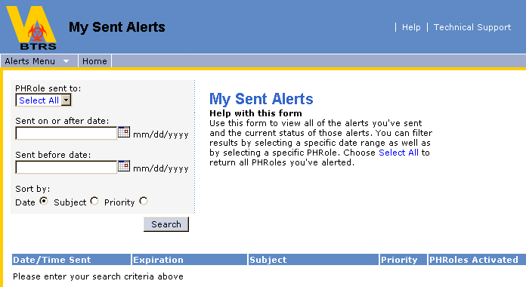

4. Click Search. All results fulfilling your search criteria will be displayed in the box below the Search button.
5. To view the complete details of a specific alert, click on the Date/Time Sent link of that alert and you will be shown the Alert Details dashboard of that alert. The details of the alert will include:
- The subject of the alert
- The priority of the alert
- The time the alert was sent
- Who the alert is from
- The message of the alert
- When the alert expires
- The PHRoles notified by the alert
- The alerts sent
  - Contact Name
  - Contact Type
  - Location
  - Status
- Reason for status

Confirming Receipt of Alerts

Users can confirm their receipt of an alert several ways.

- If the alert is received via e-mail, there will be a link in the e-mail that the user can click on to confirm receipt, and they will be prompted for their portal login.
- If the alert is received via telephone, they will be prompted to confirm receipt of the alert via the telephone using a personal Alerting Security Code number.
- Users are also able to confirm receipt of a fax, phone, e-mail or pager alert via the portal when they view the details of the alert.

To Confirm Receipt of an Alert via E-mail

1. When you receive an alert via e-mail, click the link that says, Click to confirm receipt of this message.
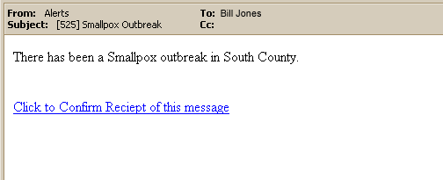

2. You will then be prompted for your BTRS system login information. Enter your User Name and Password. You will be taken to an alert receipt confirmation page.

Important! If a user replies to an e-mail alert, their reply will not be sent to the alert originator, but will instead go to a person that has been designated by the agency administering the BTRS system.

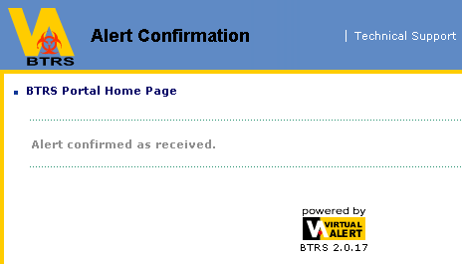

To Confirm Receipt of an Alert via Telephone
Note: Only systems with a telephone server can send alerts via telephone

1. When your alert has been read to you via the telephone, you will be asked to enter a number (Alerting Security Code) to confirm receipt of the alert.
2. Enter the Alerting Security Code.

To Confirm Receipt of an Alert via the Portal

1. When you log into the portal, click on the Alert Time of your alert.
2. If you have not yet confirmed the alert you received, you will see a link to click that says, Confirm Receipt of Alert.
3. Click the Confirm Receipt of Alert link. The link will then disappear, and your confirmation will be complete.

Public Health Directory

About the Public Health Directory

The BTRS Public Health Directory contains personal profile information about each user that is integrated into the security and alerting functions of the portal. The Public Health Directory dashboard allows users to view all of their Alertable PHRoles as well as the profile information of the users that have been assigned to those PHRoles.

Using My Public Health Directory

Users may view all of their Alertable PHRoles and the profiles of the users assigned to those PHRoles.

To View My Public Health Directory

1. On the navigation bar of the dashboard site, click Public Health Directory. You will be taken to the Public Health Directory dashboard, which will contain your Public Health Directory.

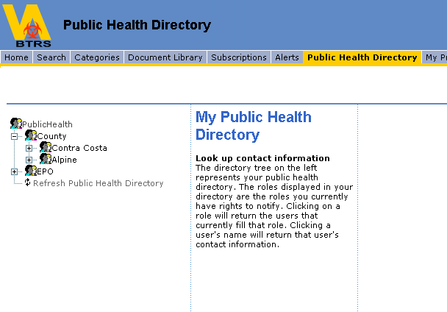

2. To view the profile of a user assigned to a PHRole, click on the PHRole within the Public Health Directory tree. The names of all users assigned to that PHRole will appear in the center column.

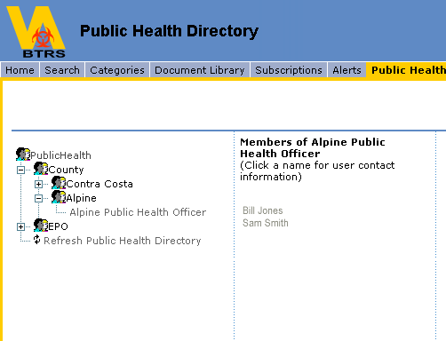

3. Click on the name of the user whose profile information you would like to view. The information will appear in the far right column.

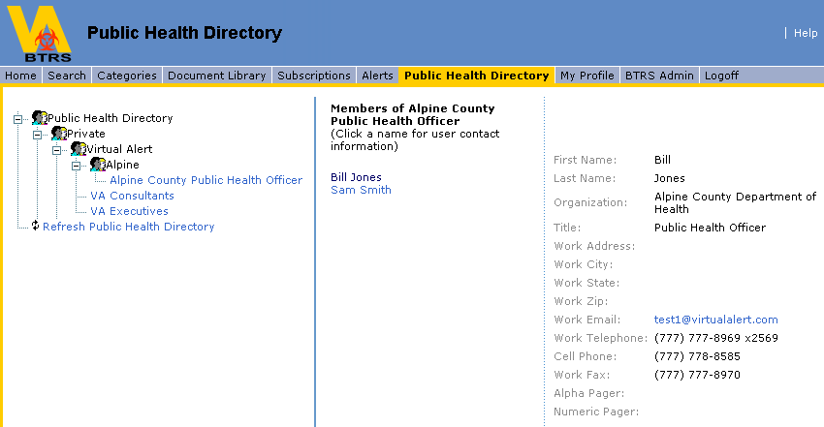

4. To view another user profile, simply click on another PHRole in the directory tree and follow the same steps.

My Profile

About My Profile

The BTRS Public Health Directory contains personal profile information about each user that is integrated into the security and alerting functions of the portal. Users’ access to their individual profiles is achieved through the My Profile dashboard. This information is editable so that users may populate or correct the various fields of information critical to the accurate function of BTRS. Additionally, users are able to change their own passwords for accessing the portal via this dashboard, change their alerting profiles so that they may determine how they are contacted for each priority of alert, as well as set/change their Alerting Security Code so that users who receive alerts via telephone can access those alerts with their personal Alerting Security Code.

Note: If you are logging into the portal for the first time, you will be guided page-by-page to confirm your profile information, set your Alerting Security Code and create at least one Alerting Profile. If you skip any of these steps, you will be taken directly back to that step when you click the My Profile link. If you have not updated your profile in 30 days, you will be taken directly to the My Profile page upon login. Please review and confirm that your profile information is still accurate and up-to-date. If your information is still accurate, click Save.

To Change Your Profile Information

1. On the navigation bar of the dashboard site, click My Profile.
2. In the Information section, review the current User Profile information for accuracy.
3. To make changes to your User Profile click on Change My Profile in the Actions section on the left.
4. Edit or add information in the appropriate fields as necessary.
5. Click the Save button at the bottom.
6. A Profile Change Confirmation screen will appear indicating that the profile information was successfully updated. Click the OK button to return to the My Profile dashboard.

Your personal profile information in the BTRS Public Health Directory is now updated.

Note: An e-mail will be sent notifying you of the changes you have made to your user profile.

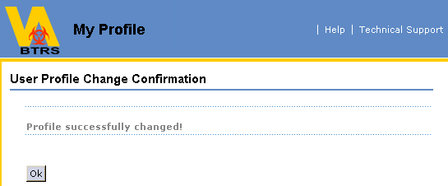
Sample View of Profile dashboard
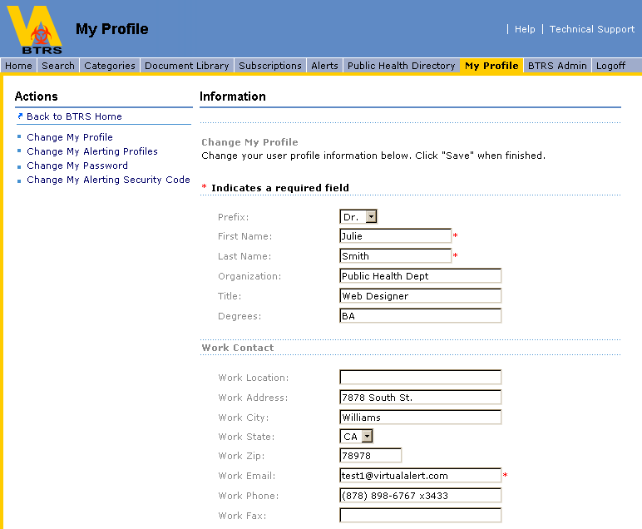

How to Change My Password
Users may change their own passwords for security reasons, from an assigned password to one of their own choosing. Please note that if you forget your password, your BTRS Admin must arrange to reset it for you so that you may log on again and customize it. Passwords are not stored in the system.

To Change Your User Password

1. On the navigation bar of the dashboard site, click My Profile.
2. To make changes to your Password, click on Change My Password in the Actions section.
3. In the appropriate fields, enter your current password, your new password and confirm your new password.
4. Click Save.
5. A Password Change Confirmation screen will appear indicating that the password was successfully changed. Click the OK button to return to the My Profile dashboard.
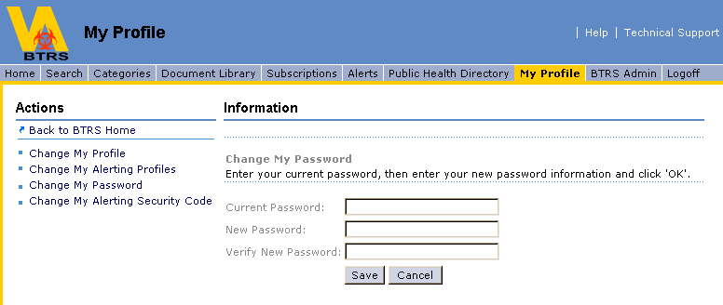

Your personal password to access BTRS has now been changed to a new password known only by you. You will be prompted to close all browser windows and log back in using your new password.
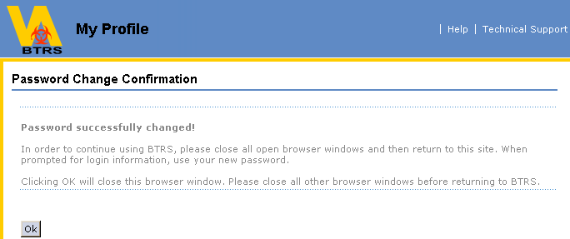

How to Set/Change My Alerting Security Code

Users have the ability to set and change the Alerting Security Code that they need to access phone alerts they may receive. When a user attempts to change their alerting profiles for the first time, they will be forced to set their Alerting Security Code first. Alerting Security Codes must be exactly 4 numeric characters.

Note: Only systems with a telephone server can utilize telephone alerting

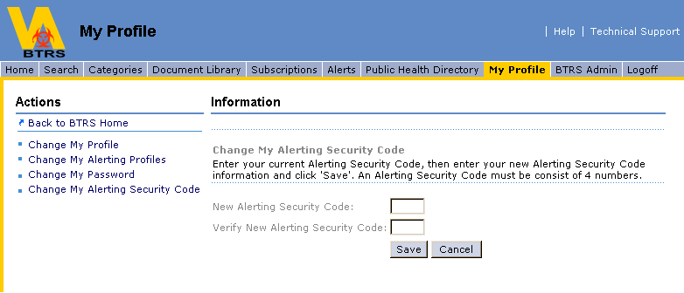

1. If you have never set your Alerting Security Code, you will be prompted to do so when you go to My Profile, and forced to do so before you are able to change your alerting profiles.
2. Click Set My Alerting Security Code.
3. Enter the Alerting Security Code you would like to use and verify it in the corresponding fields.
4. Click Save.
5. You will receive a confirmation that your Alerting Security Code was created. Click OK.

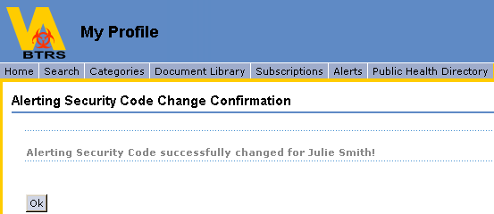

To Change My Alerting Security Code

1. On the navigation bar of the dashboard site, click My Profile.
2. Click on Change My Alerting Security Code.
3. Enter your new Alerting Security Code.
4. Confirm your new Alerting Security Code.
5. Click Save. You will receive a confirmation that your Alerting Security Code was changed. Click OK.

How to Change My Alerting Profiles
Users have the ability to create, edit and activate several different alerting profiles based on their individual needs. For example, if a Public Health Officer will be on vacation, but still must remain alertable, they may activate an alerting profile called vacation, and select their cell phone and/or home e-mail as their main points of contact for any alert that may occur. All contact information will be drawn from the user's personal profile.

Note: You will only be able to create and modify your Alerting Profiles after you have set your Alerting Security Code.

Note: Alerts you receive will be delivered to your work e-mail address until you set up your custom Alerting Profile

To Create an Alerting Profile

1. On the navigation bar of the dashboard site, click My Profile.
2. Click Change My Alerting Profiles.
3. Click the New button.

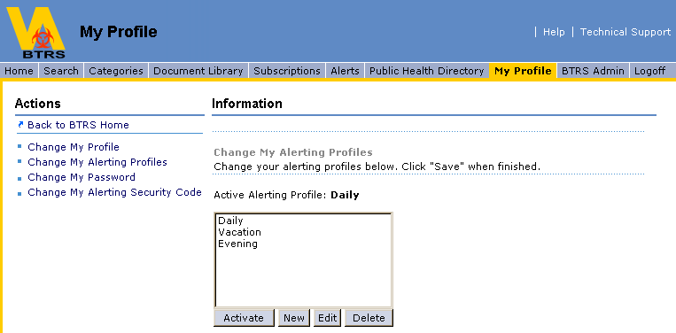

4. Type a name for your alerting profile in the Profile Name box.
5. If this will be the profile that you want to be currently active, check the Activate box.
6. For each priority of alert, select the locations where you would like your alerts to be sent from the drop-down lists. Alerts will go to all locations selected simultaneously.
Note: If you activate an alerting profile that has all locations for all alert priorities set to none, you will NOT receive alerts at all.
7. When you have set your locations for all priorities of alerts, click Save.
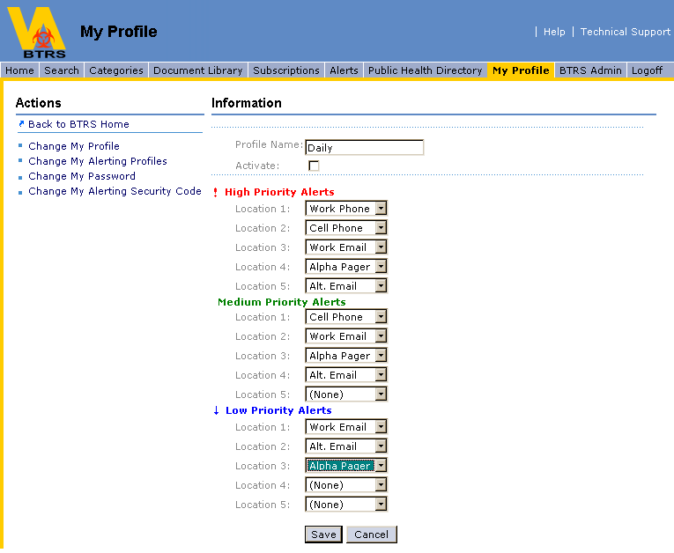

To Activate an Alerting Profile

1. Click Change My Alerting Profiles.
2. Click the Alerting Profile that you would like to activate.
3. Click the Activate button. The selected Alerting Profile will then be activated.
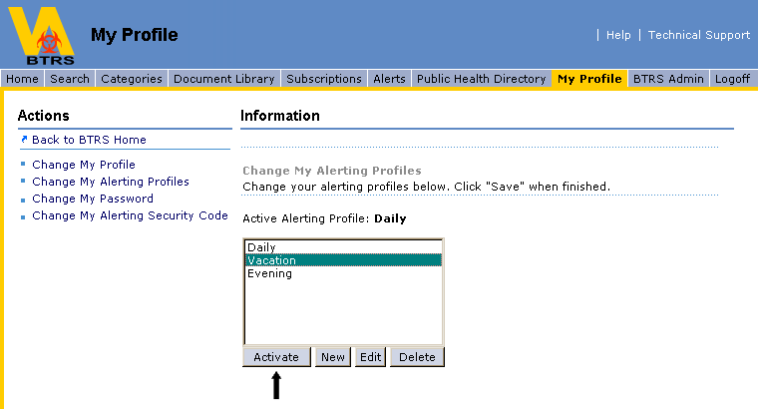

To Edit an Alerting Profile

1. Click Change My Alerting Profiles.
2. Click the Alerting Profile that you would like to edit.
3. Click the Edit button. This will open the locations of the selected Alerting Profile.
4. Make any necessary changes to the locations of the profile and click Save.

To Delete an Alerting Profile

1. Click Change My Alerting Profiles.
2. Click the Alerting Profile that you would like to delete.
3. Click the Delete button. You will be prompted to confirm your decision.
4. If you wish to continue to delete the profile, click OK.

BTRS Admin

About BTRS Admin
For users with the proper permissions, a BTRS Administrative page is available. This page will allow the user to perform administrative functions for BTRS. Functions available are:

- Manage Discussions, including the ability to delete discussions.
- Manage Categories, including creating, deleting and editing categories and subcategories.
- Manage Subscriptions, including the ability to delete subscriptions or assign subscriptions to specified PHRoles.
- Manage BTRS Folders, in which the Admin can assign and remove folder permissions, document profiles and approval routing to each folder within the Document Library.
- Manage Users, which is the ability to create new users, create new Organizational Units (OU), rename OUs, move OUs, move users to different OUs, assign OU managers, edit user properties, edit user alert profiles, deactivate users, reset user passwords, reset user Alerting Security Codes, assign users to PHRole(s) and assign users portal permissions.
- Manage PHRoles, which is the ability create new PHRoles, create new Organizational Units (OU), rename OUs, Move OUs, move several PHRoles to different OUs, assign OU Managers, assign Alertable PHRoles, assign users to PHRoles, rename PHRoles, move individual PHRoles to different OUs view members of PHRoles and view corresponding Alertable PHRoles.
- Manage Portal Permission Groups, which is the ability to create custom Portal Permission Groups, delete Portal Permission Groups, add members to Portal Permission Groups, as well as view the members of any Portal Permission Group.
- Generate a report of profile information for all of the users that the BTRS Admin manages.
- Generate Alert History Logs using a search criteria.
- Generate Alert Fax Logs using a search criteria.
- Generate Alert Confirmation Reports, showing which users have confirmed alerts and which users have not confirmed alerts.
- Generate Folder Permission Reports, showing which users or Portal Permission Groups are assigned to any specified folder as a Reader, Author, Admin or Approver.
- Generate a report of all documents that are checked out on the portal, including the document title, the folder where it resides, who checked out the document and the date it was checked out.
- Generate a Documents Awaiting Approval Log, showing all documents that are awaiting approval, the folder the document resides and who needs to approve the document in order for it to publish (i.e. if any approvers have already approved the document, the list will only consist of who is left). The Admin has the option to override the approval process, or cancel the publishing.
- Generate a Document History Report, showing the version history of documents within a selected folder in the Document Library, and its subfolders.
- Generate a Document Totals Log, giving document counts within the portal that can be sorted according to: folder, category, or the user who last modified a document.
- Generate a Modified Content Report, showing which documents in a selected folder have been modified, according to a specified search criteria.

Using Manage Discussions

If you are a BTRS Admin, you can delete obsolete or unnecessary discussions.

BTRS maintains discussions separately from the documents with which they are associated. Even if you delete a document from the workspace, any discussions about that document remain in the workspace until they are deleted.

Note: If revision feedback by authors on a specific document is not supposed to be available to the general reader public, the BTRS Admin may be asked to delete the discussion before the document is published.

1. On the navigation bar of the dashboard site, click BTRS Admin.
2. On the BTRS Admin dashboard, click Manage Discussions.
3. Two lists of documents appear, one with documents containing discussions in this workspace and one with documents containing discussions located outside this workspace.
4. Select a document or documents from which you want to delete discussions.
5. To select multiple, adjacent documents, SHIFT+click.
6. To select multiple, individual documents, CTRL+click.
7. When you have finished selecting the documents, click Delete Discussions on Selected Documents below the list from which you have selected the documents to delete Discussions.
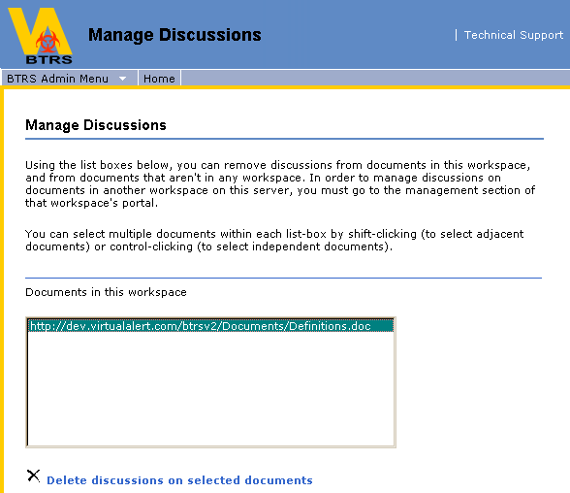

Using Manage Categories

The BTRS Admin has the ability to manage and maintain the categories within the portal. When the web part is initially displayed, it shows the top-level categories defined for the workspace. You can view subcategories of a category by clicking the link to the category. As you drill down, your top-level category is displayed at the top of the web part.

1. On the navigation bar of the dashboard site, click BTRS Admin.
2. On the BTRS Admin dashboard, click Manage Categories.
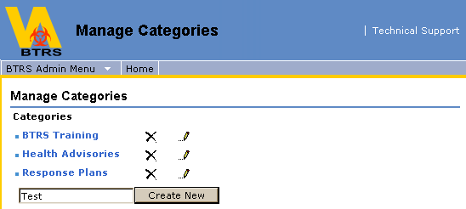

3. Determine whether you want to add a new category, modify an existing category, create a sub-category or delete a category.
4. To create a new category, type a name for the new category, and then click Create New.
5. Enter all necessary information for the new category:
a) Category Name
b) Category Description
c) Contact Name – Person who would be best to contact regarding that category of the information assigned to that category.
d) Contact E-mail – e-mail address of person who would be best to contact regarding a specific category or the information assigned to that category.
6. Click Save.
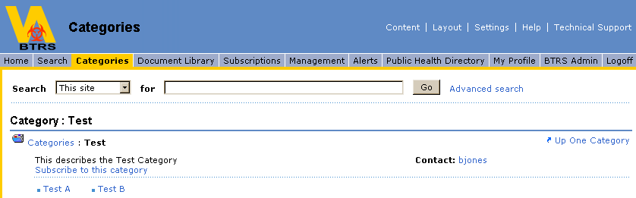

7. To edit an existing category, select the pencil icon next to the title of the category, and edit the properties, including the name, description, and contact information for the category and then click Save.

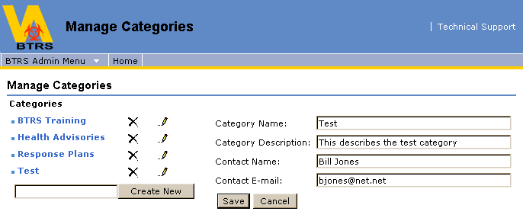

8. To create a sub-category or nested category, click on the top-level category in which you want to nest a sub-category, then type the name in the box next to the Create New button. Then click Create New.

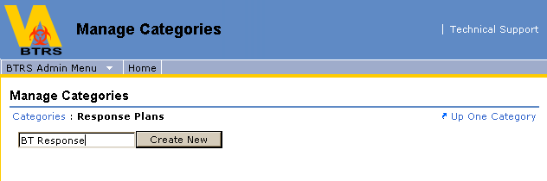

9. To delete a category, select X next to the category.

Caution: Once a category has been deleted, it cannot be restored.

Using Manage Subscriptions

If you are a BTRS Admin, you can view and delete another user's subscriptions. When a user is deactivated, their subscriptions are automatically deleted. The BTRS Admin also has the ability to assign subscriptions to PHRoles that they manage.

To Manage Another User's Subscriptions

1. On the navigation bar of the dashboard site, click BTRS Admin.
2. From the BTRS Admin dashboard, click Manage Subscriptions.
3. In Manage Subscriptions, enter the user name of the user whose subscriptions you want to manage. It is not necessary to enter the DOMAIN name.
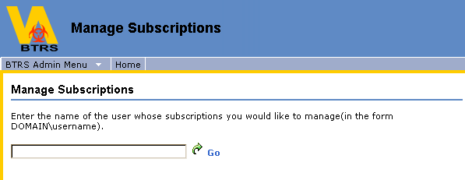

4. Click Go.
5. If the specified user name has subscriptions, you see the Subscriptions page for that user.

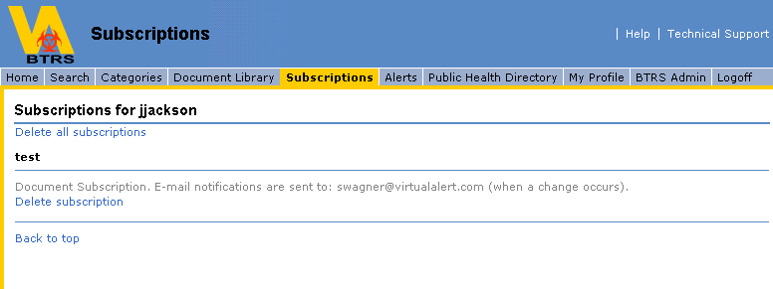
6. If the user name does not exist, the system will indicate that it failed to get subscription results.
7. If the user has no subscriptions, a message is displayed indicating this.
8. Delete the subscriptions as appropriate.

Note: The user name may not exist if they have been deactivated. If this is the case, it is no longer necessary to delete the subscriptions.

To Assign Subscriptions to PHRoles

Note: You can only assign subscriptions to PHRoles that you manage

1. On the navigation bar of the dashboard site, click BTRS Admin.
2. From the BTRS Admin dashboard, click Manage Subscriptions.
3. Under the Assign Subscriptions link, select the folder that you would like to assign a subscription to, or that contains a document that you would like to assign a subscription to from the drop-down menu and then click Next.
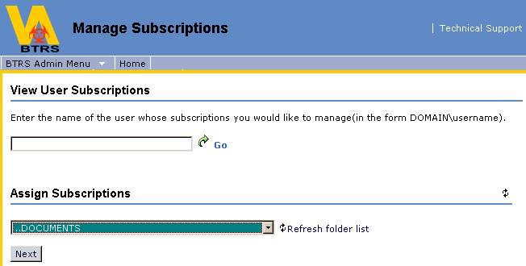

4. You will then see the Public Health Directory (according to the OU that you manage) on the left side of the screen. Click down in the tree until you locate the PHRole(s) to which you would like to assign the subscription.
5. Click on the name of each PHRole you want to assign the subscription. This will add their name to the PHRoles to assign this subscription to box.
6. Type a descriptive name for the subscription in the Subscription Title field.
7. If the subscription is for a single document only, select the document from the Choose a document to assign subscriptions for drop-down menu.
8. If you want the subscription to be to the entire folder, simply click in the check box that says Check here to subscribe to entire folder.
9. Select from the How Often drop-down menu how often you would like subscription notifications to be sent via e-mail. If When a change occurs, Once a day, or Once a week is selected, the notification will automatically go to the work e-mail address in the profiles of each user that is assigned to the PHRole(s) selected for the subscription. If Never (portal only) is selected, notifications will not be sent via e-mail, they will only appear on the users' Home page and Subscriptions page when they log into the portal.
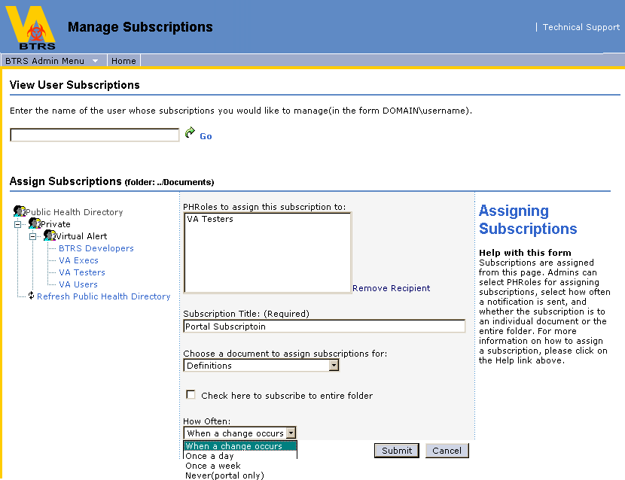

10. Once all selections have been made, click Submit.
11. You will receive a confirmation of the subscription, with the names of the users subscribed. Click OK.
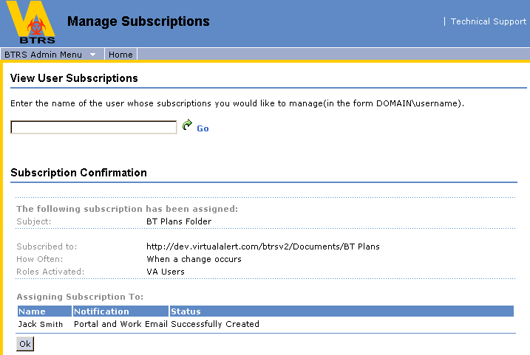

Using Manage Folders
The BTRS Admin has the ability to set folder permissions, set folder profiles and set folder approval routing on any given folder within the Documents folder of the Document Library.

1. On the navigation bar of the dashboard site, click BTRS Admin.
2. On the BTRS Admin dashboard, click Manage Folders.
3. Under Manage Folders, select a folder whose properties need to be modified from the drop down menu.
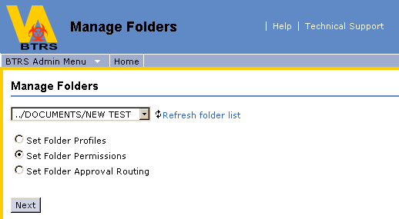

Set Folder Profiles

1. Once you've selected a folder, click on the Set Folder Profiles radio button and click Next. All Available Document Profiles appear on the left and the current profiles assigned to that folder will appear on the right.

How to Add a Profile

1. To add a profile to the folder you've chosen, select a profile (by clicking on it) from the All Available Document Profiles and then click add. The profile will then appear within the Profiles assigned to this folder box.
2. Repeat this procedure until all needed profiles have been assigned to the selected folder.

How to Remove a Profile

1. To remove a profile from a folder, select the folder from the Choose a Folder drop-down menu.
2. Within the Profiles assigned to this folder box, select the profile (by clicking on it) that you would like to remove from the folder and then click remove.

How to Assign a Default Profile

1. To assign a default profile to the folder (see below for more information on Default Profile), simply select the profile you want the default to be from the Default Profile drop-down menu.
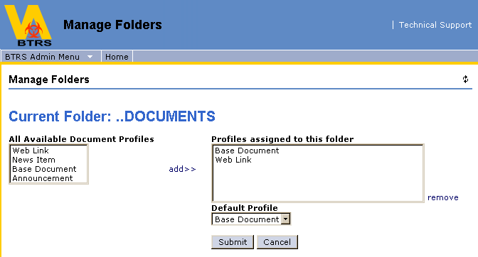

Default Profile

The Default Profile assigned will be the initial profile presented to a user choosing to publish a document to that folder. The user will still have the option to choose from other profiles that may be assigned to the folder as well.
Note: Publishing requires the user to be a member of a group that has Author rights on that folder.
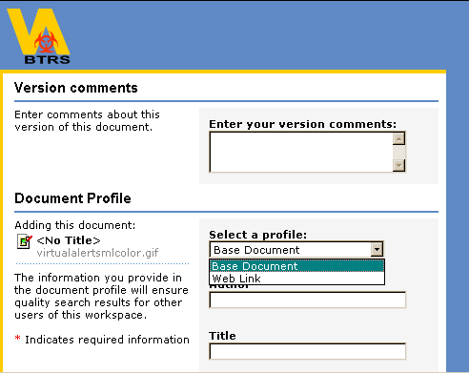

Set Folder Permissions
1. Once you've selected a folder, click on the Set Folder Permissions radio button and click Next. All of your Available Groups (Portal Permission Groups and PHRoles) appear on the left and the current permissions of that folder will appear on the right.

Note: You will only be able to assign PHRoles that reside in OUs that you manage.
2. If you would like to add a Portal Permission Group or PHRole to the permissions of the selected folder, click on the name to select it.
3. Click add to the left of either the READERS or AUTHORS box to assign as a Reader or an Author.
4. To remove a Portal Permission Group or PHRole from the folder permissions, select the PPGroup or PHRole from either the READERS or AUTHORS box and click remove.
5. If you would like the permissions you've assigned to overwrite permissions to all subfolder permissions beneath the one you are working with, check the Apply to all subfolders box.
Important: Selecting Apply to all subfolders will overwrite any subfolders with the permissions you've chosen. It will NOT add to the existing permissions of the subfolders.
6. Click Submit.
7. You will receive a confirmation that the folder permissions were successfully updated. Click OK.
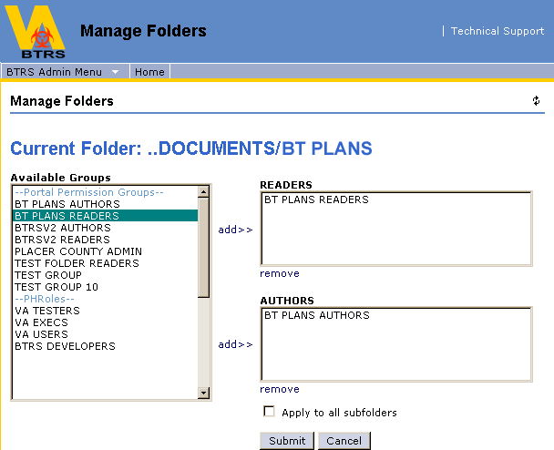

Set Folder Approval Routing

Approval routes are an easy way to ensure that a document is adequately reviewed before it is published. When an Author chooses to publish a document, it can be presented via the portal to one or more people for review before publishing it. Each of these people, called Approvers, has the option of approving or rejecting the document.

1. Once you've selected a folder, click on the Set Folder Approval Routing radio button and click Next.
2. There are several options for approval on a folder:

- No approval required - nobody has to approve a document being published to the folder
- Everyone must approve (parallel) - All Approvers assigned to the folder must approve any given document before it can be published
- Only one approval needed (parallel) - Although there may be several Approvers assigned to the folder, only one must approve any given document for it to be published
- All must approve in assigned order (serial) - All Approvers assigned to the folder must approve any given document before it can be published, but they must approve in the order they are assigned as Approvers. (In the example below, a document would have to be approved by Kenneth Loggins, then Mark Anderson and then Alicia Reyes, in that order)

In each case, once the approval criteria has been met, the document will automatically publish.

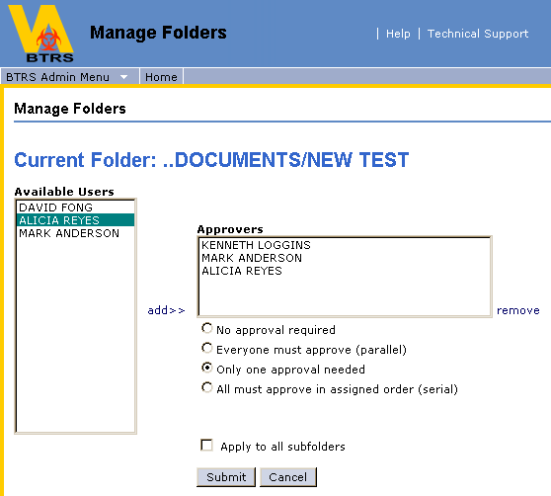
3. Select the Approvers you would like to assign to the folder from the Available Users by clicking on their name and clicking add.

Note: You will only be able to assign users that reside in OUs that you manage.

4. Select the approval criteria from the radio buttons below the Approvers box.
5. To remove a user as an Approver, click on their name in the Approvers box and click remove.
6. If you would like the approval routing to apply to all subfolders of the folder you've selected, click in the checkbox next to Apply to all subfolders.
7. Click Submit.
8. You will receive a confirmation that the approval routing was successfully updated. Click Ok.

Important: Selecting Apply to all subfolders will overwrite any subfolder approval routing assignments with the assignments you've chosen. It will NOT add to the existing approval routing assignments of the subfolders.

Note: You can make changes to a folder approval process, but the changes take effect only for documents submitted for approval after the changes are made.

Note: If a folder has been set up with restricted access, and a user who does not have access to that folder is assigned as an Approver on that folder, they will inherit Reader permissions on that folder.

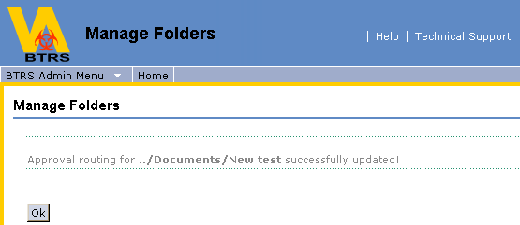

Using Manage Users (Public Health Users Directory)

Note: You are only able to manage the users that reside within the OUs that you manage within the Public Health Users Directory

The BTRS Admin has the ability to create new users, create new OUs, rename OUs, move OUs, move users to different OUs, assign OU managers, edit user properties, edit user alert profiles, deactivate users, reset user passwords, reset user Alerting Security Codes, assign users to PHRoles and assign users portal permissions. To manage users, click on the BTRS Admin link in the main navigation bar. Then click on the Manage Users link.

Create a New User

1. Locate the Organizational Unit (OU) where you would like to create the new user. Right-click on the name of the Organizational Unit and select Create New User. This will open the Create New User page.
2. Within the Create New User page, fill in all of the appropriate fields by tabbing from section to section (Required Information, Work Contact, Home Contact, Alternate Contact and Misc. Personal). All fields in the Required Information tab must be filled out to successfully create the new user.
3. When you have filled in all of the necessary information, click Save.
4. You will receive a confirmation that the user has been successfully added. Click OK to refresh your view and reflect the change, or you can continue working without refreshing your view. See Supplementary Information.

Note: A User ID must be 20 characters or less
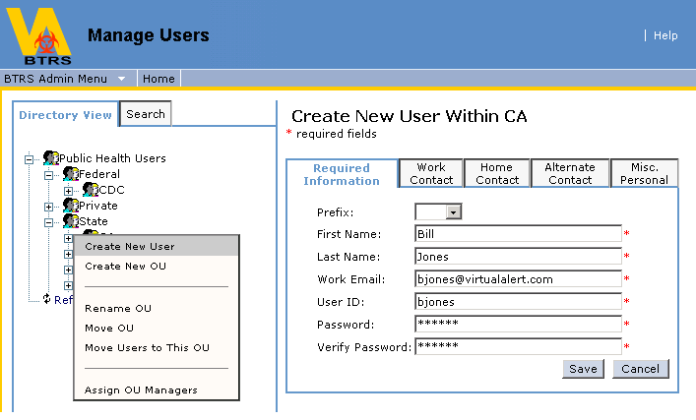

Create a New Organizational Unit (OU)

1. Locate the Organizational Unit (OU) in which you would like to create a new OU.
2. Right-click on the OU and select Create New OU.
3. Enter the name of the new OU in the New OU Name box and click Save.
4. You will see a confirmation that the new OU has been successfully created. Click OK to refresh your view and reflect the change, or you can continue working without refreshing your view. See Supplementary Information.

Note: An OU name must be 64 characters or less (including spaces)

Note: It is recommended that an OU structure not be more than 10 OUs deep (or embedded). The example to the right displays an OU structure that is 4 OUs deep, meaning that CDC resides within Federal, which resides in Demo 1, which resides within Public Health Users. | 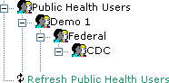

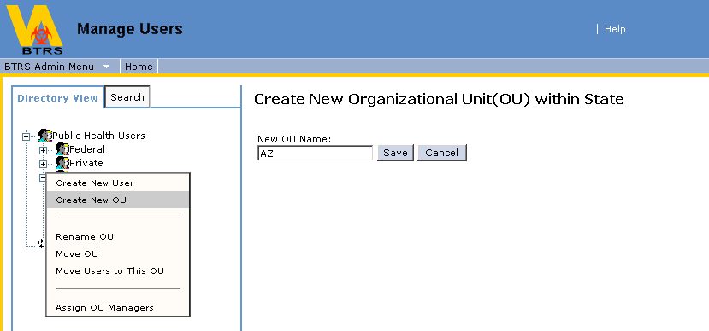

Rename an OU

1. Locate the Organizational Unit (OU) that you would like to rename.
2. Right-click on the OU and select Rename OU.
3. Enter the new OU name in the New OU Name box.
4. Click Save.
5. You will be asked to confirm that you wish to rename the OU. Click Ok.
6. You will receive a confirmation that the OU was renamed. Click Ok to refresh your view and reflect the change, or you can continue working without refreshing your view. See Supplementary Information.
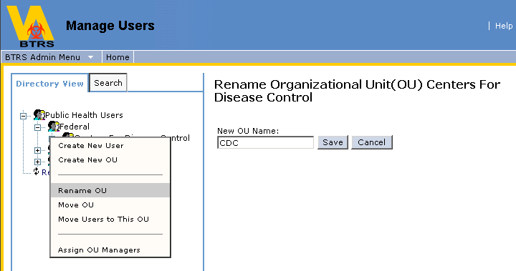

Move an OU (and all of its contents)

1. Locate the Organizational Unit (OU) that you would like to move.
2. Right-click on the OU and select Move OU.
3. A second directory will open titled Choose An OU. Select the OU you wish to move your selected OU into by clicking on it.
4. The OU you wish to move your selected OU into should be listed in the Currently Selected OU box.
5. Click Save.
6. You will be asked to confirm that you wish to move the OU and all of its contents. Click Ok.
7. You will receive a confirmation that the OU was successfully moved. Click Ok to refresh your view and reflect the change, or you can continue working without refreshing your view. See Supplementary Information.
Note: When an OU is moved to a different location, the manager of the OU will be relocated with that OU, which may alter what that OU manager sees.
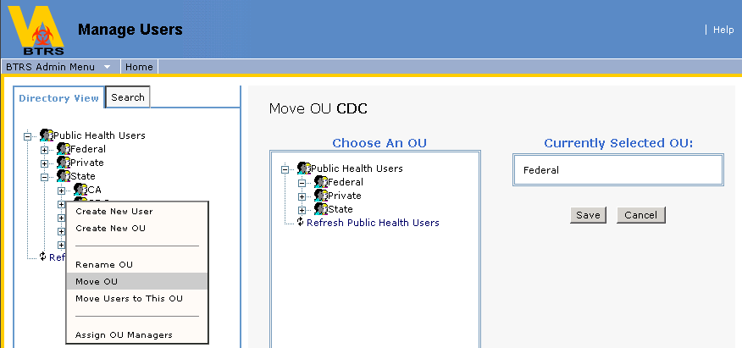

Move Several Users to a Different OU

1. Locate the OU that you would like one or more users to be moved to.
2. Right-click on the name of the OU and select Move Users to this OU.

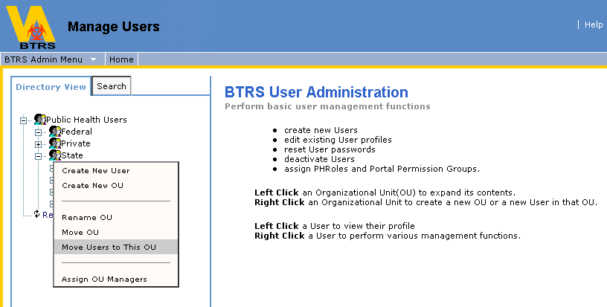

3. The Public Health Users Directory will open again to allow you to select the users you want to move to the selected OU.
4. Select the user(s) you wish to move by clicking their name, which will add them to the Users to move to box.
5. To remove any users that you've selected, click on their name in the Users to move to box and click Remove User(s).
6. When you've selected all of the users you wish to move, click Move.
7. You will be asked to confirm that you wish to move the selected users. Click Ok.
8. Your confirmation will give you the names of all users assigned to the selected OU. Click Ok to refresh your view and reflect the change, or you can continue working without refreshing your view. See Supplementary Information.

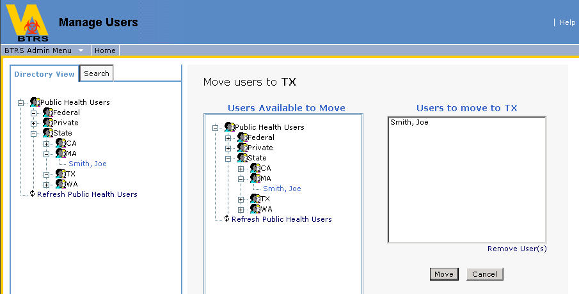

Assign Manager(s) to an OU

Note: You can assign any user(s) within the Public Health Users Directory to manage one of your OUs

1. Locate the Organizational Unit (OU) in which you would like to assign a manager to.
2. Right-click on the name of the OU and select Assign OU Managers.
3. The Public Health Users Directory will open. Click on any user names in the directory to add them to the Current Managers box.

Note: You may assign one or several managers to any OU that you manage

4. When all users to be assigned as an OU Manager have been selected, click Save.
5. You will be prompted to confirm your decision to assign the users to manage the selected OU. Click OK.
6. You will then receive a confirmation that the users you selected were assigned as managers of the OU you selected. Click OK to refresh your view and reflect the change, or you can continue working without refreshing your view. See Supplementary Information.

Note: Any users assigned as an OU manager will automatically be assigned to the BTRS Admin Portal Permission Group

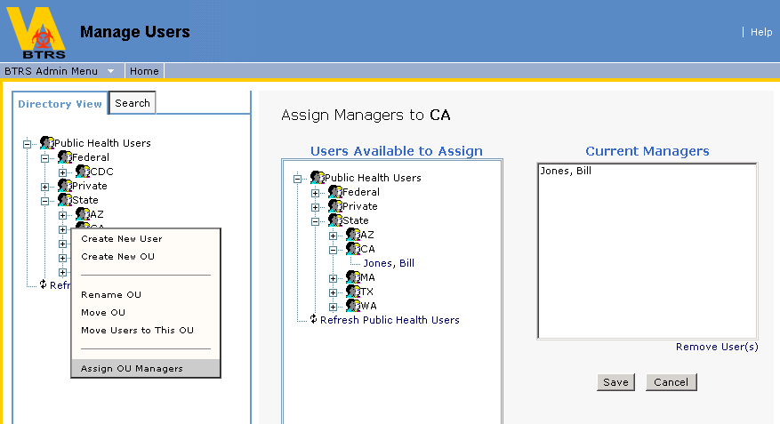

Edit User Properties

1. Locate the user (within Public Health Users) whose properties you want to edit.
2. Right-click on the user's name and select Edit User Properties. This will open the user's information fields for you to edit.
3. When you've made all of the changes necessary, click Save.
4. You will receive a confirmation that the account was successfully saved. Click OK to refresh your view and reflect the change, or you can continue working without refreshing your view. See Supplementary Information.

Note: Permission changes to an active user account may take up to 15 minutes to take affect

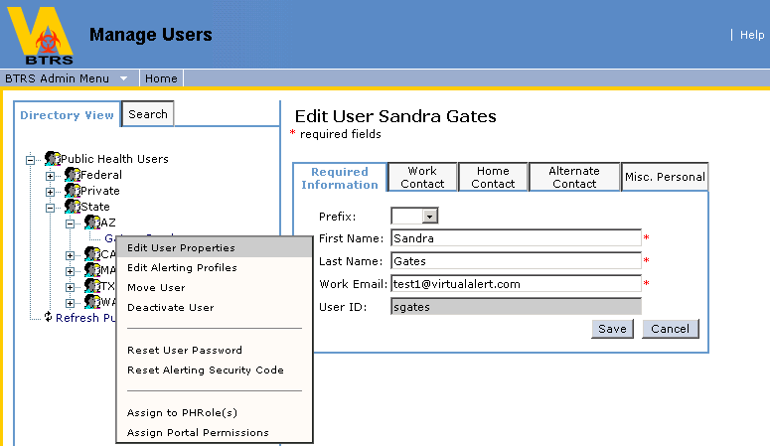

Edit User Alerting Profiles

To Create an Alerting Profile for a User

1. Locate the user (within Public Health Users) whose properties you want to edit.  2. Right-click on the user's name and select Edit Alerting Profiles. This will open the user's alerting profiles for you to edit.  3. Click the New button.  4. Type a name for the alerting profile in the Profile Name field.  5. If this will be the profile that you want to be currently active, check the Activate box.  6. For each priority of alert, select the locations where the user's alerts are to be sent from the drop-down lists. Alerts will go to all locations selected simultaneously.  7. When you have set your locations for all priorities of alerts, click Save. | 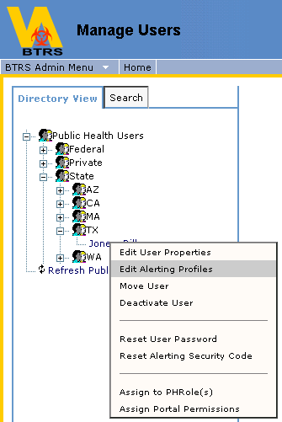

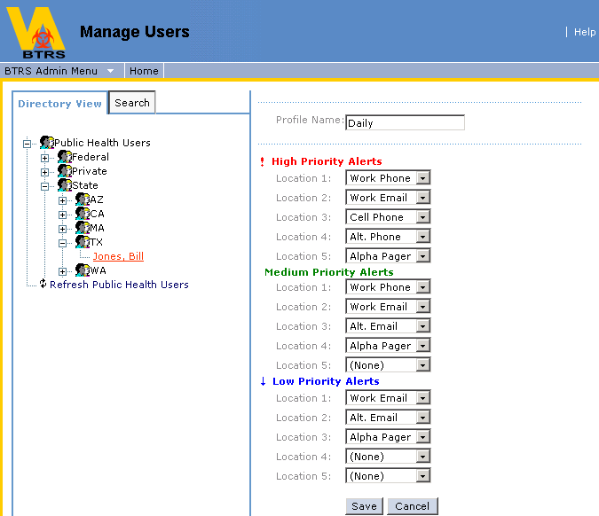

Activate An Alerting Profile For a User

1. Locate the user (within Public Health Users) whose properties you want to edit.
2. Right-click on the user's name and select Edit Alerting Profiles. This will open the user's alerting profiles for you to edit.
3. Select the alerting profile you wish to edit and click the Activate button. The selected Alerting Profile will then be activated.

Edit a User’s Alerting Profile

1. Locate the user (within Public Health Users) whose properties you want to edit.
2. Right-click on the user's name and select Edit Alerting Profiles. This will open the user's alerting profiles for you to edit.
3. Select the alerting profile you wish to edit and click the Edit button. This will open the locations of the selected Alerting Profile.
4. Make any necessary changes to the locations of the profile and click Save.

Delete a User’s Alerting Profile

1. Locate the user (within Public Health Users) whose properties you want to edit.
2. Right-click on the user's name and select Edit Alerting Profiles. This will open the user's alerting profiles for you to edit.
3. Select the alerting profile you wish to delete and click the Delete button. You will be prompted to confirm your decision.
4. If you wish to continue to delete the profile, click OK.

Move a Single User to a Different OU

1. Locate the user (within Public Health Users) that you would like to move.
2. Right-click on the user's name and select Move User.

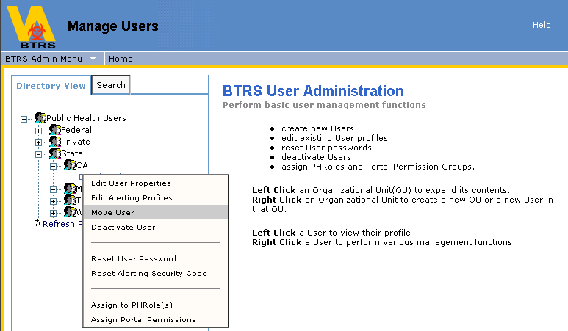

3. The Public Health Users Directory will open again to allow you to select the OU that you wish to move the user to.
4. Select the OU that you wish to move your user to by clicking on it. This will add it to the Currently Selected OU box.
5. Click Save.
6. You will be if you are sure you want to move your selected user. Click Ok.

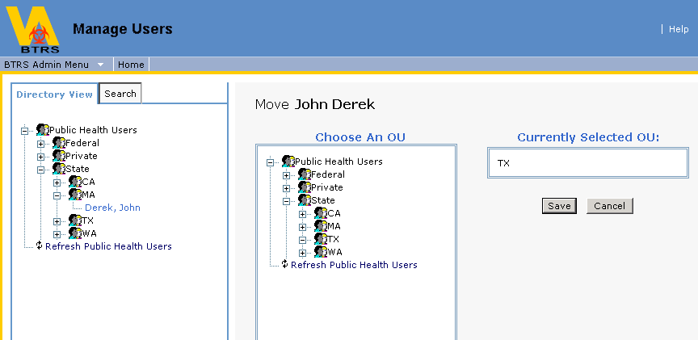

- You will receive a confirmation that your user was successfully moved. Click Ok to refresh your view and reflect the change, or you can continue working without refreshing your view. See Supplementary Information.

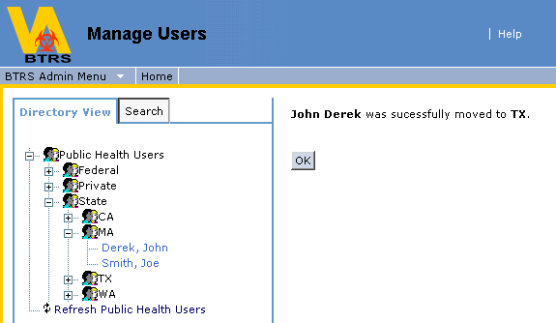

Deactivate a User

1. Locate the user (within Public Health Users) whom you want to deactivate.
2. Right-click on the user's name and select Deactivate User. You will be prompted to verify your choice to deactivate the user. Click OK.
3. The user will be deactivated, and you will receive a confirmation screen verifying the deactivation. Click OK to refresh your view and reflect the change, or you can continue working without refreshing your view. See Supplementary Information.

Note: If you deactivate a user:
- It may take up to 15 minutes for the deactivation to take effect
- You will have to contact your BTRS System Administrator to reactivate that user
- Any subscriptions for that user will be permanently removed

Reset a User Password

1. Locate the user (within Public Health Users) whose password you want to reset.
2. Right-click on the user's name and select Reset User Password. This will open the Reset Password screen.
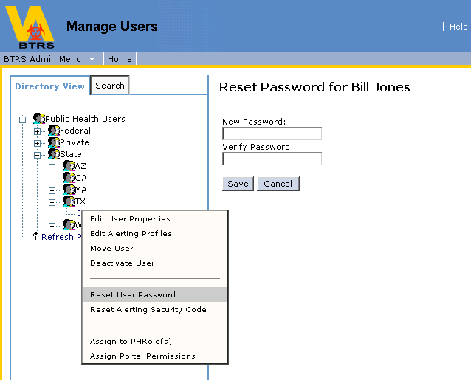

3. Enter the new password for the user in the New Password field.
4. Verify the new password by typing it again in the Verify Password field.
5. Click Save. The user's password has now been reset.
6. You will receive a confirmation that the user’s password was reset. Click OK to refresh your view and reflect the change, or you can continue working without refreshing your view. See Supplementary Information.

Reset a User's Alerting Security Code

1. Locate the user (within Public Health Users) whose Alerting Security Code you want to reset.
2. Right-click on the user's name and select Reset Alerting Security Code.
3. Enter the new Alerting Security Code in the top text field called New Alerting Security Code.
4. Verify the new Alerting Security Code in the bottom text field called Verify Alerting Security Code.
5. Click Save.
6. You will receive a confirmation that the Alerting Security Code was successfully reset. Click OK to refresh your view and reflect the change, or you can continue working without refreshing your view. See Supplementary Information.
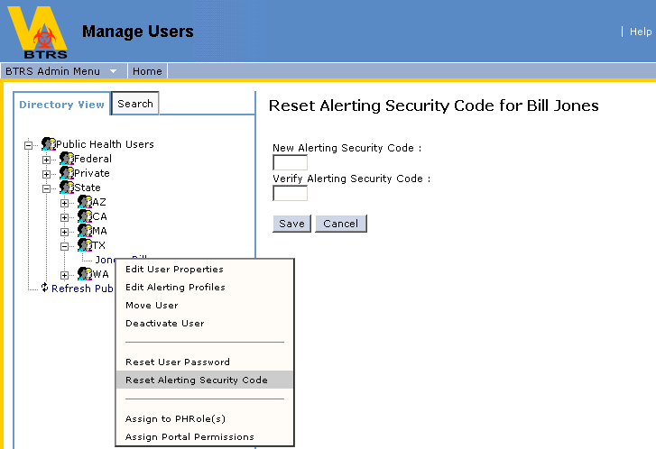

Assign a User To PHRole(s)

Note: You will only be able to assign users to PHRoles that reside in OUs that you manage within the Public Health Directory.

1. Locate the user (within Public Health Users) whom you would like to assign to a PHRole.
2. Right-click on the user's name and select Assign to PHRole(s). This will open the Assign PHRole(s) screen.
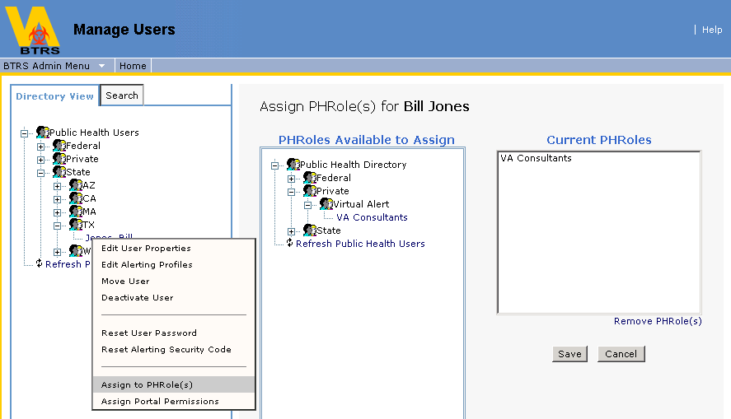

3. Locate the PHRole (within the Public Health Directory) that you would like to assign the user to.
4. Once you've located the PHRole, clicking on that PHRole will add it to the Current PHRoles box. After you've assigned all necessary PHRoles to the user, click Save.
5. If you need to remove a PHRole, select the PHRole by clicking on it (within the Current PHRoles box), then click Remove PHRole(s). Click Save.
6. You will be asked to confirm your assignment choice. Click OK.
7. You will receive a confirmation of the PHRole assignment. Click OK to refresh your view and reflect the change, or you can continue working without refreshing your view. See Supplementary Information.

Assign a User Portal Permissions

Portal Permissions determine the access that a user will have on the BTRS system. A user with a Full Access license will need to be assigned to one of the following default Portal Permission Groups:

- BTRS Readers - A user who can search for and read documents but cannot add them to the workspace.
- BTRS Authors - A user who can create folders (within folders that they author) and search for, read, edit, add, or delete any documents in the folder.
- BTRS Admin - A user with author privileges who can also perform administrative functions for BTRS, such as managing portal content and settings, managing groups and users, and generating reports and logs.

Note: Users with a Limited license should not be assigned to any Portal Permission Groups.

1. Locate the user (within Public Health Users) whom you would like to assign to a Portal Permission Group.
2. Right-click on the user's name and select Assign Portal Permissions. This will open the Assign Portal Permissions screen.
3. Select the Portal Permission Groups from the Available Groups box. Click the Add button. That Portal Permission Group will then be moved over to the Assigned Groups box.
4. If you wish to remove the user from a Portal Permission Group that they are assigned to, select the Portal Permission Group from the Assigned Groups box by clicking on it and click the Remove button.
5. Once all Portal Permission Groups have been assigned or removed for the user, click Save.
6. You will receive a confirmation of the Portal Permission assignments. Click OK to refresh your view and reflect the change, or you can continue working without refreshing your view. See Supplementary Information.

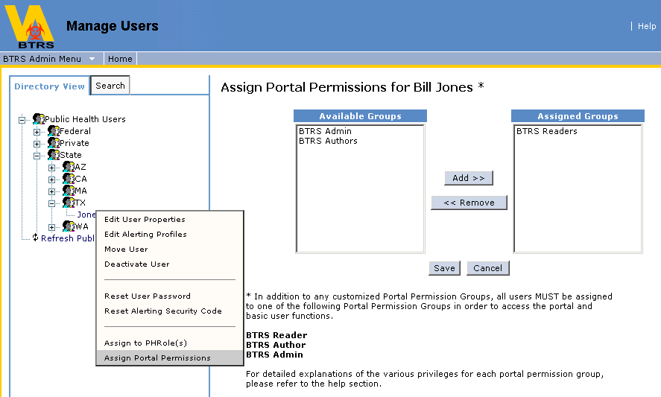

View User Properties
1. Locate the user (within Public Health Users) whose properties you want to view.
2. Click on the user's name. This will open the user's information for viewing.
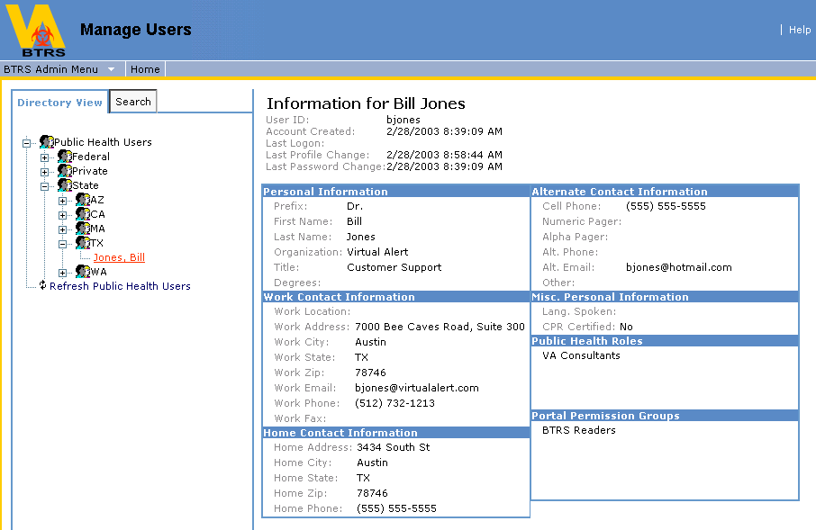

Use the Search Tab to Locate an Individual User

As your Public Health Users Directory develops in size, it may be simpler to modify a user's properties by using the Search tab.

Note: You will only be able to locate users that reside within the OUs that you manage within the Public Health Users Directory

1. Click on the Search tab.
2. Type the name of the user in the Find User box. If you are unsure of how to spell the user's name, type at least one letter of the first or last name, or a known letter string of that user's name.
3. Click go.
4. If the user exists within the Public Health Users Directory and you manage them, their name will appear below the Find User box.

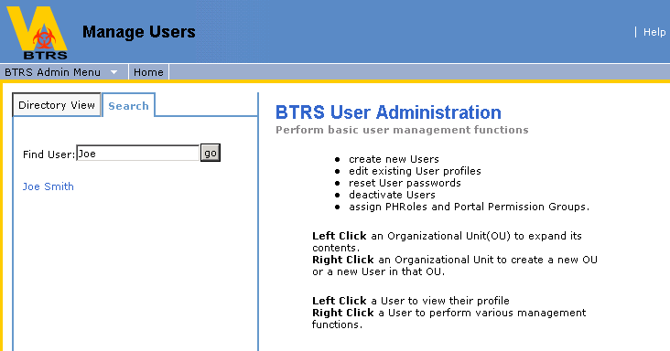

5. If the user's properties need to be modified, right-click on the name that the search produced and you will be given all of the options to edit that user's properties.
6. Left-click on the name of the user to only view their properties.

Using Manage PHRoles (Public Health Directory)
Note: You will only be able to manage PHRoles that reside with the OUs that you manage in the Public Health Directory

The BTRS Admin has the permissions to create new PHRoles, create new Organizational Units (OUs), rename OUs, Move OUs, move several PHRoles to different OUs, assign OU Managers, assign Alertable PHRoles, assign users to PHRoles, rename PHRoles, move individual PHRoles to different OUs view members of PHRoles and view corresponding Alertable PHRoles. To manage PHRoles, click on the BTRS Admin link in the main navigation bar. Then click on the Manage PHRoles link.

Create a New PHRole

1. Locate the Organizational Unit (OU) in which you would like to create a new PHRole.
2. Right-click on the OU and select Create New PHRole.
3. Enter the name of the new PHRole in the New PHRole Name box and click Save.
4. You will see a confirmation that the PHRole has been successfully created. Click OK to refresh your view and reflect the change, or you can continue working without refreshing your view. See Supplementary Information.

Note: A PHRole name must be 64 characters or less (including spaces)

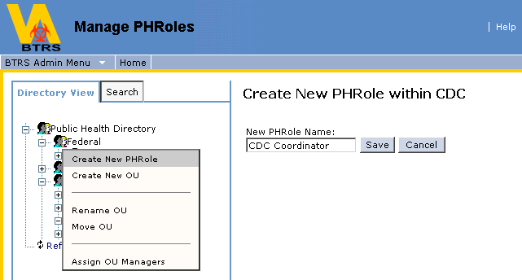

Create a New Organizational Unit (OU)

1. Locate the Organizational Unit (OU) in which you would like to create a new OU.
2. Right-click on the OU and select Create New OU.
3. Enter the name of the new OU in the New OU Name box.
4. Click Save.
5. You will see a confirmation that the new OU has been successfully created. Click OK to refresh your view and reflect the change, or you can continue working without refreshing your view. See Supplementary Information.

Note: An OU name must be 64 characters or less (including spaces)

Note: It is recommended that an OU structure not be more than 10 OUs deep (or embedded). The example to the right displays an OU structure that is 4 OUs deep, meaning that CDC resides within Federal, which resides in Demo 1, which resides within Public Health Directory. | 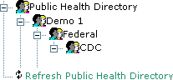

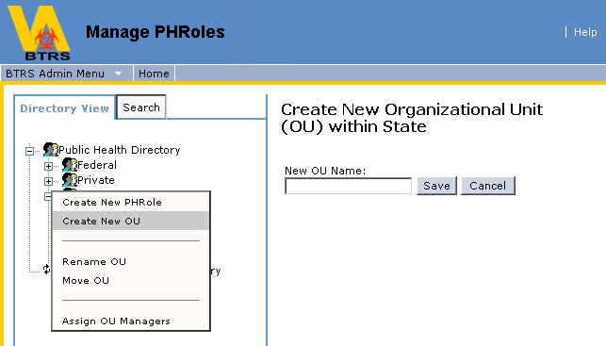

Rename an OU

1. Locate the Organizational Unit (OU) that you would like to rename.
2. Right-click on the OU and select Rename OU.
3. Enter the new OU name in the New OU Name box.
4. Click Save.
5. You will be asked to confirm that you want to rename the OU. Click Ok.
6. You will receive a confirmation that the OU was renamed. Click Ok to refresh your view and reflect the change, or you can continue working without refreshing your view. See Supplementary Information.

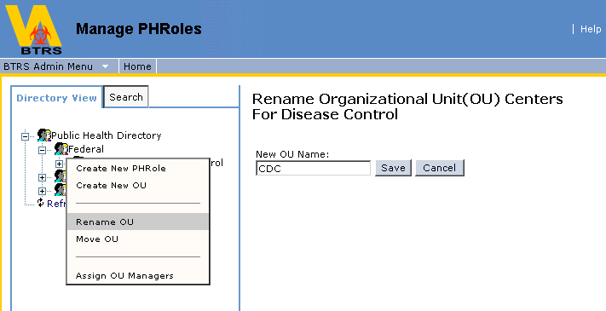

Move an OU (and all of its contents)

1. Locate the Organizational Unit (OU) that you would like to move.
2. Right-click on the OU and select Move OU.
3. A second directory will open titled Choose An OU. Select the OU you wish to move your selected OU into by clicking on it.
4. The OU you wish to move your selected OU into should be listed in the Currently Selected OU box.
5. Click Save.
6. You will be asked to confirm that you want to move the OU you selected. Click Ok.
7. You will receive a confirmation that the OU was successfully moved. Click Ok to refresh your view and reflect the change, or you can continue working without refreshing your view. See Supplementary Information.

Note: When an OU is moved to a different location, the manager of the OU will be relocated with that OU, which may alter what that OU manager sees.
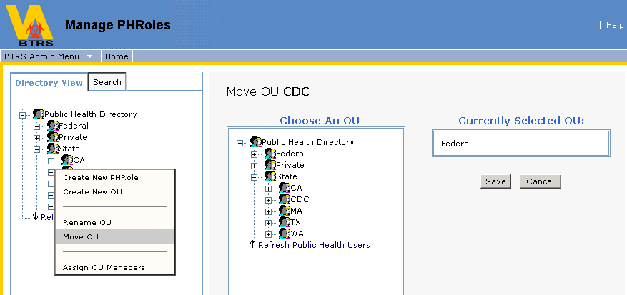

Move Several PHRoles to a Different OU

1. Locate the OU that you would like one or more PHRoles to be moved into.
2. Right-click on the name of the OU and select Move PHRoles to this OU.
3. The Public Health Directory will open again to allow you to select the PHRoles you want to move to the selected OU.
4. Select the PHRole(s) you wish to move by clicking the PHRole name, which will add them to the PHRoles to move to box.
5. When you've selected all of the PHRoles you wish to move, click Move.
6. You will be asked to confirm that you wish to move the selected PHRoles. Click Ok.
7. Your confirmation will give you the names of all PHRoles assigned to the selected OU. Click Ok to refresh your view and reflect the change, or you can continue working without refreshing your view. See Supplementary Information.
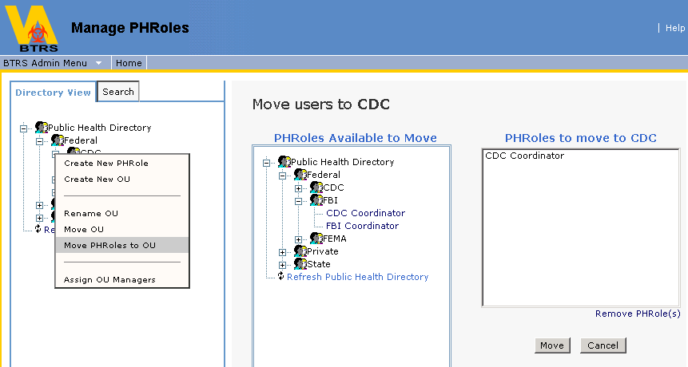

Assign Manager(s) to an OU
The BTRS Admin has the ability to assign one or several managers to an OU in the Public Health Directory.

Note: You can assign any user within the Public Health Users Directory to manage one of your OUs

Note: Any users assigned as an OU manager will automatically be assigned to the BTRS Admin Portal Permission Group

1. Locate the OU in which you would like to assign a manager.
2. Right-click on the name of the OU and select Assign OU Managers.

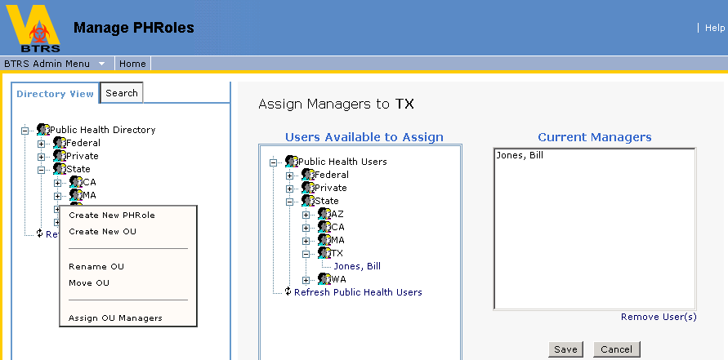

3. The Public Health Users Directory will open. Click on any user names in the directory to add them to the Current Managers box.
4. When all users to be assigned as an OU Manager have been selected, click Save.
5. You will be prompted to confirm your decision to assign the users to manage the selected OU. Click OK.
6. You will receive a confirmation that the users you selected were assigned as managers of the OU you selected. Click OK to refresh your view and reflect the change, or you can continue working without refreshing your view. See Supplementary Information.

Assign Alertable PHRoles

Note: You will only be able to assign the PHRoles that you manage as alertable

1. Locate the PHRole within the Public Health Directory to which you would like to assign Alertable PHRoles.
2. Right-click on the PHRole and select Assign Alertable PHRoles. This will open a second directory of the PHRoles that you manage, which will allow you to pick the PHRoles that can be notified.
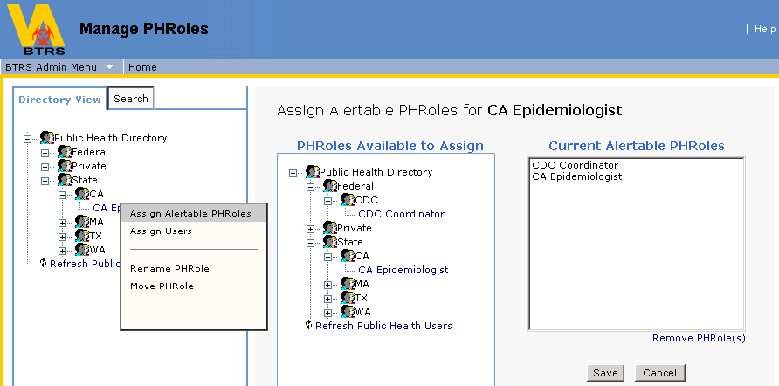
3. Select (by clicking on the PHRole) the PHRoles that you would like the PHRole you are working with to be able to send alerts to. This will add them to the Current Alertable PHRoles box.
4. Should you need to remove a PHRole from the Alertable PHRoles, simply select it by clicking on it in the Current Alertable PHRoles box and click Remove PHRole(s).
5. When you have defined all needed Alertable PHRoles, click Save. You will be prompted for a confirmation of your choices. Click OK.
6. You will receive a confirmation of the change. Click OK to refresh your view and reflect the change, or you can continue working without refreshing your view. See Supplementary Information.

Assign Users to PHRoles
The BTRS Admin has the ability to assign one or several users to any PHRole in the Public Health Directory.

Note: You will only be able to assign users that you manage within the Public Health Users Directory to PHRoles

1. Locate the PHRole within the Public Health Directory to which you would like to assign users.
2. Right-click on the PHRole and select Assign Users. This will open a second directory (Users Available to Assign) with all users that you manage, which will allow you to pick users and assign them to the PHRole.
3. Click on any user names in the directory to add them to the Current Members box.
4. When all users to be assigned to the PHRole have been selected, click Save.
5. You will be prompted to confirm your decision to assign the users to the PHRole. Click Ok.
6. You will then receive a confirmation that the users you selected were assigned to the PHRole you selected. Click Ok to refresh your view and reflect the change, or you can continue working without refreshing your view. See Supplementary Information.

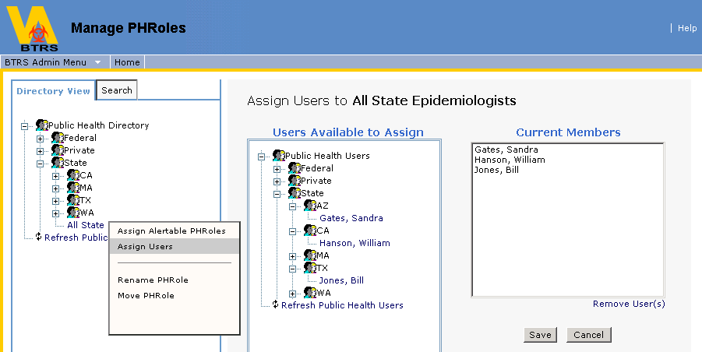

Rename a PHRole
1. Locate the PHRole that you would like to rename.
2. Right-click on the PHRole and select Rename PHRole.
3. Enter the new PHRole name in the New PHRole Name box.
4. Click Save.
5. You will be asked to confirm that you want to rename the PHRole you selected. Click Ok.
6. You will receive a confirmation that the PHRole was successfully renamed. Click Ok to refresh your view and reflect the change, or you can continue working without refreshing your view. See Supplementary Information.

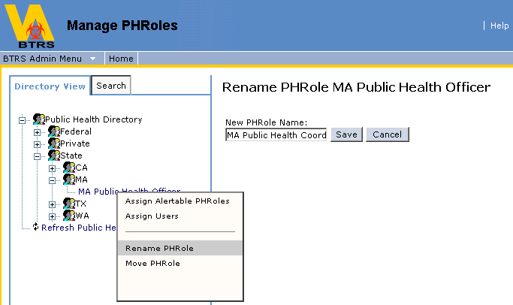

Move a Single PHRole to a Different OU

1. Locate the PHRole that you would like to move.
2. Right-click on the PHRole and select Move PHRole.
3. The Public Health Directory will open again to allow you to select the OU that you wish to move the PHRole to.
4. Select the OU that you wish to move your selected PHRole to by clicking on it. This will add it to the Currently Selected OU box.
5. Click Save.
6. You will be asked to confirm that you want to move the PHRole you've selected to the OU you've selected. Click Ok.
7. You will receive a confirmation that the PHRole was successfully moved. Click Ok to refresh your view and reflect the change, or you can continue working without refreshing your view. See Supplementary Information.

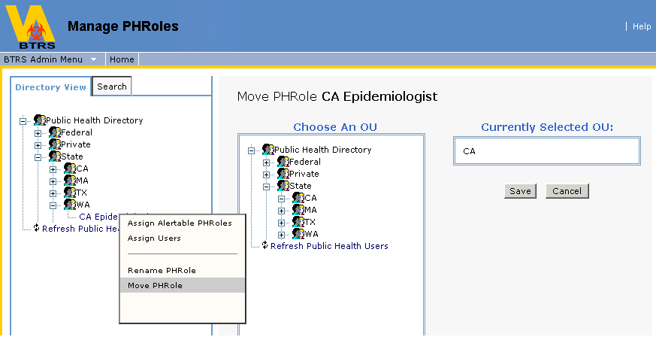

View PHRole Members and Corresponding Alertable PHRoles

1. On the navigation bar of the dashboard site, click BTRS Admin.
2. On the BTRS Admin dashboard, click Manage PHRoles.
3. Left click on Organizational Units (OUs) to expand their contents until you locate the PHRole you would like to view.
4. Click on the PHRole name to view its members and corresponding Alertable PHRoles.
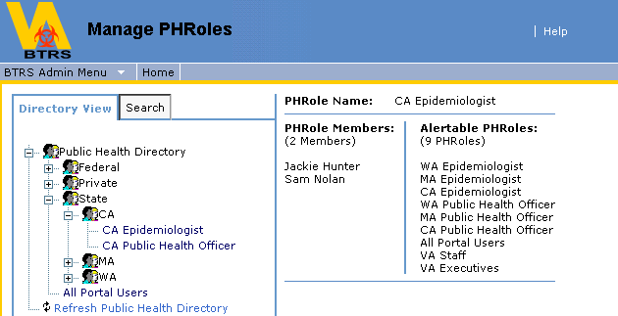

Use the Search Tab to Locate an Individual PHRole

As your Public Health Directory develops in size, it may be simpler to modify a PHRole's properties by using the Search tab.

Note: You will only be able to locate PHRoles that reside in OUs that you manage

1. Click on the Search tab.
2. Type the name of the PHRole in the Find PHRole box and click go. If you are unsure of how to spell the PHRole name, type at least the first letter, or a known string of letters in that PHRole name.
3. If the PHRole exists within the Public Health Directory and you manage it, the PHRole name will appear below the Find PHRole box.

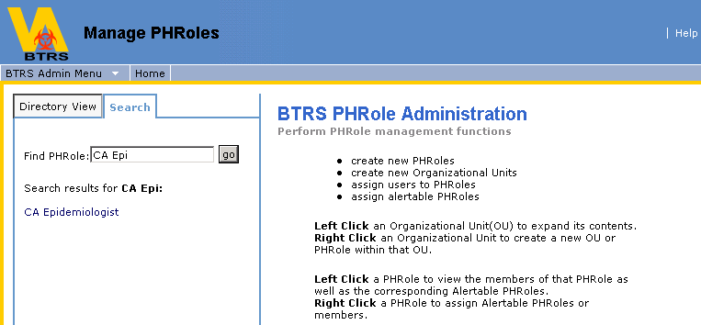

4. If the PHRole's properties need to be modified, right-click on the PHRole name that the search produced and you will be given all of the options to edit that PHRole's properties.
5. Left-click on the name of the PHRole to only view their properties.
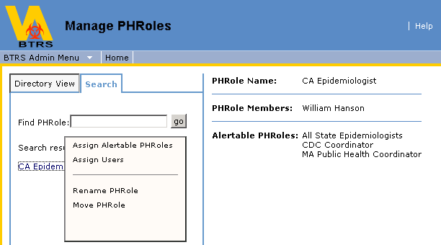

Using Manage Portal Permission Groups

BTRS Admins have the ability to create, delete, view members of and assign user to Portal Permission Groups.

Create a New Portal Permission Group

1. On the navigation bar of the dashboard site, click BTRS Admin.
2. On the BTRS Admin dashboard, click Manage Portal Permission Groups. This will take you to the Manage Portal Permission Groups page.
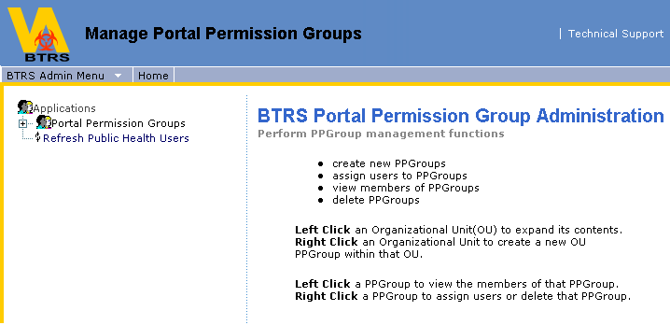
3. Locate the OU with the name of your workspace.
4. Right-click on the workspace OU and select Create New PPGroup.
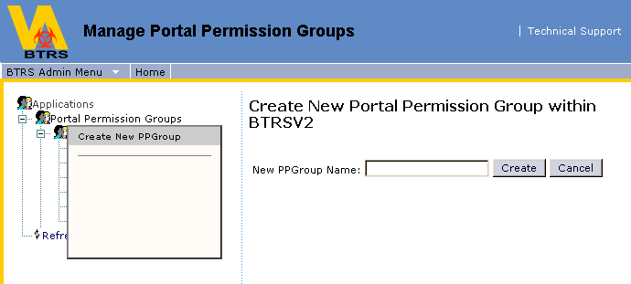

5. Type the name of the new Portal Permission Group in the New PPGroup Name box.
6. Click Create.
7. You will then receive a confirmation that the Portal Permission Group has been created. Click OK to refresh your view and reflect the change, or you can continue working without refreshing your view. See Supplementary Information.

Assign Users to a Portal Permission Group

Note: You will only be able to assign users that you manage within the Public Health Users Directory to Portal Permission Groups

1. On the navigation bar of the dashboard site, click BTRS Admin.
2. On the BTRS Admin dashboard, click Manage Portal Permission Groups. This will take you to the Manage Portal Permission Groups page.
3. Locate the Portal Permission Group you would like to assign users to within the tree structure.
4. Right click on the Portal Permission Group and select Assign Users.
5. A second directory tree with all available users will become available.
6. Click on the user names to add them to the Current Members box.

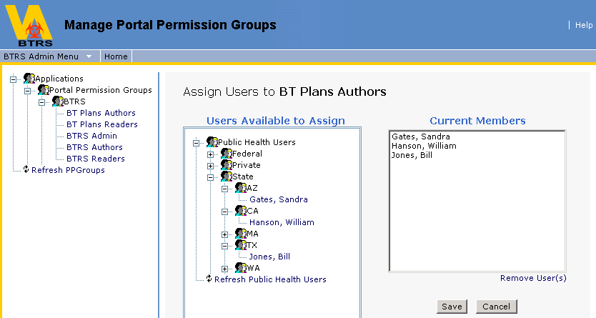

7. When you've added all users to the Portal Permission Group, click Save.
8. You will be asked to confirm that you want to add the users to the PPGroup. Click OK.
9. You will receive a confirmation that the users have been added to the Portal Permission Group. Click OK to refresh your view and reflect the change, or you can continue working without refreshing your view. See Supplementary Information.

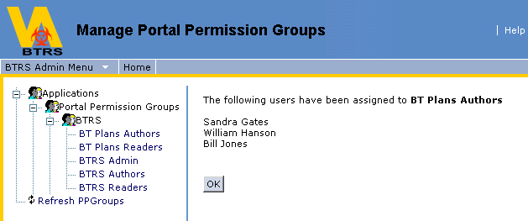

Delete a Portal Permission Group

1. On the navigation bar of the dashboard site, click BTRS Admin.
2. On the BTRS Admin dashboard, click Manage Portal Permission Groups. This will take you to the Manage Portal Permission Groups page.
3. Locate the Portal Permission Group you would like to delete within the tree structure.
4. Right click on the Portal Permission Group and click Delete PPGroup.
5. You will be prompted to confirm your decision to delete the Portal Permission Group. Click OK.
6. You will receive a confirmation that the selected Portal Permission Group has been deleted. Click OK to refresh your view and reflect the change, or you can continue working without refreshing your view. See Supplementary Information.

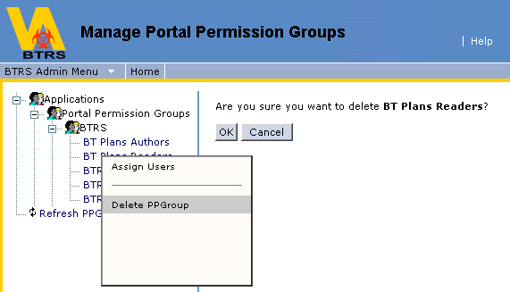

View the Members of a Portal Permission Group

1. On the navigation bar of the dashboard site, click BTRS Admin.
2. On the BTRS Admin dashboard, click Manage Portal Permission Groups. This will take you to the Manage Portal Permission Groups page.
3. Click on the name of the Portal Permission Group whose members you would like to view. A list of all members of the Portal Permission Group you chose will be listed.
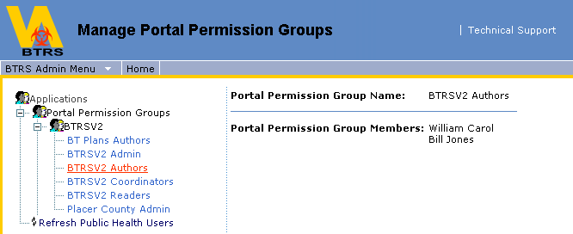

Using Basic User Report
BTRS Admins have the ability to generate a report of profile information for all of the users that they manage.

Generate a Basic User Report
1. On the navigation bar of the dashboard site, click BTRS Admin.
2. On the BTRS Admin dashboard, click Basic User Report.
3. Select the fields you would like to view for the users that you manage by clicking in the checkbox next to each field.
4. To select all fields in any given section, click the Select All link in the section header.
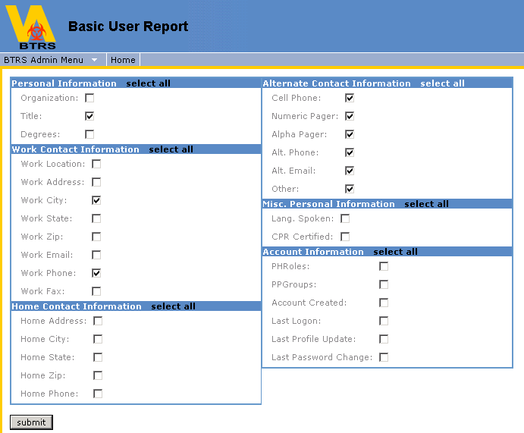
5. Once you've selected your criteria, click Submit.
6. A report will be generated fulfilling your search criteria.
7. To run a new/different report, click the New icon at the top of your report.
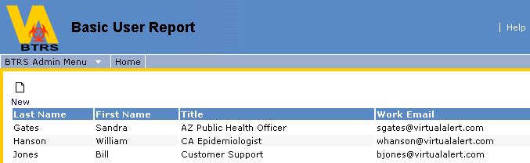

Using Alert History Log

The BTRS Admin has the permissions to generate an Alert History Log based on search criteria.

Generate an Alert History Log

1. On the navigation bar of the dashboard site, click BTRS Admin.
2. On the BTRS Admin dashboard, click Alert History Log.
3. Within the Alert History Log web part, enter your search criteria.
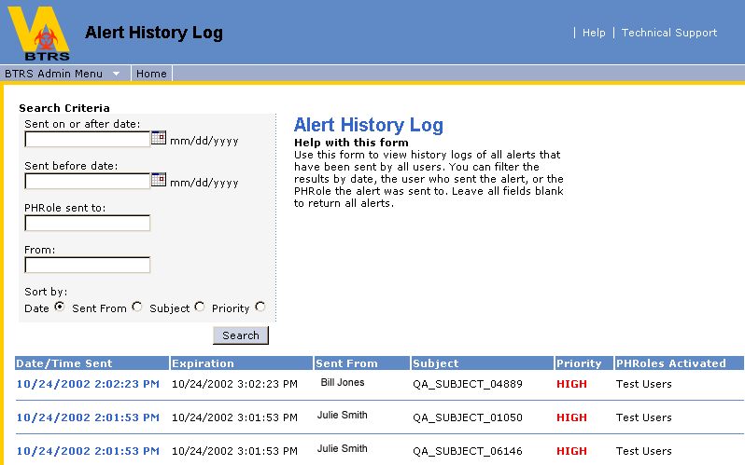

a) Sent on or after date (You can use the automatic date selector, or put the date in manually in the mm/dd/yyyy format).
b) Sent before date (You can use the automatic date selector, or put the date in manually in the mm/dd/yyyy format).
c) PHRole Sent To (You can enter a specific role, or leave the field blank to include all PHRoles in the PHD).
d) From (You can enter a specific user name, or leave the field blank to include all users).
e) Sort by (You can sort results by Date, Sent From, Subject or Priority).

4. Click Search.

Results will appear below the search button. The log provided will include:

a) The Date/Time the alert was sent
b) The date and time the alert expires
c) Who the alert was sent from
d) The subject of the alert
e) The priority of the alert
f) The PHRoles activated in the alert

Using Fax History Log
The BTRS Admin has the permissions to generate a Fax History Log based on search criteria.

Generate a Fax History Log

1. On the navigation bar of the dashboard site, click BTRS Admin.
2. On the BTRS Admin dashboard, click Fax History Log.
3. Within the Fax History Log web part, enter your search criteria.
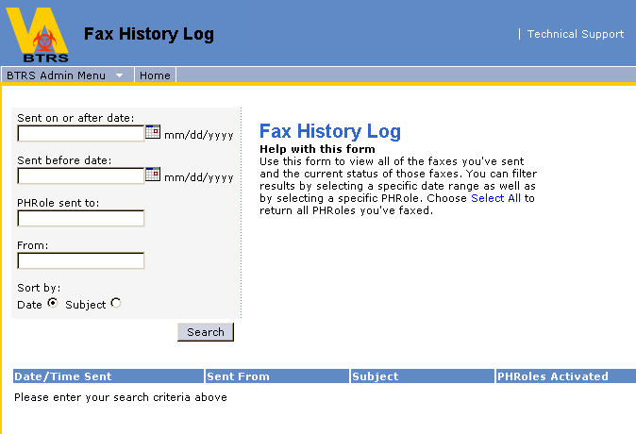

a) Sent on or after date (You can use the automatic date selector, or put the date in manually in the mm/dd/yyyy format).
b) Sent before date (You can use the automatic date selector, or put the date in manually in the mm/dd/yyyy format).
c) PHRole Sent To (You can enter a specific role, or leave the field blank to include all PHRoles in the PHD).
d) From (You can enter a specific user name, or leave the field blank to include all users).
e) Sort by (Date or subject)

4. Click Search.

Results will appear below the search button. The log provided will include:

a) The Date/Time the fax was sent
b) Who the fax was sent from
c) The subject of the fax
d) The PHRoles activated

Using Alert Confirmation Reports

A BTRS Admin has the ability to generate alert confirmation reports, using a search criteria. This report can be sorted by alert (date alert was sent) or by user (who alerts were sent to). The purposes of these sort options are:
- Sort by alert: To view who has and has not confirmed any given alert. Results displayed according to the date and time the alert was sent. (See example below)
- Sort by user: To view which alerts a given user has or has not confirmed. Results displayed alphabetically according to users’ first names. (See example below)

Generate an Alert Confirmation Report

1. On the navigation bar of the dashboard site, click BTRS Admin.
2. On the BTRS Admin dashboard, click on Alert Confirmation Reports.
3. Determine your search criteria
a) Sent on or after date (You can use the automatic date selector, or put the date in manually in the mm/dd/yyyy format).
b) Sent before date (You can use the automatic date selector, or put the date in manually in the mm/dd/yyyy format).
c) Sort by (Alert or User)
4. When your search criteria has been determined, click Search.
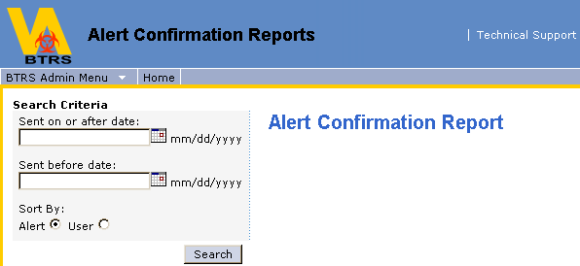

Sample of Alert Confirmation Report Sorted by Alert
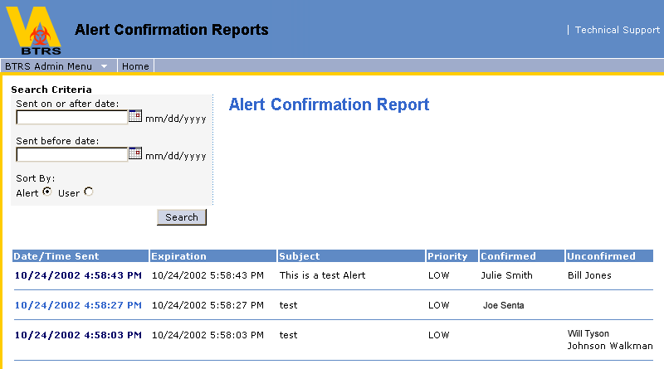

Sample of Alert Confirmation Report Sorted by User
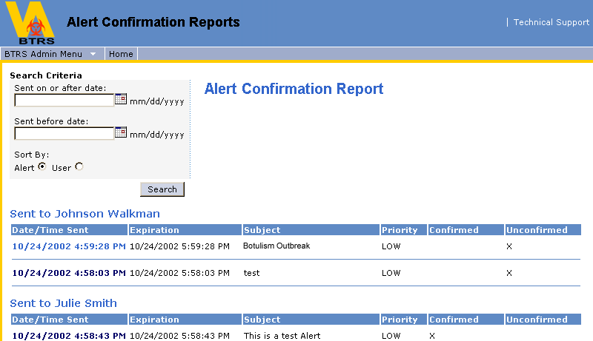

Using Folder Permission Reports

A BTRS Admin has the ability to generate folder permission reports, showing which PHRoles or Portal Permission Groups are assigned to any specified folder as a Reader, Author, Admin or Approver.

Generate a Folder Permission Report

1. On the navigation bar of the dashboard site, click BTRS Admin.
2. On the BTRS Admin dashboard, click Folder Permission Reports.
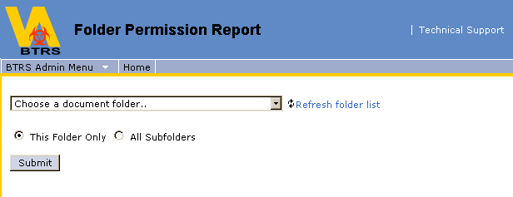

3. Select the folder whose permission you would like to see from the Choose a document folder drop-down menu.
4. Select This Folder Only or All Subfolders according to your reporting needs, and click Submit.
5. A report of all permissions on the folder(s) you've selected will then be generated.
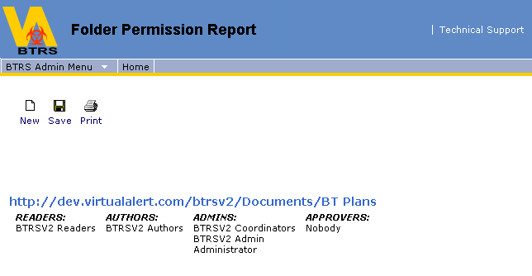

6. In addition to the report information, you are given the option of either New, Save or Print.

- Clicking New will return you to the option of selecting another folder for a report
- Clicking Save will give you the option to save the report (in html format) to a location that you choose
- Clicking Print will open your print properties box & allow you to print the report you've generated

Using Documents Checked Out Log

A BTRS Admin has the ability to generate a log of all documents that are checked out on the portal, including the document title, the folder where it resides, who checked out the document and the date it was checked out.

Generate a Documents Checked Out Log

1. On the navigation bar of the dashboard site, click BTRS Admin.
2. On the BTRS Admin dashboard, click Documents Checked Out Log.
3. A log of all documents checked out will be generated.

- Clicking on the document title will take you to the Document Inspection (Show Actions) page for the document, where as a BTRS Admin, you can click Undo Check Out if necessary, which will check the document back in without any changes the user who checked the document out may have made.
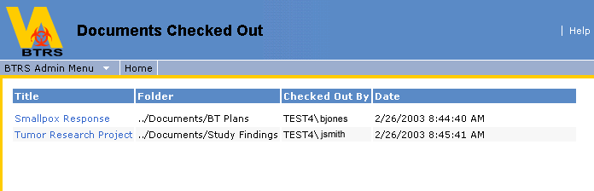

Using Document Documents Awaiting Approval Log

A BTRS Admin has the ability to generate a log of all documents that are awaiting approval. This log displays a link to the "Show Actions" page of the document, the folder the document is residing in, whom the document is awaiting approval from (to clarify, if one or several approvers have already approved the document, their names will not be displayed. The log will display any users who still need to approve the document), the date and time the document was submitted for approval as well as the options to override the approval or cancel the publishing.

Generate a Documents Awaiting Approval Log
1. On the navigation bar of the dashboard site, click BTRS Admin.
2. On the BTRS Admin dashboard, click Documents Awaiting Approval Log.
3. A log of all documents awaiting approval will be generated.

- Clicking on the document title will take you to the Document Inspection (Show Actions) page for that document
- Clicking the Override Approval button will end the approval process and automatically publish the document
- Clicking the Cancel Publishing button will end the approval process and place the document back to a checked in state

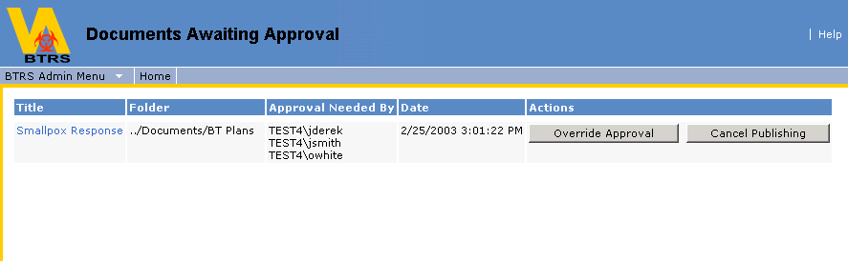

Using Document History Report

A BTRS Admin has the ability to generate a report of the version histories of the documents in any given folder and subfolders.

Generate a Document History Report

1. On the navigation bar of the dashboard site, click BTRS Admin.
2. On the BTRS Admin dashboard, click Document History Report.
3. From the drop-down menu, select the folder that you would like to generate a document history report for.
4. If you would only like a report on the documents of a specific folder, be sure the This Folder Only radio button is selected.
5. If you would like a report to include all subfolders, be sure the All Subfolders radio button is selected.
6. Click Submit. The report will be generated.

Note: If you would like a report for the entire Document Library, select the ../Documents folder from the drop-down menu and then select the All Subfolders radio button.

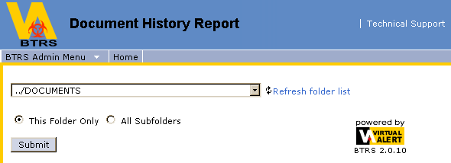

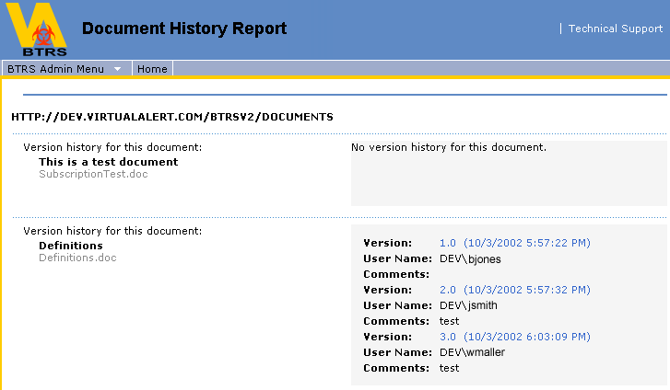

Using Document Totals Log

A BTRS Admin has the ability to generate a document totals log. This log displays the number of documents in each folder of the Document Library, the number of documents assigned to each category and the number of documents published according to the user who most recently published them. The log can be filtered by one or all of the stated options.

Generate a Document Totals Log

1. On the navigation bar of the dashboard site, click BTRS Admin.
2. On the BTRS Admin dashboard, click Document Totals Log.
3. All three log-sorting criteria will be selected. If you wish to filter by only specific criteria, uncheck the items you do not wish to view.
4. Click View. The log will be generated.
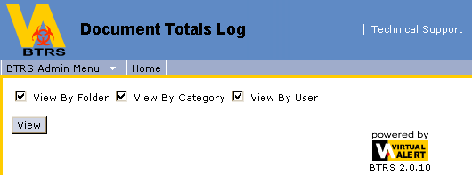
5. In addition to the log information, you are given the option of either New, Save or Print.

- Clicking New will return you to the sort criteria options to run another report
- Clicking Save will give you the option to save the report (in html format) to a location that you choose
- Clicking Print will open your print properties box & allow you to print the report you've generated

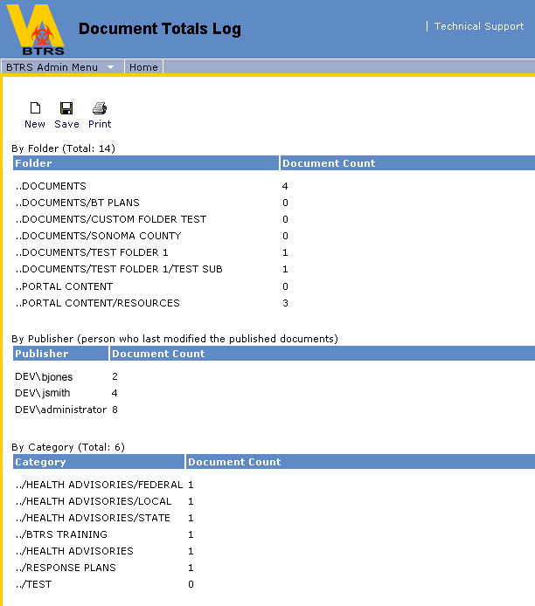

Using Modified Content Report

A BTRS Admin has the ability to generate a report based on a search criteria of all documents within the Document Library that have been modified, including their title, which folder they reside in, who modified them, and the date they were modified.

Generate a Modified Content Report

1. On the navigation bar of the dashboard site, click BTRS Admin.
2. On the BTRS Admin dashboard, click Modified Content Report. This will open the Modified Content Report dashboard, where a search criteria can be established.
3. Select the folder you wish to generate the report for from the Choose a document folder drop-down menu (if you would like a report on the entire Document Library, select the ../Documents folder). Selecting any given folder will return results for that folder and any of its subfolders.
4. Determine your search criteria:

a) Documents published after (You can use the automatic date selector, or put the date in manually in the mm/dd/yyyy format).
b) Documents published before (You can use the automatic date selector, or put the date in manually in the mm/dd/yyyy format).
c) Sort by (You can sort results by Folder, Author or Date Modified).

5. Click Submit. Your report will be generated according to your specified search criteria.

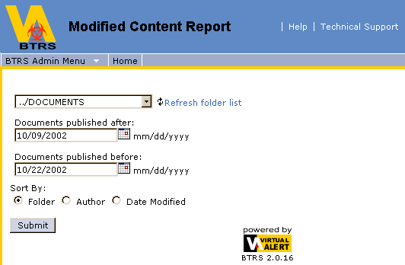

6. In addition to the report information, you are given the option of either New, Save or Print.

- Clicking New will return you to the option of selecting another folder for a report
- Clicking Save will give you the option to save the report (in html format) to a location that you choose
- Clicking Print will open your print properties box & allow you to print the report you've generated

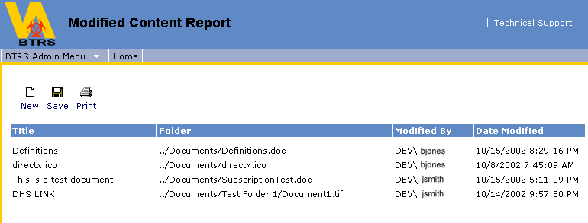

Managing Home Page Content

Adding News or Announcements

News and Announcements are stored in standard folders, which means as soon as something is put in that folder, it appears on the portal. To add a News or Announcement item to the portal:

1. Click on the Document Library link in the main navigation bar.
2. Within the Document Library is a folder called Portal Content. Within Portal Content you will see the folders for News, Announcements and Quick Links.
3. Open the News or Announcements folder (whichever you wish to post content to).
4. Once in the folder you chose, click Add Document. You will then be prompted to browse for the file name.

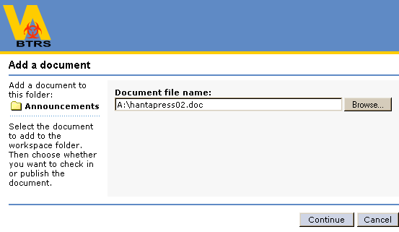
5. Browse to where the file you wish to upload is located and click Open. That will load the document in the Document File Name box. Click Continue. This will open the Document Profile.
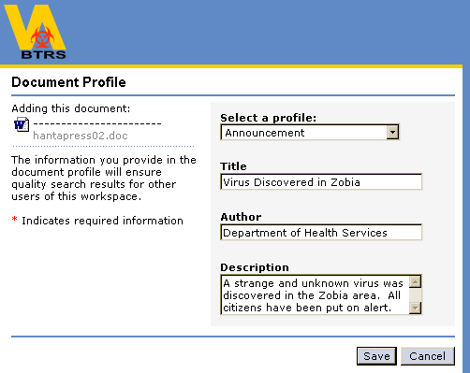

6. Fill in all fields of the Document Profile and click Save. The news or announcement item will then show up at the top of the News or Announcements Web Part on the Home Page.
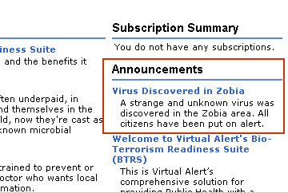

Adding Quick Links
1. Create a document and save it with a name that describes the link you want to add. You do not need to add any text to the document.
2. Click on the Document Library link in the main navigation bar.
3. Within the Document Library is a folder called Portal Content. Within Portal Content you will see the folders for News, Announcements and Quick Links.
4. Open the Quick Links folder.
5. Once in the folder, click Add Document. You will then be prompted to browse for the file name.

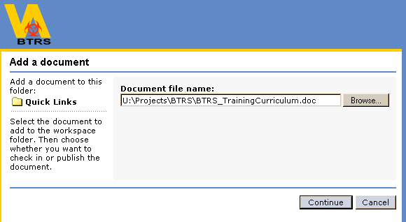

5. Browse to where the file you created is located and click Open. That will load the document in the Document File Name box. Click Continue. This will open the Document Profile.
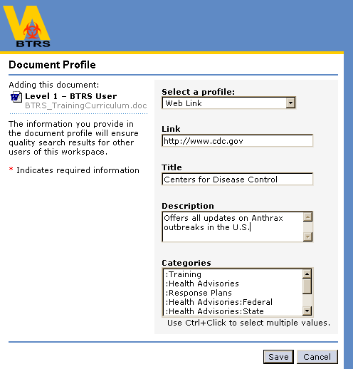

6. Fill in all fields of the Document Profile and click Save. The new Quick Link will then show up at the top of the Quick Links Web Part on the Home Page. The description you entered in the Document Profile will appear when you mouse over the link.

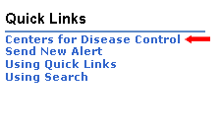

Help

About Help

Much of the information referenced in this guide has been taken from the online help within the BTRS portal. If you are working on BTRS and find you need assistance, there will always be a link in the top right hand corner called Help. Whatever you are working on at the time, the Help button will offer guidance and instructions specific to that area, as well as links to further information on other topics.

The help function is a very valuable resource of BTRS. It is highly recommended that each user review the online help before beginning work on the portal so that they may become familiar with terms and functionality of the main application and its features before attempting to work with it.

Glossary

A
Active Public Health Alerts
Alerts that have been sent and have not yet expired from their duration setting.

Alert
A notification sent to inform or warn PHRoles within the Public Health Directory.

Alert Details
All details of an alert that has been sent, including: who sent the alert, the subject of the alert, the message of the alert, the priority of the alert, the time the alert was sent, when the alert expires and the PHRoles that the alert notified.

Alertable PHRoles
An Alertable PHRole is a PHRole that has been configured to receive alerts. Users can be members of Alertable PHRoles, which means they would be a member of a PHRole that can receive an alert. PHRoles can also be assigned Alertable PHRoles, which will be the PHRoles that they are able to send alerts to.

Author
A user who has permission to add, edit, delete, or read all documents in a folder. Authors can also create, rename, and delete folders, but cannot set the security policy on a folder. In an enhanced folder, Authors can also submit any document for publishing.

B
Best Bet
A document property that designates a document as highly relevant to a specific category or keyword search.

BTRS Admin
A user who has the broader permissions to manage portal content, portal settings, groups and users. Additionally, the BTRS admin has the ability to generate & view various administrative reports and logs.

BTRS System Administrator
A user who has permission to set up, configure, and maintain servers, manage server resources, create and update indexes, and control security at the top level of the workspace.

C
Categories
Groups of related content, organized hierarchically by subject matter.

Category Folder
A folder that is used by coordinators to organize categories.

Check-In
Add or return a document to an enhanced folder. Releases the editing reservation on a document, allowing others to open and edit it.
See also: check-out, enhanced folder, check-in form
Check-In Form
In the user interface, a form appearing when a user checks in a document. It contains check-in comments, an option to publish a document, and a drop-down menu for selecting a document profile.

Check-Out
Create a writable version of a document while preventing other users from editing the same document.
See also: check-in, enhanced folder
Content Source
The starting point for crawling a file system, database, or Web site in order to include content in an index.
See also: build, crawl

D
Dashboard
See definition for: digital dashboard

Dashboard Site
A Web site created by using Digital Dashboard technology. The dashboard site contains a number of pages, or dashboards, and includes customization pages and custom Web Part forms. The dashboard site is used to distribute information to workspace users through a Web browser.
See also: digital dashboard, Web Part
DASL
See definition for: Distributed Authoring Search and Location (DASL)
DAV
See definition for: Distributed Authoring and Versioning

Default Version
The version selected when a particular version is not specified.

Demote
To copy the property values found in a BTRS document profile to the properties of a Microsoft Office document. For example, the Author name entered in the Author property on the document profile is copied to the Author field on a Word document's properties page.
See also: promote
Depth
A measure of folder enumeration depth, such as how many links to follow from the content source.
See also: scope
Dictionary
A defined list of values referenced by a property.

Digital Dashboard
A page on a dashboard site. Each dashboard contains a collection of Web Parts in a modular view that can be presented to users in a Web browser.
See also: dashboard site, Web Part
Discussions
A feature for adding threaded remarks about a document.

Distributed Authoring and Versioning (DAV)
An extension to the HTTP protocol, DAV enables a client to perform file-system type operations on a remote server, opening the door for creating Web-based document management applications.

Distributed Authoring Search and Location (DASL)
Defines the SEARCH operation implemented in DAV. The body of the SEARCH method contains the request or criteria for the search.

Document
A discrete unit of content and its associated metadata.
See also: file
Document Library
The storage location for documents in the workspace.
See also: documents folder
Document Profile
A set of properties applied to similar documents.

Documents Folder
A folder that is used to store documents in the workspace.

E
Enhanced Folder
A document storage folder that supports document management tasks such as check-in, check-out, versioning, approval, and publishing.

Exclusion Rules
See definition for: inclusion/exclusion rules

F
Folder
A means of organizing and storing programs, files, and documents on a disk or server.

Folder Tree
A hierarchical display of folder organization.

Full-Text Index
A resource that is compiled by the Index engine to enable full-text search of documents, document properties, and content stored outside the workspace but made available through content sources. The full-text index contains all text content and properties retrieved from the document through indexing filters (IFilters).
See also: full-text search

Full-Text Search
Search of documents, document properties, and content through the use of full-text search predicates.
See also: search

G
There are no glossary terms that begin with this letter.

H
There are no glossary terms that begin with this letter.

I
Index
See definition for: full-text index.
See also: search

J
There are no glossary terms that begin with this letter.

K
Keywords
A list that represents terms a user might enter in a search form. These terms can be organized into optional hierarchies to help organize them more effectively.

L
There are no glossary terms that begin with this letter.

M
Management Folder
A folder that contains the tools for managing document profiles, search resources, and workspace settings.

Metadata
The properties associated with a document. Metadata can be system-defined, such as file size or modified date, or user-defined, such as Author or title.

Multi-Valued
A property that can hold more than one value.
See also: property value

N
Namespace
A prefix applied to URIs, URNs, and XML entities to prevent naming conflicts.

O
OLE/DB
See definition for: Object Linking and Embedding Data Base

Object Linking and Embedding Data Base (OLE/DB)
A set of OLE interfaces that provide applications with uniform access to data stored in diverse information sources. These interfaces support the amount of DBMS functionality appropriate to the data source, enabling it to share its data.

Organizational Unit
A container that holds objects. Typically, an organization will create Organizational Units that resemble their organizational structure, having an OU for each department.

P
Permission(s)
Authorizations within the portal, which determine access to documents/sections in the workspace. The three standard permissions are: Reader, Author and BTRS Admin.

PHRoles (Alerting)
A position within an Organizational Unit that is able to be notified. A PHRole can have more than one person assigned to it.

Policy, Folder Policy
Restrictions placed on a folder or other object that limit access to it, or that limit operations that can be performed on the object.

Profile (Portal)
Information about individual documents that are uploaded into BTRS. The profile information is attached to the corresponding documents and aids in searches.

My Profile (Alerting)
Information about individual users that can be updated by those users.

Promote
To copy the property values found in a Microsoft Office document to the properties of a BTRS document profile. For example, the Author name entered in the Author field of a Word document's properties page is copied to the Author property on the document profile.
See also: demote
Property
An element of metadata for a document profile. Each document profile has multiple properties. Properties can be system-defined, such as file size or creation date, or can be user-defined, such as title or keywords.
See also: metadata
Property Definition
The scope and behavior for a single element of metadata that can be applied to a resource. It can have an allowed list of values (a dictionary) that is restrictive or unrestrictive for the setting of the value. It can be either optional or required to contain data. All required property values must have a valid value assigned to them before they can be successfully submitted to the BTRS store. A property definition can also be specified as either single valued or multi valued, and simple ranges can be set for validity checking.
See also: metadata, property
Property Store
Table of properties and their values used and maintained by the Search service. Each row in the table corresponds to a document in the full-text index.

Property Value
The value of a single element of metadata that has been applied to a resource. It can be either single valued or multi valued.
See also: resource, single valued, multi valued
Property Weighting
The ability to manipulate the rank of a search result by assigning more importance to particular property values. For example, a file that matches a search term in the title might rank higher than a file that matches the search term only in the text.
See also: rank coercion
Public Health Directory
A collection of Organizational Units and PHRoles within those units.
Publish
To make a document available to Readers.
See also: approve

Q
There are no glossary terms that begin with this letter.

R
Rank
The relevance of a file to a search query.

Rank Coercion
The ability to rank a file at the top of search results for a given search query.
See also: property weighting
Reader
A user who can search for and read documents but cannot add them to the workspace. By default, all folder users have Reader permissions. In an enhanced folder, Readers can only view folders and published versions of documents. A Reader cannot check-out, edit, or delete workspace documents and cannot view draft document versions.

Resource
Data, metadata, a collection of data, or a collection of metadata accessed as a content item. Examples: a document, a database table, a content class.

S
Schema
The configuration of stored metadata. Schema also refers to a particular language for describing the nature and particulars of the structure of stored metadata.

Scope
The range and depth of a search on the dashboard site. For example, when searching for the term fiscal reports, you can narrow the scope of your search to a particular category such as Earnings.
See also: depth

Search
The functionality of finding information in documents based on keywords found in the text of those documents or related to the properties of the documents. This is commonly referred to as full-text search. You must create full-text indexes to use full-text search.
See also: index
Single Valued
A property that can hold only one value.
See also: property value
Standard folders
Supports document profiles, but does not support check-in, check-out, publishing, or document version history
Stemming
A method of mapping a linguistic stem to all matching words. For example, in English, the stem buy matches bought, buying, and buys.
Subscription
A request for notification when changes are made to a document, the contents of a folder, a category, or a search results list.

T
There are no glossary terms that begin with this letter.

U
Undo Check-Out
Cancel the check-out of a document. Undoing a check-out returns the document to the state it was before the check-out.

Update
The process through which search crawls content and compiles an index of the content. Full updates include all content, incremental updates include only content that has changed. Adaptive updates include only content that is likely to have changed based on an analysis of historical information.

V
Version History
The (reverse) chronological listing of revisions that have been made to an item, and any associated comments attached to the version by the user performing the check-in or check-out.

Version Label
A number or other text that indicates the version of an item.

Vocabulary
All of the values associated with documents in a workspace. These may include property values, document profiles, categories, and other keywords.

W
Web Part
A customizable, reusable component used to display specific information on a dashboard. Web Parts are used to associate web-based content (such as XML, HTML, and scripting) with a specific set of properties in an organizational framework.
See also: dashboard site, digital dashboard, Web Part folder
Web Folder
Provides an interface for managing files on a remote Web server. Web folders provide document storage and publishing functionality.
See also: dashboard site, digital dashboard, document profile, Web Part
Web Storage System
A storage platform that provides a single repository for managing multiple types of unstructured information in one infrastructure. The Web Storage System combines the features and functionality of the file system, the Web, and a collaboration server (such as Microsoft Exchange Server) through a single, URL-addressable location for storing, accessing, and managing information, in addition to building and running applications. The Web Storage System is based on the technology that drives Exchange Server Information Store.

Word Breaking
A search technology used to separate text into individual words for implementing search queries.

Workspace
An organized collection of documents, content sources, management folders, categories, document profiles, subscriptions, and discussions. It provides a central location to organize, manage, and publish content.

X
There are no glossary terms that begin with this letter.

Y
There are no glossary terms that begin with this letter.

Z
There are no glossary terms that begin with this letter.

Supplementary Information

Part 1 - Levels of Licensing for BTRS

Full Access License
These users have full access to the functionality provided on the BTRS portal. This includes the ability to access information, publish and edit documents, subscribe to content, fax distribute documents, look up others in the Public Health Directory, and participate in discussions. Furthermore, they will be able to initiate alerts. They are able to maintain their own profiles through the portal and are able to receive alerts via any device that is addressable via SMTP messaging, via any telephone through voice alerts and through fax. Administrators can maintain the user profiles, PHRoles and permissions through the portal.

Limited License
Users can maintain their profiles through a web page. They are able to receive alerts via any device that is addressable via SMTP messaging, via any telephone through voice alerts and through fax. Administrators can maintain the user profiles and PHRoles through the portal.

Basic License
Administrators can maintain the user profiles and PHRoles through the portal. Users are able to receive alerts via any device that is addressable via SMTP messaging, via any telephone through voice alerts and through fax.

Part 2 - Office XP and Discussions

Currently, there is a conflict with Microsoft Office XP and Microsoft SharePoint discussions. This conflict can be resolved by following these steps on your computer (you will need to have administrative rights on your local computer to complete these tasks):

- Click the Start button, mouse over Settings and select Control Panel
- From the Control Panel, select Add/Remove Programs
- From the Add/Remove Programs section, select Change or Remove Programs
- Locate and highlight Microsoft Office XP and then click the Change/Remove button
- Select Add and Remove Features, then click Next
- Navigate down to the Office Tools button and expand it
- Locate Microsoft SharePoint Support, left click and select unavailable
- Select the Update button.
- Select Ok

Disclaimer: Always check with your system administrator before making system configurations. This is a recommended solution for the above issue ONLY. Virtual Alert claims no responsibility for the effects to your system that this change may cause.

Part 3 - Alternate System and Browser Compatibility

Macintosh - Does not use the MS DDSC component, so it cannot access most of the site's functionality. It can be used to confirm receipt of alerts and view documents. It cannot be used to participate in discussion threads, browse the user tree or the Public Health Directory. It also cannot send alerts. Using VPC (Virtual PC) with a supported Windows OS installed in that environment results in "standard" behavior and functions.
AOL - Browser display is not fully compliant with the java implementation required to have full site functionality.
Netscape - Browser does not display the site correctly, does not correctly render the graphics and does not provide full integration of site features.

Part 4 – View Refreshment Needs

If you are a BTRS Admin working within the Public Health Users Directory or the Public Health Directory, it is sometimes necessary to refresh your view of the directory tree while working (usually done by clicking OK when you receive a message that an action you’ve performed has been completed). See example below

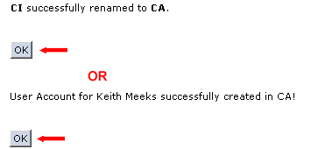

Although the action has actually taken place, you will not see the result in the directory tree until you refresh your view by clicking OK, clicking Refresh via your browser or visiting another page and then returning.

Examples of actions that may require a refresh of your view:

- When you want to work with a Portal Permission Group, OU, user or PHRole that you’ve just created, renamed or moved

Examples of actions that may not require an immediate refresh of your view:
- When you are creating several new OUs on the same or a higher level (refresh when you are ready to work within the new OUs)
- When you are creating or modifying the properties of several users (refresh when you are ready to work with new users)
- When you are creating or modifying the properties of several PHRoles (refresh when you are ready to work with new PHRoles)

Note: Deactivating a user does not remove them from the BTRS system, it only eliminates their ability to log in. Therefore, if you deactivate a user but do not refresh your view (which will remove them from your Public Health Users directory tree), then you will still be able to modify the properties of that user until you refresh your view or leave and return to the Manage Users page.

