 | Dukes County Emergency Management Agency  9 Airport Road, Edgartown, Ma.  RR1 Box 860  Vineyard Haven, MA 02539  Phone: 508-696-3811 Fax: 508-696-3841  email: emergencymanagement@dukescounty.org | 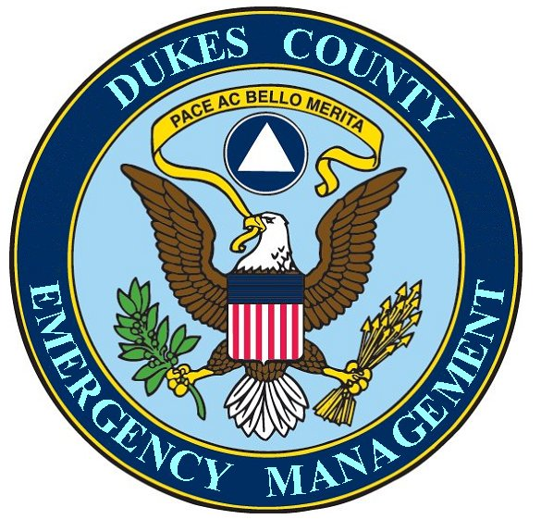
Chuck Cotnoir, Director |  | Dukes County  Emergency Management Team  www.  dukescounty.org/emteam

Mr. Timothy Walsh
Martha’s Vineyard Hospital
P.O. Box 1477, 1 Hospital Rd.
Oak Bluffs, Ma. 02557

Dear Mr Walsh,
I am enclosing a letter from Mr. Scott Kenfield (Massachusetts Department of Public Health) to me which asks that, during his Health & Homeland Alerting Network (HHAN) orientation visit to the County, that I also help him set up an introductory meeting with you and those members of your staff that are eligible for inclusion on the Health & Homeland Alerting Network, IAW the Mass Decontamination Unit (MDU) Activation system requirement for all Massachusetts hospitals.

I will be happy to arrange the scheduled times of his visits to the other Island departments to be scheduled around the time that your staff would be available for the HHAN meeting, as Mr. Kenfield believes that the Martha’s Vineyard Hospital staff’s inclusion on the HHAN is of the utmost importance.

I will call you to see if we can work out a time for you and your staff to meet with Mr Kenfield, if you feel that this would be helpful to your organization.

Thank You,

Chuck Cotnoir, Director
Dukes County Emergency Management

