` | Dukes County Emergency Management Agency  9 Airport Road, Edgartown, Ma.  RR1 Box 860  Vineyard Haven, MA 02539  Phone: 508-696-3811 Fax: 508-696-3841  email: emergencymanagement@dukescounty.org | 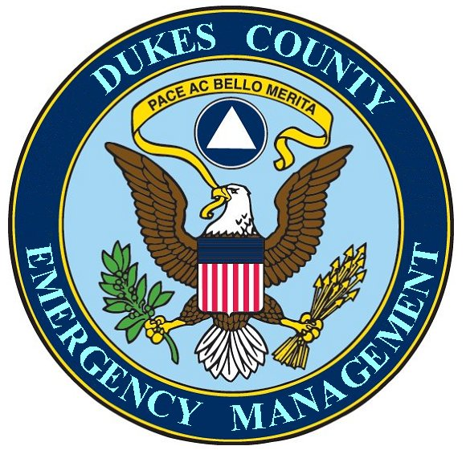
Chuck Cotnoir, Director |  | Dukes County  Emergency Management Agency

February 25, 2007

Mr. Duncan Ross
Chairman, Oak Bluffs Selectmen
Oak Bluffs, Ma. 02557

Dear Chairman Ross

I would personally like to thank you for stepping up to convene a meeting of the Island Chairmen of Selectpersons, the MV Hospital, the Wampanoag Tribe, and Dukes County on the matter of Island Pandemic Preparedness. Your conclusions, along with those of Mike Dutton, were very succinct and understanding of the Pandemic challenges that we face and were, I believe, greatly appreciated by the majority of the group.

I can’t tell you how relieved I am that we are finally going forward on a political level with the actual leaders of the Island. I am relieved because I believe that, without this effort on the part of our political leaders, the efforts to combat an Island-wide pandemic, would be doomed to fail. I believe this because if our policy makers and other political leaders are unaware of the entire ranges of the very serious risks that a Pandemic presents to all sectors of our Island infrastructure, resource allocation and monetary support and political support will not be forthcoming.
Further, Communication and coordinating actions between the towns will not be possible because Inter-town Pandemic Mitigation and Response plans will not have not been made beforehand.
And lastly, if proper Island-wide policy-making for preparation and planning is not begun by the Leadership, I believe that only a very fragmented response to Pandemic planning and response is possible. Accordingly, the Island-wide Pandemic response will be fragmented not only by town but also by disciplines within each town. Also, the response by our Island non-municipal and private sector infrastructure will not be coordinated with any town efforts. Therefore, this will mean that the spread of the disease through our community will be much faster and involve a much higher rate of sickness and death, to be dealt with by the Island Leadership.

The CDC and others have been strongly advocating a political leadership involvement to confronting the risks that a Pandemic would cause to the local communities [In our case, the risks to Island citizenry [currently estimated at twenty thousand persons (20,000)], ….and to Island Municipal Government Infrastructures (First Responders, Emergency Management, Health Departments, Water Departments, sewage treatment, town revenue collection and disbursement, Payroll, Employees, etc.), ….and to the non-municipal and private sector infrastructure (public transportation, banking, utilities, communications, fuels {heating/ & First Responder transportation fuels})].

Letter to Duncan Ross
February 25, 2007
Page 2

An important part of the involvement of the political leadership could be an initial and continuing education process for the Island Leadership, regarding the medical and non-medical risks that a Pandemic would present to the citizenry, Municipal Government Infrastructure and its Employees, and to the non-municipal and private sector infrastructure. It will be extremely important for the Island leaders to be briefed by qualified State and Federal agencies such as the Mass Department of Public Health, Mass Emergency Management Agency, the Mass Executive Office of Public Safety, OSHA, and the Department of Homeland Security/FEMA. These agencies can provide unbiased and professional solutions for the Island leaders, along with local Health and Emergency Management, to use to craft an Island-wide Pandemic Mitigation and Response Plan.

***

And lastly and most importantly to Oak Bluffs, it is appropriate for Oak Bluffs to begin this effort to convene the Island Leaders and to motivate those other leaders to work together to prepare an Island-wide plan for Pandemic Mitigation and Response.
If even a midlevel category 2 or 3 Pandemic should infect the Island, facilities in Oak Bluffs will be the focal point for an unknown percentage of the 20,000. During the duration of the pandemic, the Town of Oak Bluffs will be the repeated destination for much greater than normal numbers of sick, worried-well, and highly excitable individuals and families; all demanding access to the Hospital, to the Temporary Morgue, to Funeral services, to cemeteries, and to other facilities located in Oak Bluffs such as the High School.
Without an Island-wide coordinated plan for Pandemic Mitigation and Response, which could include cost-sharing and manpower-sharing agreements with other towns, one can only conclude, that it could be Oak Bluffs whose town services could be overstretched, and it might be the Oak Bluffs taxpayers who would have to pay a disproportionate part of the financial burden.

***

According to the latest CDC guidance, “A severe pandemic would challenge all facets of governmental and Community functions. Advance planning is necessary to ensure a coordinated communications strategy and the continuity of essential services.”

Please let me know if I can help in any way, as I believe that this is one of the most serious threats that we face.

Chuck Cotnoir, Director
Dukes County Emergency Management Agency

cc: Michael Dutton, Town Administrator

