` | Dukes County Emergency Management Agency  9 Airport Road, Edgartown, Ma.  RR1 Box 860  Vineyard Haven, MA 02539  Phone: 508-696-3811 Fax: 508-696-3841  email: emergencymanagement@dukescounty.org | 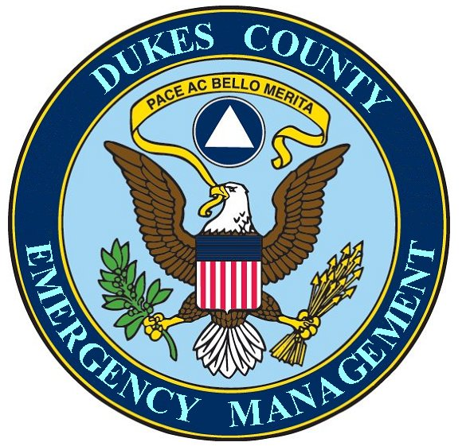
Chuck Cotnoir, Director |  | Dukes County  Emergency Management Team  www.  dukescounty.org/emteam

Proposal
to the
Board of Governors
Medical Reserve Corps

For the purpose of furthering the establishment of a Medical Reserve Corps in Dukes County, the Dukes County Emergency Management Agency proposes to contribute the following:

Access to County Infrastructure, mailing address, email address, telephone number, etc.
Office space, computer, and office furniture
Wireless Internet service
Electronic off-site record storage
Telephone service- 1st year
Fax service
Copy machine
Communications system – Radios (fixed and mobile) and operators
Mini-HAN for Command personnel (built and administered by County Emergency Management personnel)
Command & Control room
Separate Communications facility
Access to County Comm. Center services
Generators and other equipment
Mobile Trailer
Ford Ranger 4-wheel drive pick-up truck
Web space on County web site
Web site construction for MRC owned web site
Independent Web site hosting with unlimited email accounts – 1st year
Web domain services – 1st year

The County will also offer to build a HAN for volunteers for both EDS and the MV Hospital’s Emergency System for Advance Registration - Volunteer Healthcare Professionals. There may be some cost involved with this because of the incredible number of hours required to build the system and to gather and input the data.

Chuck Cotnoir, Director
Dukes County Emergency Management

