` | Dukes County Emergency Management Agency  9 Airport Road, Edgartown, Ma.  RR1 Box 860  Vineyard Haven, MA 02568  Phone: 508-696-3811 Fax: 508-696-3841  email: emergencymanagement@dukescounty.org | 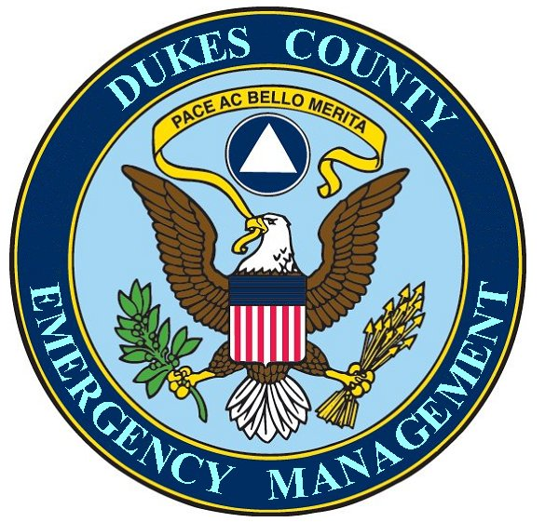
Chuck Cotnoir, Director |  | Dukes County  Emergency Management

May 22, 2007

Mr. Ron Maclaren, Health Director
Wampanoag Helath Service
20 Black Brook Rd.
Aquinnah, Ma.

Mr. Ron MacLaren,

The Dukes County Emergency Management Agency, as a partner in the Martha’s Vineyard Medical Reserve Corps, wholeheartedly supports your grant initiative to the CDC Health People and Health Communities for Environmental Health education.

This worthwhile endeavor will provide much needed public education for Environmental Health for the entire Island community and is a fitting task for the Martha’s Vineyard Medical Reserve Corps.

Please let me know if there are any County assets that would be useful to you.

Chuck Cotnoir, Director
Dukes County Emergency Management

