`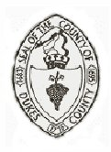 | Dukes County Emergency Management Agency  9 Airport Road, Edgartown, Ma.  RR1 Box 860  Vineyard Haven, MA 02568  Phone: 508-696-3811 Fax: 508-696-3841  email: emergencymanagement@dukescounty.org | 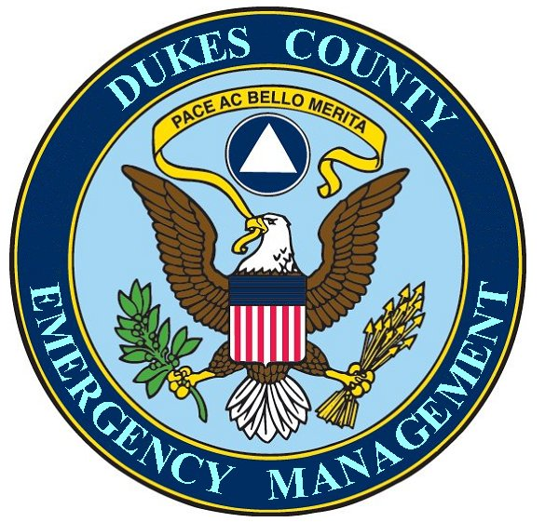
Chuck Cotnoir, Director |  | Dukes County  Emergency Management

Proposal : To consider the formation of a partnership between the Wampanoag Tribe of Gay Head/Aquinnah and the County of Dukes County Emergency Management Agency to form a Native American Community Emergency Response Partnership.

This letter is taken from a planned presentation to the tribe

My name is Chuck Cotnoir and I’m the County Emergency Management Agency Director. My area of responsibility for emergency management functions is for County owned property and for County Employees. I am not the Emergency Management Director for the Island. The Commonwealth of Massachusetts has mandated that the responsibility for performing emergency management functions for its citizens rests with each individual Town Emergency Manager. And it has been this way since the state of Massachusetts was formed.
However, because the County is a regional body, I believe that the County Emergency Management Director has to look at ways that he can help the people of the whole region of the County.
And, I’ve found that the best way to do this is by forming equal partnerships.

For Example, last year, I became involved with the planning for a nation-wide Flu Pandemic with town Boards of Health. At one of the state sponsored Pandemic Flu drills, it became apparent that a group of mostly medical and some non-medical support volunteers was needed to help the local medical and health professionals that would be overwhelmed in a catastrophe of this kind.
The Federal Government, supported by the state Government, has a volunteer program called the Medical Reserve Corps (MRC) that is designed to create these small local individual Medical Reserve Corps units.
I decided to try to create a Medical Reserve Corps for the Island of Martha’s Vineyard. I knew that it had to be a cooperative partnership of all public health and medical professionals who would have to deal with a nation-wide Flu Pandemic, so I pulled together a meeting of each of the Board of Health agents, (they had already wanted to start an MRC), the County Emergency Management Agency, the Martha’s Vineyard Hospital, and the Wampanoag Tribal Health Officer to see if a MRC could be formed. Today, the Martha’s Vineyard Medical Reserve Corps has a good start at success and our first Chairman was the representative from the Wampanoag Tribe , Ron MacClaren. The County hosts the offices of this organization and provides logistical and financial accounting support.

Another partnership example started by the County: Three years ago, the Martha’s Vineyard Emergency Management Director’s Association was formed by the County Emergency Management Director, and with much cajoling on my part, meets monthly to discuss Island Emergency Management matters. The Wampanoag Tribe is a member of this organization. Spencer Booker filled that role for awhile.

This year I would like to propose a new partnership:
An equal partnership between the Sovereign Nation of the Wampanoag of Gay Head/Aquinnah and the County to form an organizational partnership which would create a Native American Community Emergency Response Team.

This Native American Community Emergency Response Team (NACERT) initiative would be organized, directed and implemented under the auspices of the Tribal Council and its planning agencies. The NACERT would be partnered with the County Emergency Management Office who could provide emergency management support, governmental liaison, logistical support, communication support, transportation support and other types of support.

This Tribal/County partnership would serve the tribal members of the Tribe, no matter which town they reside in.

The purpose of this Native American Community Emergency Response team would be to foster and teach Individual Emergency Preparedness and Community Emergency Preparedness.

Individual Preparedness training involves Tribal/County instructors helping tribal members know what to do in an emergency, where to go, who to contact, First Aid, CPR, basic safety during an emergency, etc.

Community Emergency Preparedness involves Tribal/County emergency management leaders combining efforts to implement emergency management systems that ensure the safety and survival of all members of the tribe, no matter where they are located on the Island
For example, when short duration emergencies like hurricanes or blizzards happen, the Wampnaoag/County team could activate systems for family communications, locating family members, emergency feeding and sheltering, child care and other systems necessary to serve those tribal members who are affected by the emergency. Longer term emergencies involve tribal elders teaching those methods of basic survival traditionally practiced during years of extreme hardship.

A second function which could be explored is to establish a group of volunteers who could act as backups to Island first responders during emergencies, when requested, similar to the Medical Reserve Corps volunteers.

So where did this idea come from. It came from two places. Spencer Booker and I have been talking about ways that the County Emergency Management Director and the Tribe could work together and Jen told me about the efforts that the County would be making to engage the Tribe. She asked me if I knew of any Emergency Management projects that the County could do with the Tribe.

I had several ideas, but I thought I’d talk to people that I know and worked for at the Massachusetts Emergency Management Agency to see if they knew of any projects that tribal entities and local governments had partnered in.

It turns out that the guy I talked to, Allen Phillips, at the State, is intimately involved in a Federally funded effort, established in 1993 and recently updated, called Community Emergency Response Teams. He has just written a paper on it for making it more user friendly in Massachusetts. He also works extensively with tribes. We talked about tribal/local partnerships and then he sent me to Fred Vander Shmidt at the Federal Emergency Management Agency, who is also intimately involved in Community Emergency Response Team projects and tribes. I talked to Fred for a good 45 minutes, I must have caught him at a good time. It turns out that I’ve worked with Allen at the state and I met Fred during last summer’s breach at Norton Point. Both expressed enthusiasm about the concept of a combined regional Community Emergency Response Team effort, especially because of its tribal/local government connections.

After talking to both, I told them that I was going to approach the Tribe with this concept. I asked them, if the Tribe wanted to learn more about this Emergency Response Team concept while in partnership with the County, would they speak with the Tribe about this Federal/State program. Both told me that if the Tribe wanted to know more about this Community Emergency Response Team concept, that they would be glad to explain how to establish a Community Emergency Response Team. Both he and Allen told me that they are scheduled to come down to the Tribe, anyways, in May.

So that’s my proposal. I hope you will consider it and Thank You for your attention.

Thank You

Chuck Cotnir, Director
Dukes County Emergency Management Agency

